23rd September 2020

Dear Parent/Carer,

I hope you and your family are well, and your child has enjoyed their return to school. Unfortunately, due to the current restrictions we are all having to navigate, and to minimise risk to our school communities, we will not be running our usual Primary Presentation Evenings this year. Instead, we will produce a video presentation for Year 6 pupils and their parents. We are currently working on our video presentation and will share it with you via your child's school, along with an electronic copy of our prospectus, the week commencing 5th October.

Please find attached to this correspondence further information about our school and our virtual Moving up to Ryedale School Event.

Your sincerely,

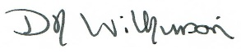

Domenica Wilkinson
Secondary Director

