

Money

Most people earn money for doing their job. Different jobs pay different amounts of money. Look at some of the different coins we use (use real ones if possible).

* Which is a 5 pence coin?
* Which one is worth 1 pound?
* Can you tell me what this coin is worth?
* Select two or three coins. How much altogether?

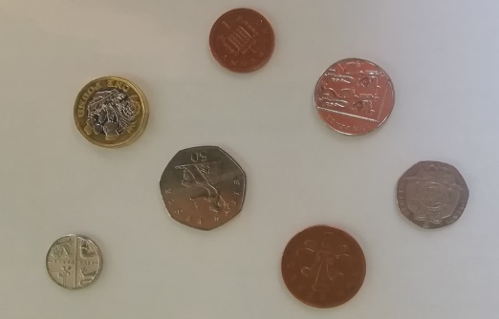

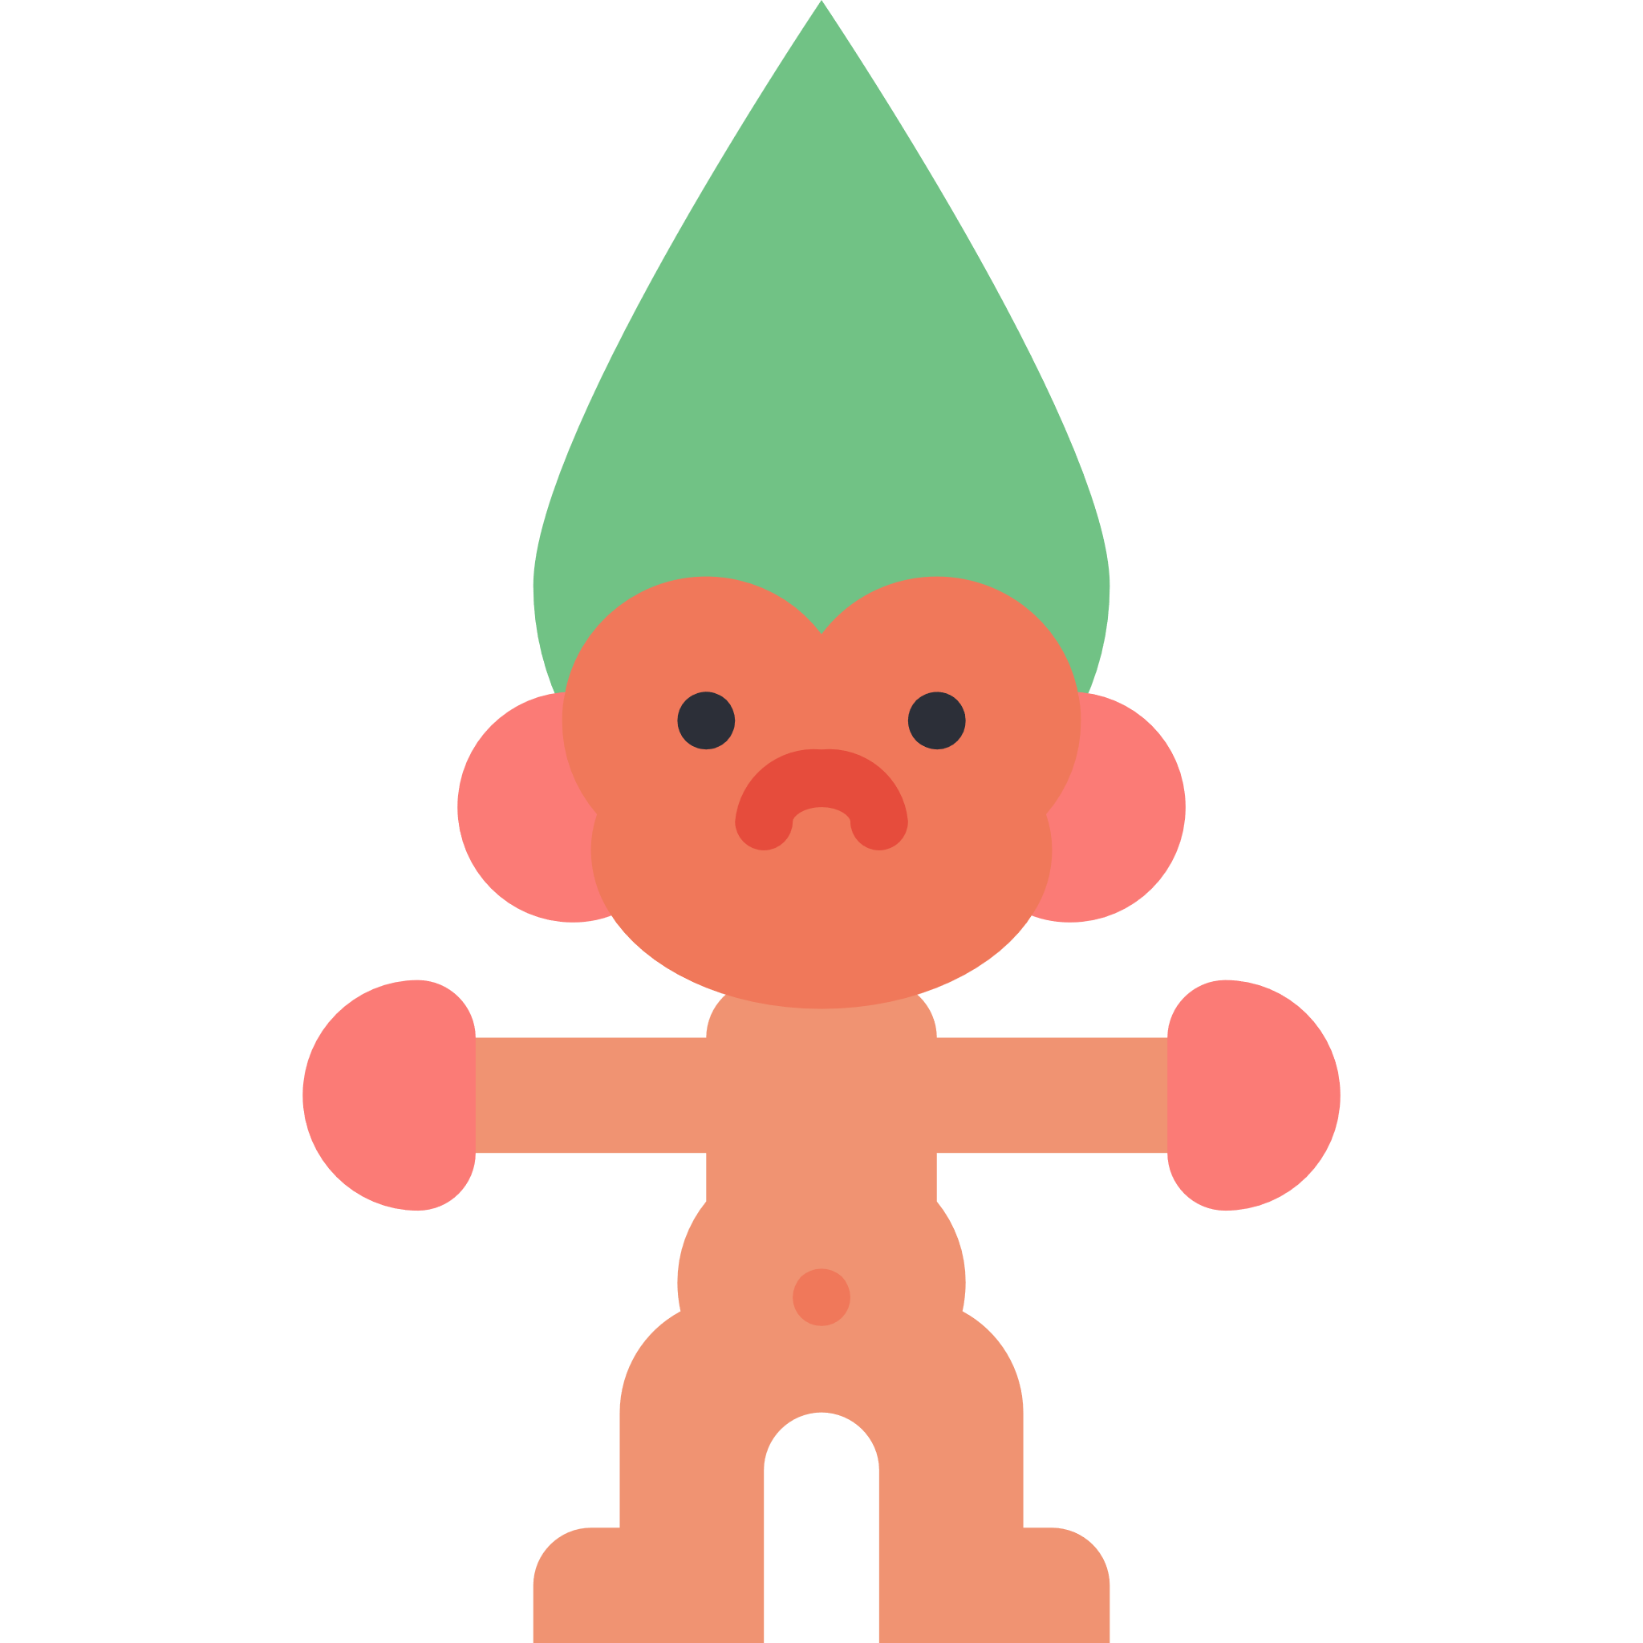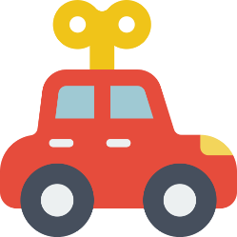

17p

21p

32p

55p

8p

Look at the items for sale in this shop. Select the exact coins to pay for each item.

* How much would the teddy and the car cost altogether?
* If you used a 10 pence coin to pay for the pencil, how much change would you get?