Class 3 WEEK 4 – Food

Maths Tasks

(Aim to do 1 per day)

● Purple Mash Maths- a 2do will be set for you on Monday.

● Play on ​Hit the Button​ - focus on number bonds, halves, doubles and times tables (including division.)
https://www.topmarks.co.uk/maths-games/hit-the-button

● Practise your written methods for addition and subtraction, using the ‘column method.’
Year 3: 2-digit + / - 2-digit numbers
Year 4: 3-digit + / - 3-digit numbers
*Remember to carry over when adding if needed, and exchange when subtracting, if needed.

● Practise telling the time. This could be done through this ​game​ (scroll down to access the game).
https://mathsframe.co.uk/en/resources/resource/116/telling-the-time
Year 3: Read to the quarter hour and the nearest 5 minutes on an analogue clock.
Year 4: Tell the time accurately using both analogue and digital clocks. Convert between 12 and 24h time.

- Could you make a clock outdoors using stones and sticks to help tell the time? Perhaps you could (with an adult’s permission,) record a tutorial to teach someone else how to tell the time?
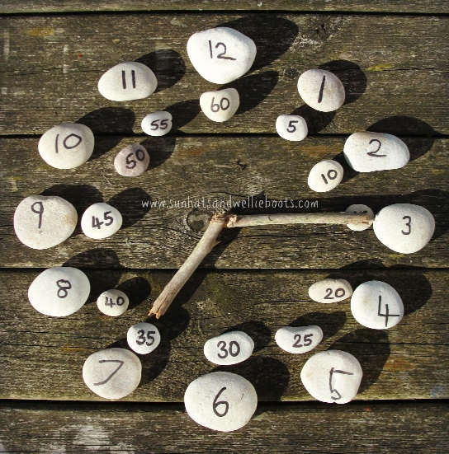

Reading Tasks

(Aim to do 1 per day)

- Read the final chapter (Chapter 7) of Beth and the Nile on Purple Mash (set as a 2Do) and complete the 2Do to review the story. What did you enjoy? Would you recommend the story to others? Why/why not? Remember to make sure that your writing makes sense.

● Get your child to choose a picture on Once Upon a Picture and go through the comprehension questions and tasks
https://www.onceuponapicture.co.uk/

● Listen to your child read and let them discuss what they have read. Encourage them to read using our ‘6Ps of Fluency’ – Pace, Pitch, Pause, Power, Punctuation, Passion.

● Get your child to read a book on ​Oxford Owl​, discuss what your child enjoyed about the book.
https://www.oxfordowl.co.uk/for-home/find-a-book/library-page/

● Explore the Vocabulary Ninja ‘word of the day’
https://www.vocabularyninja.co.uk/word-of-the-day.html
You could print, make your own, or create a Powerpoint ‘vocab lab’ https://www.vocabularyninja.co.uk/vocabulary-laboratory.html

Spelling Tasks

Aim to do one spelling activity each day, from a choice of the following:

● Practise the Year 3/4 Common Exception​ words​
https://www.chawton.hants.sch.uk/attachments/download.asp?file=53&type=pdf

● Practise your spellings (see List 4 on the half-termly spelling sheet)

● Choose 5 Common Exception words. Write a synonym, antonyms, the meaning and an example of how to use the word in a sentence. Can the word be modified?

● Choose 5 Common Exception words and practise spelling them using Egyptian Hieroglyphs!

Writing Tasks

(Aim to spread these across the week. In school we always explore existing texts, plan our writing, write, edit and then redraft so don’t worry if you don’t get through more than one of these tasks!)

● Take part in a writing ​master class. (If you haven’t done one of these yet… I can highly recommend them! They are writing tasks set by real authors.) My personal favourites are Abi Elphinstone, Katherine Rundell and Onjali Q. Rauf)
https://authorfy.com/masterclasses/?age=7-11&masterclass_author=&keywords=

● Write a descriptive menu for a wealthy Ancient Egyptian’s banquet.

● Write a recipe. How to make ........ Remembering to include a list of ingredients and things they need. Also not forgetting to include headings and subheadings. Then write their set of instructions, remembering to include imperative verbs. (Verbs that command you to do something). You might like this template:
https://www.sparklebox.co.uk/literacy/writing/frames/recipes.html#.XoXBdBDTXmo

Food

Some ideas to pick and choose to do throughout the week…

The theme this week aims to provide opportunities for your child to learn more food. Learning may focus on where different foods originate from, what makes a healthy meal, opportunities to cook etc. and could also link with Ancient Egypt, if you’d like it to!

● Let’s Wonder:
What is a balanced diet? Find out about the 5 food groups. Make slides or
posters about what they find out about. ​Carbohydrates​ ​Protein​ ​Dairy​ ​Fruits and ​Vegetables​ ​Fats​. Where does their food come from? Which foods come from the UK? ​What is fair-trade?
https://www.bbc.co.uk/bitesize/topics/zrffr82/articles/zppvv4j

● Let’s Create:
Take a look at some food recipes from other historical periods using http://cookit.e2bn.org/historycookbook/

● Be Active:
Try out some story-yoga using ‘Cosmic Kids yoga’ on Youtube.

● Time to Talk:
As a family, design a healthy meal plan for the week. Discuss their favourite foods and why they enjoy them? Talk about healthy and unhealthy foods and explain the importance of eating a balanced diet.

● Understanding Others and Appreciating Differences:
Lunch around the world.​ Look at lunch around the world and investigate how differently people eat in other parts of the world. Find out what a vegetarian is? Vegan? Kosher food?
Halal food?

● Reflect:
Make a meal by combining a variety of ingredients using a range of cooking techniques.
Measure and weigh ingredients appropriately to prepare and cook a range of savoury dishes.

