Class 1 Week 5 Celebrations
Talk to your grown up about different celebrations that have taken place in your life.  Which has been your favourite and why?  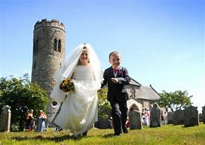 | Plan a party for your teddies and family.  Do you remember how we wrote invitations, made cards, wrapped pass the parcel, made paperchains, prepared food and then we had a big party in class 1?  A fair few of you have just had a birthday or have a birthday coming up shortly. Why don’t we all have a party at our own houses to celebrate everyone’s birthday 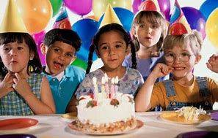 | Think about how old everyone is going to be.  If they are 4 now, how old were they before they were 4? If they are 4, are you older or younger than them?  How old are they going to be after they have been 4?  How old will then be after they are 5?  Do you know anyone who is 1,2,3,4,5,6,7,8,9…..  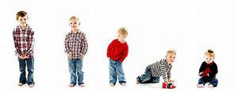
Do you have any books about celebrations?  They could be about birthdays, weddings, christenings, Christmas, Easter….  Do we all celebrate the same celebrations? Look at different celebrations that people may celebrate.  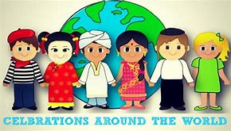 | Using toilet rolls can you make a bride and groom. You could also make a church out of boxes. Have you ever been to a wedding? What are we celebrating when people get married?  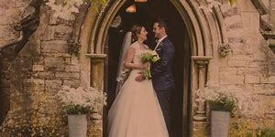 | May 18th International Museum Day  No Dirty Dishes Day  May 19th World Plant A Vegetable Garden Day  May 20th Be A Millionaire Day  May 21st National Memo Day  National Waiters and Waitresses Day  May 22nd Buy a Musical Instrument Day  May 23rd International Jazz Day  Lucky Penny Day.  Pick some days to celebrate – talk to your child about how you will celebrate. Lots of virtual museum tours are available online. You could make an instrument out of your recycling.  Do you know what ‘Jazz’ is? Ask your grown up or Alexa to play some.
Make a celebration cake either for real/ out of  Playdough or a junk model one.  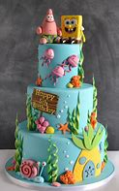 | Ask members of your family what month of the year their birthday is in. Do you know what day and month your birthday is?  Talk about the months of the year, what celebrations are when.  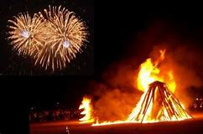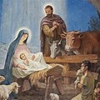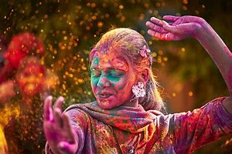 | Holi looks a really fun festival. What facts can you find out about it?  I think this would be my favourite festival if I was a Hindu.  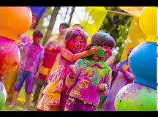
Can you make a face or person using dandelions?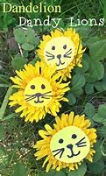 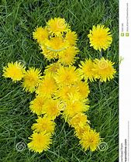 | Make a mud pie or mud cake  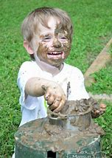 | Look out for butterflies, how many can you spot and what breed are they?  Look at the butterfly lifecycle.  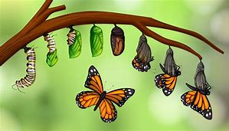

Have a great week, have fun, be kind and keep safe xxxx

