Class 1 Week 4 – Food Twinkl have lots of activities about healthy and unhealthy foods
Can you make a book about your favourite foods?  I like chips  I like strawberries  Let them sound out the word, it does not have to be spelt correctly, just the sounds they hear. Some may just hear the ‘s’ and the ‘b’ – that is great.  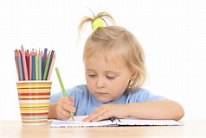 | Make a picnic – do you have any cutters to make shaped sandwiches? What other food could you have? Where could you have your picnic? In the garden, make an indoor den.  Plan it with your mummy or daddy. Think how many bags of crisps you need, how many drinks ..  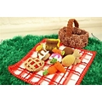 | With all your recycling could you make a roleplay food shop. Do you remember when we had the dinosaur shop and one of you was the shop keeper and one was the customer? You had your money to spend, you had to look at the price labels and pay the right amount of money. What would your shop be called? You make a sign for your shop.  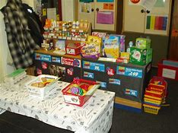
Toast painting  Put some milk into some little pots, add food colouring to the milk. Give it a little stir then paint your bread. Don’t make it too soggy. Put it in the toaster to toast lightly.  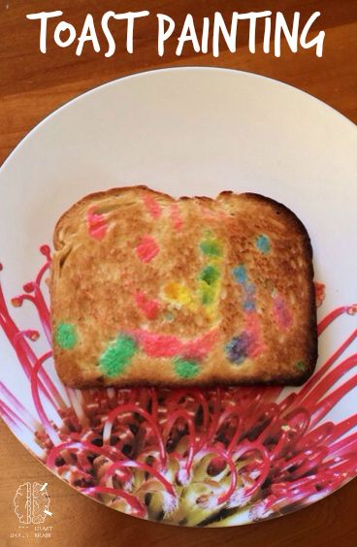 | Look on your bookshelf, what books do you have about food.  Do you have: Supertato?  Barry the fish with fingers?  Oliver’s Vegetables?  You might be able to find them on YouTube  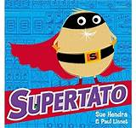 | Look at an app called ‘Chatterkid’. It is a simple app that can make anything talk. Can you make some fruit/veg/crisps talk?  You just need to give your object a face first  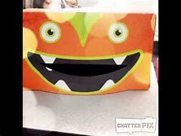
Look in your fruit bowl  Can you sort them into groups? Count how many apples you have and record that number. You could make a graph using the purple mash graph like you did at school when you asked your friends which was their favourite fruit  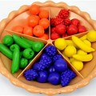 | Ask your grown up if they could possibly add a variety pack of crisps to your shopping order. You will need a blindfold (scarf will do the job), a bag of each flavour crisps, a record sheet with the flavours and people taking part. If the person gets it wrong put a x if they get it right a smiley face or a tick. Everyone should have a turn then count up who got the most right and who needs more practise eating crisps?  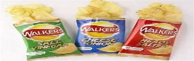 | You could do the same as with the crisps but with sweet and sour things, can you taste the difference?  You could make scent pots using empty yogurt pots. Put different edible scented things into the pots, cover them with kitchen foil or kitchen towel. Can people guess what is inside the pot?  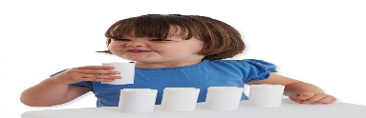
It could be your job for the week to set the table and to clear the plates away after you have eaten. You could write place labels for everyone, writing their name and drawing something that you know they like. Ask your grownup if you could pick 3 flowers from the garden to put in a vase or jam jar, to make the table look beautiful. Can you find out what the flowers are called?  I would like you to ask your family these questions whilst you are all having lunch/tea:  - What was the best thing about being a child?  - Did you have a favourite toy or teddy when you were younger?  - Who were your friends when you were at primary school?  - What was your favourite meal?  - Did you used to eat the same sort of food that we eat now? | Can you help make pancakes?  Measure out:  1 cup of milk  1 cup of flour  1 egg  Ask your grown up what they would like on their pancake.  Do you remember what you had on your pancakes when we had them at school?  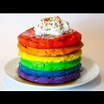 | You might not have been in a super market for a few weeks, can you remember which part you like to visit the most? Amy likes to visit the bakery as she likes to sample all the breads. Toby likes the fruit area and the cereals. Which parts are a bit boring? Do you miss not going to the shops?  Can you write your dream shopping list?  