Class 1 Week 3
Environments – Different Countries
If you live on a street, can you count how many houses are on it? When you are out on a walk can you recognise the numbers on the doors? Count how many windows a house has.  If you don’t live near another house, can you count how many windows your house has?  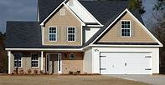 | Pick a country from a map, learn some facts about this country. You could have a themed day, drawing the countries flag, help mummy or daddy make some food from that country, you could design a menu. Learn to say ‘hello’ and ‘goodbye’ in their language.  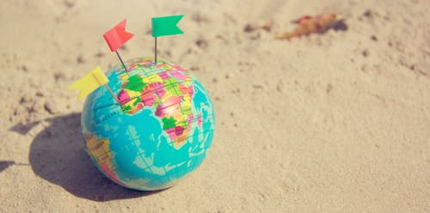 | Look at the flags of the world, can you count and record how many start with each capital letter?  Can you spot different shapes on the flags?  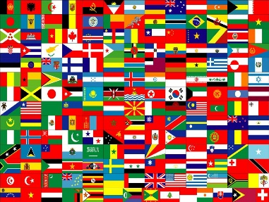  This Photo by Unknown Author is licensed under CC BY-NC
Give your Granny/Grandpa/ Aunt/ Uncle/friend a call. Ask them if they have visited a different country? What was their favourite part of the holiday? What food did they eat? Was the weather hot or cold? How did they get there? Look on a map and see how far they had to travel to get there. 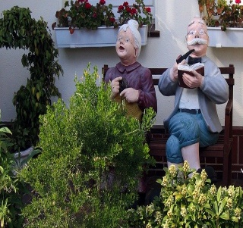 | Can you make a desert island out of your recycling? You could include a boat, raft, trees, tent …  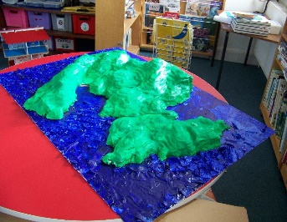 | Look at the shape of a globe.  Can you remember what the shape is called?  Does it have any corners?  Does it have any sides?  What other things can you find around the house that are this shape?  Could you draw them or look through a magazine to see if there are any in there?  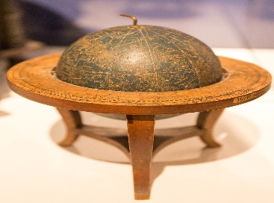  This Photo by Unknown Author is licensed under CC BY-SA
Make a book about different types of houses, start off by drawing a picture of your own house. Look at different ‘homes’ around the world. Some people live in igloos, tents, houses made out of straw. You could write ‘My house is made from bricks’ Then for the others you could write ‘straw’ ‘cloth’ underneath as they are very tricky words to write.  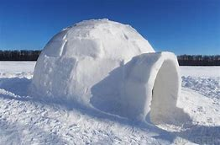 | Talk to your family about the holidays that you have been on. What did you like best? What did you eat? How did you get there? Where did you stay? Who went with you? It’s good to look back and remember things from the past.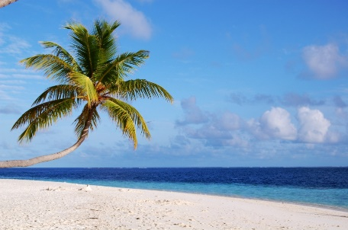  This Photo by Unknown Author is licensed under CC BY-SA  I would like to be here, eating ice creams. | Using your recycling can you design your own home? Think about the different homes that you have been looking at. You could even try to make an ice house  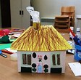
If it’s a nice day you could have a go at making the world. It gets a bit messy. Instructions are attached.  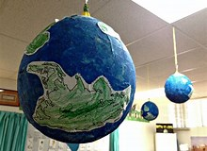 | Look at the clothes that people wear.  Do you have any traditional clothes from different countries at your house?  If you have scraps of material at your house, could you make an outfit for your teddy or doll? If you don’t have any material, you could make it out of paper.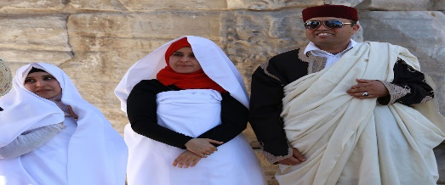  This Photo by Unknown Author is licensed under CC BY-SA-NC | Can you design your own flag?  You could draw different shapes, add your favourite animal ……  This Photo by Unknown Author is licensed under CC BY-SA

Twinkl – Design your own flag
Uk map – The United Kingdom
World Flags and Capitals
World map animals
Landmarks display poster

Or email: class1@crayke.n-yorks.sch.uk and I can email you the individual sheets. It won’t let me attach them to the document, as we found out with last weeks!

How to Make Paper Mache

Step 1

Put two cups of flour into a mixing bowl.
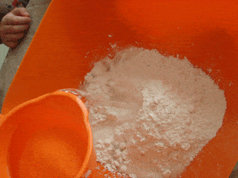<img id="wd-cl-img1" src="https://i2.wp.com/thecraftyclassroom.com/wp-content/uploads/2015/10/earth16.gif" >

Step 2
Add two cups of warm water.
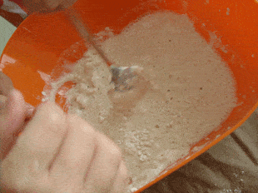<img id="wd-cl-img2" src="https://i2.wp.com/thecraftyclassroom.com/wp-content/uploads/2015/10/earth15.gif" >

Step 3
Stir, Stir, Stir......
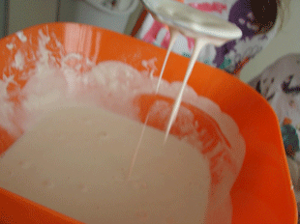<img id="wd-cl-img3" src="https://i2.wp.com/thecraftyclassroom.com/wp-content/uploads/2015/10/earth14.gif" >

Step 4

Your paper mache is ready when it's nice and goopy/runny without any lumps.
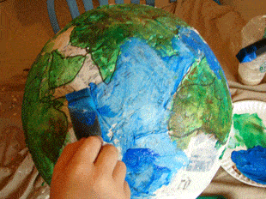<img id="wd-cl-img4" src="https://i2.wp.com/thecraftyclassroom.com/wp-content/uploads/2015/10/Earth3.gif" >

All Done!

Paper Mache is a great medium for all types of sculpting! Check out our Paper Mache Globe!

