Class 3 - WEEK 2 – Animals

Maths Tasks

(Aim to do 1 per day)

● Purple Mash Maths- a 2do will be set for you on Monday.

● Play on ​Hit the Button​ - focus on number bonds, halves, doubles and times tables (including division.)
https://www.topmarks.co.uk/maths-games/hit-the-button

● Adding totals of the weekly shopping list or do some work around money. This game​ could support work on adding money.(Requires Flash)
http://flash.topmarks.co.uk/4020

● Practise telling the time. This could be done through this ​game​ (scroll down to access the game).
https://mathsframe.co.uk/en/resources/resource/116/telling-the-time
Year 3: Read to the quarter hour and the nearest 5 minutes on an analogue clock.
Year 4: Tell the time accurately using both analogue and digital clocks. Convert between 12 and 24h time.

● Get a piece of paper and ask your child to show everything they know about Division.​ This could be pictures, diagrams, explanations, methods (we use the ‘bus-stop method’ in school) They can be as creative as they want to be.
What vocabulary can they use? Divide? Share equally? Can they link division to fractions? Times tables?

Reading Tasks

(Aim to do 1 per day)

● Read chapter 3 and 4 of ‘Beth and the Nile’ (on Purple Mash, set as a 2Do) and complete the multiple choice questions for each chapter after you have read them carefully. Note: Click on any underlined word in the story to discover what it means.

● You could share a story together. This could be a chapter book where you read and discuss a chapter a day.

● Listen to your child read and let them discuss what they have read. Encourage them to read using our ‘6Ps of Fluency’ – Pace, Pitch, Pause, Power, Punctuation, Passion.

● Get your child to read a book on ​Oxford Owl​, discuss what your child enjoyed about the book.
https://www.oxfordowl.co.uk/for-home/find-a-book/library-page/

● Explore the Vocabulary Ninja ‘word of the day’
https://www.vocabularyninja.co.uk/word-of-the-day.html
You could print, make your own, or create a Powerpoint ‘vocab lab’ https://www.vocabularyninja.co.uk/vocabulary-laboratory.html

Spelling Tasks

Aim to do one spelling activity each day, from a choice of the following:

● Practise the Year 3/4 Common Exception​ words​
https://www.chawton.hants.sch.uk/attachments/download.asp?file=53&type=pdf

● Practise your spellings (see List 2 on the half-termly spelling sheet)

● Choose 5 Common Exception words. Write a synonym, antonyms, the meaning and an example of how to use the word in a sentence. Can the word be modified?

● Choose 5 Common Exception words. Do they contain any spelling patterns that you know? Practise spelling them using chalk outside, a paintbrush and water outside, writing in a shallow tray with salt or sand in, or making each word using play dough!

Writing Tasks

(Aim to spread these across the week. In school we always explore existing texts, plan our writing, write, edit and then redraft so don’t worry if you don’t get through more than one of these tasks!)

● Take part in a writing ​master class.
https://authorfy.com/masterclasses/?age=7-11&masterclass_author=&keywords=

● Design an information leaflet about an animal of their choice. Remember to use headings and subheadings.
https://www.woodlandtrust.org.uk/trees-woods-and-wildlife/animals/

● Write a description of a fictional animal that has just been discovered. Think about what it looks like, where it lives and what it eats. Draw a picture to show what this new creature is like. You could also create a character web for your new creature, describing its characteristics. (Remind the children of the fabulous work they did on their dragons – they could use this to help as a starting point.)

Animals

Some ideas to pick and choose to do throughout the week…

Our theme in school would have been ‘Ancient Egypt’ – so if you would prefer to look at animals that live in and along the Nile, as well as animals linked to Ancient Egyptian beliefs, then go for it!

The theme this week aims to provide opportunities for your child to learn more about key​ ​animals they are interested in. Learning may focus on exploring the physical aspects of an animal, their habitat, categorising animals etc.

● Let’s Wonder:
Create fact files about deadly predators. Draw pictures of the predators
and label them with information they find out. Where does the predator live? Why does it live there? What does it eat? How does it capture its prey? What special qualities do these predators have? Make a ​food chain​ to demonstrate why a predator is at the top of the chain. They could make a set of ​top trump cards​ using the information they found out.
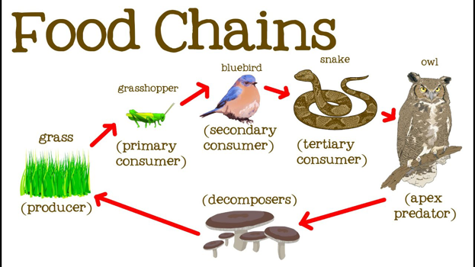
https://youtu.be/hLq2datPo5M

● Let’s Create:
Explore the artist ​Franz Marc​. Find out who he was and what type of artist he was. What did he like to create pictures? Look at some of his paintings online. Then choose an animal to draw and add colour to, in a similar style to his. What do they think of his paintings? Did they like their finished piece of artwork? Why?/Why not?
https://www.artyfactory.com/art_appreciation/animals_in_art/franz_marc.htm

● Be Active:
Join in with the Joe Wicks workout for 30 minutes on Youtube every weekday at 9am (Mrs Rayner will be giving it a go, too!) Ask an adult to search for ‘PE with Joe’
Recommendation is at least 2 hours of exercise a week.

● Time to Talk:
Find out which animals are their family members' favourites and why. Have a family debate about whether zoos should exist? Discuss whether they agree/disagree and why? Do their family members have a different opinion to them? Why not debate whether animals should be kept as pets?

● Understanding Others and Appreciating Differences:
Which animals are considered to be sacred around the world and why?

● Sacred Animals
Who admires cows? Lions? Wolves? Which animals were important to the Egyptians and why?
https://animalogic.ca/blog/7-sacred-animals-from-around-the-world

● Christianity and animals
Watch these clips of Bible stories featuring animals
https://youtu.be/teu7BCZTgDs
https://youtu.be/ZV3eQ2PBqHE
https://youtu.be/QAsfOcGjgoM

Reflect: what do these stories about what Christians believe about animals?
Think: What do you think of animals and how do you treat animals?

