Class 3

WEEK 1 – Viewpoints

Maths Tasks

(Aim to do 1 per day)

● Purple Mash maths - a 2do will be set for you on Monday.

● Play on ​Hit the Button​ - focus on number bonds, halves, doubles and times tables (including division.)
https://www.topmarks.co.uk/maths-games/hit-the-button

● Adding totals of the weekly shopping list or some work around money. This game​ could support work on adding money.
https://mathsframe.co.uk/en/resources/resource/44/solve-2-step-money-problems-

● Watch this clip and follow the activities:
https://www.bbc.co.uk/bitesize/clips/z6487ty

● Practise telling the time. This could be done through the ​game​ below (scroll down to access the game).
Alternatively… do you have a spare paper plate at home? Why not make a paper plate clock?

Year 3: Read to the quarter hour and the nearest 5 minutes on an analogue clock.
Year 4: Tell the time accurately using both analogue and digital clocks. Convert between 12 and 24h time.
https://mathsframe.co.uk/en/resources/resource/116/telling-the-time

Reading Tasks

(Aim to do 1 per day)

● Read chapter 1 and 2 of ‘Beth and the Nile’ (on Purple Mash, set as a 2Do) and complete the multiple choice questions for each chapter after you have read them carefully. Note: Click on any underlined word in the story to discover what it means.

- You could share a story together. This could be a chapter book where you read and discuss a chapter a day.

● Listen to your child read and let them discuss what they have read. Encourage them to read using our ‘6Ps of Fluency’ – Pace, Pitch, Pause, Power, Punctuation, Passion.

● Explore the Vocabulary Ninja ‘word of the day’
https://www.vocabularyninja.co.uk/word-of-the-day.html
You could print, make your own, or create a Powerpoint ‘vocab lab’ https://www.vocabularyninja.co.uk/vocabulary-laboratory.html

● Get your child to read a book on ​Oxford Owl​, discuss what your child enjoyed about the book.
https://www.oxfordowl.co.uk/for-home/find-a-book/library-page/

Spelling Tasks
Aim to do one spelling activity each day, from a choice of the following:

● Practise the Year 3/4 Common Exception​ words​
https://www.chawton.hants.sch.uk/attachments/download.asp?file=53&type=pdf

● Practise your spellings (see List 1 on the half-termly spelling sheet)

● Choose 5 Common Exception words. Write a synonym, antonyms, the meaning and an example of how to use the word in a sentence. Can the word be modified?
Synonym = A word that means the same
Antonym = A word that is the opposite
Modified = changed

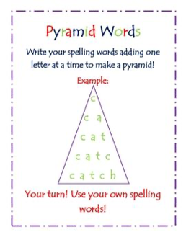
● Choose 5 Common Exception words and practise spelling them using pyramid words. Write the word in a pyramid, e.g.
Writing Tasks

(Aim to spread these across the week. In school we always explore existing texts, plan our writing, write, edit and then redraft so don’t worry if you don’t get through more than one of these tasks!)

● Take part in a writing ​master class.
https://authorfy.com/masterclasses/?age=7-11&masterclass_author=&keywords=

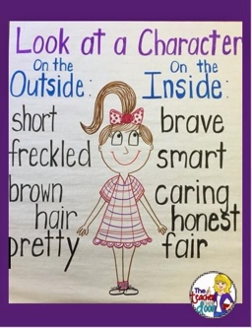
● Choose a favourite character from a book, game, T.V. Programme or film. On the centre of a piece of paper draw the character. Around the picture write/characteristics of the character to create a character web. Include what they look like, strengths, weaknesses, hobbies and interests and any other interesting details.

● If they were to become a superhero what would their superpower be? Write a character description or create a character web of them as a superhero. Explain how they save the day.

Viewpoints

Some ideas to pick and choose to do throughout the week…

The theme this week aims to provide opportunities for your child to learn more about different viewpoints. Learning may focus on physical viewpoints in terms of what you can see outside of the window at home, what others can see looking into your home and then progress onto personal viewpoints and of others.

● Let’s Wonder:
Draw a picture of them self and label their drawing with the qualities they have.
How do others see them differently? Ask people at home to add to their qualities.
How are they different to other children in different parts of the world? What makes them similar to other children around the world?

● Let’s Create:
Complete an observational drawing of what they see outside a window in their house. Then get out into the garden and find natural forms such as stones, leaves, flowers and animals. Complete sketches, showing an awareness of different viewpoints of the same object. Remember to concentrate on tone and shading.

● Be Active:
Move around their home and garden taking photographs from different viewpoints. Which photos do they like? Do the people they live with like the same photos as them? Why? Why not?

Join in with the Joe Wicks workout for 30 minutes on Youtube every weekday at 9am (Mrs Rayner will be giving it a go, too!) Ask an adult to search for ‘PE with Joe’
Recommendation is at least 2 hours of exercise a week.

● Time to Talk:
Talk about keeping safe, discuss different ways to keep safe. Basic hygiene rules, road safety, internet safety, water safety, being safe around the home, stranger danger. How do different people view this?

● Understanding Others and Appreciating Differences:
Listen to different pieces of music from around the world, which styles of music do they prefer and why? ​Music​: maybe they could learn a song by heart, perform it, present it. You could even share it (with parental discretion).

● Reflect:
Design their own ideal world. Would their world contain the same things as other people? Which things are most important to them? What are they going to include?

