Class 1 Week 2 Topic Animals
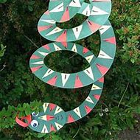  Can you draw round a plate, ask a grown up to draw a spiral, colour in your snake then cut along the lines | 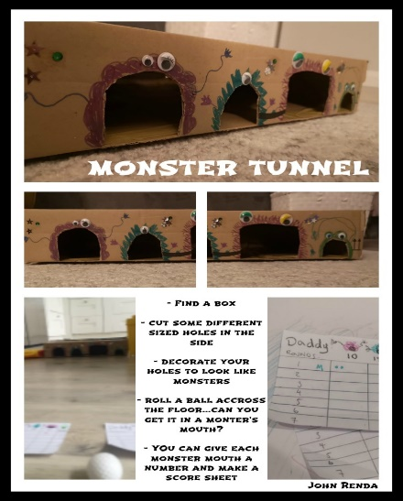 | 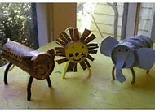  Can you make a toilet roll animal?  You could write a label for it.  I am a ………  My name is ……….. | 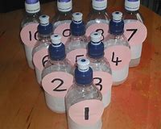  Make some skittles out of some empty bottles, toilet rolls, cans…..  What numbers can you knock down?
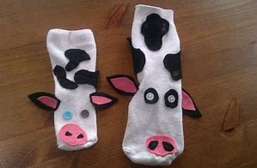  Try making a sock puppet animal. You could attach it to a thick bit of wood to make a hobby animal. You could then set up jumps and obstacles. Can you get round your course in 1 minute? | 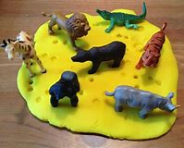  Do you have any animals at home that you could play with in the playdough? Look at their different footprints, are they the same or different? | 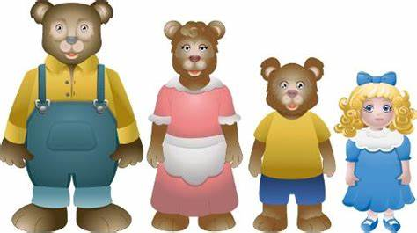  Act out the story of goldilocks and the three bears. Can your teddies be daddy, mummy and baby bear? Can you find 3 different sized bowls? You might have chairs/beds in your house that are different sized. | 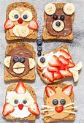  Could you make an animal using food? I like the bear and the owl.  Be as creative as you can.
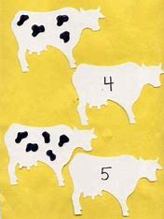  Make your own cows, hide them in the garden or around the house.  Some children could draw the markings on the cow to match the number. Hide the cows then see if your child can match the markings to the numeral. Or find 2 cows at a time, can you add the two numbers together? Can you write this in a number sentence 3+6=9 | 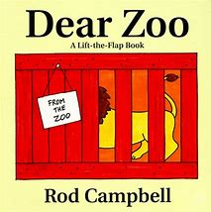  Find an animal book that you have at home. Can your child write their own book? I like dogs, I like cats, I like cows, I like fish. Draw or cut out pictures to go with the writing. | 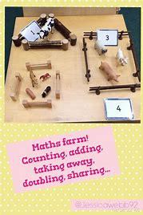  If you have a toy farm, can you sort the animals into groups?  Ask your child how many cows there are? If you took 2 away, how many would be left? | 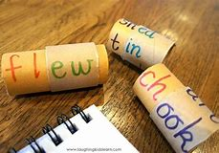  Make your own animal word tubes, if you have kitchen roll and toilet roll tubes that’s great. Can your child sound out the animal?  f i sh sh ee p  d o g  p i g g oa t
Play the animal eye spy game which is attached | Throw a dice, can they jump, hop, skip that number of times? Have 2 dice, can they add them together? If you want a room tidying, can they pick up that number of toys, books, items of clothing? | 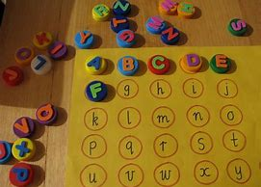  If you don’t have bottle tops you could just cut out circles. The children could write the letters on. Can they match the lowercase to its capital? | 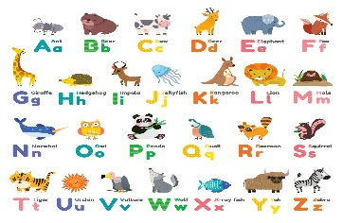  Animal phonics- can your child suggest an animal for each letter sound?
Have fun, stay, safe | I miss you all very much | Be good, be kind | xxxxxxxxx

