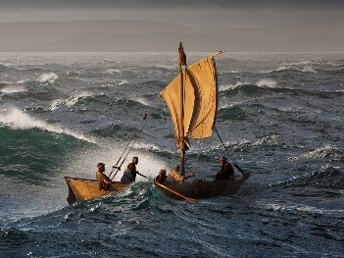
Our school: together and apart
Reflections for ‘school’ at home: We’re all in the same boat
A note for parents and carers:
At school, your child will be used to taking part in collective worship every day (they might call it ‘assembly’). This is not the kind of worship that some of you might be have been part of in a religious building. In church schools this collective worship is planned to be:
- Inclusive: something for children and teachers, of all faiths or of none to be able to join in with
- Inspirational: a time in the day to think about the big questions in our lives; an occasion that supports the school community’s spiritual development, creates an opportunity to gather around and reflect on a common theme and ‘feeds’ their inner being;
- Invitational: in school, children and teachers are invited to pray, think, or reflect, it is the child’s or teacher’s choice how they respond.

At this time, many children will be missing the familiar routines of school. One way in which we can help to keep that sense of normality is by offering these resources to schools to share with their school community at home. Please be clear: these ideas are for you to use, adapt, or not use at all. You choose!

We plan to produce these resources for the weeks that schools are ‘at home’ and would love to know if there’s anything that your school community at home would appreciate. You can find our contact details on the Diocesan website.
Jane Whittington & Rachel Boxer

Theme: We’re all in the same boat
- There is a story to share together if you would like to, on page 3.
- Look at the two pictures of the boats on the sea, taken from a version of the story of Jesus calming the storm. You can find them on the next page or view the whole story here
Things to talk about together:
- Which boat would you prefer to be in?
- How do you think it might feel to be in the boat on the stormy sea?
- We sometimes talk about ‘being in the same boat’. What do you think this means?
- At this time when everything is changing, and everything feels different, it’s good to remember that it’s changing and different for everyone: we’re all in the same boat.
- Talk about the things that are the same for everyone at the moment: share any worries or concerns together and think about how it helps to know that at this time, we are not alone. We may be apart from one another and social distancing may prevent us from seeing friends and family members, but there are lots of other ways we can feel together.
Things to do together:
- Make an origami paper boat. You can see a short video about how to do it here. Decorate it if you would like to. Or you could make a boat out of recycled materials, such as plastic tubs or cereal boxes, or from Lego or another construction kit. Test your boat out in the bath or sink to see if it will float. You might like to use it as part of the reflective activity below. Test your boat out in the bath or sink to see if it will float. You might like to use it as part of the reflective activity below.
- Draw and cut out pictures of people you love, or write their names on slips of paper, and put them in your boat. If you want to, pray for them one by one.
- Use the story of Jesus calming the storm on page 3 and join in as much as you can. Or if you prefer a less interactive version, then use the pictures in the presentation here. If you click ‘view slideshow’ you will be able to read the story as well as look at the pictures. Afterwards, talk about the story together: I wonder what this story might teach Christians today? Can it teach us anything? How might this story help us?
- Ask a grown-up first, before you do this next activity! Find lots of things around your house that you could use to make stormy sound effects for the story. Then tell it again and use your soundscape to accompany the story.
Things to reflect on or pray about together:
- This week if you are worried about anything, write it on a piece of paper and put it in the boat you made.
- If you want to, share what you’ve written with the other people in your house, or pray together if this is something that you would usually do. You might find it helps to remove the worries from the boat after you’ve shared together.

- A prayer for you to use if you would like to:
God, You hold me in your palm. Hold me close and keep me calm. Amen.
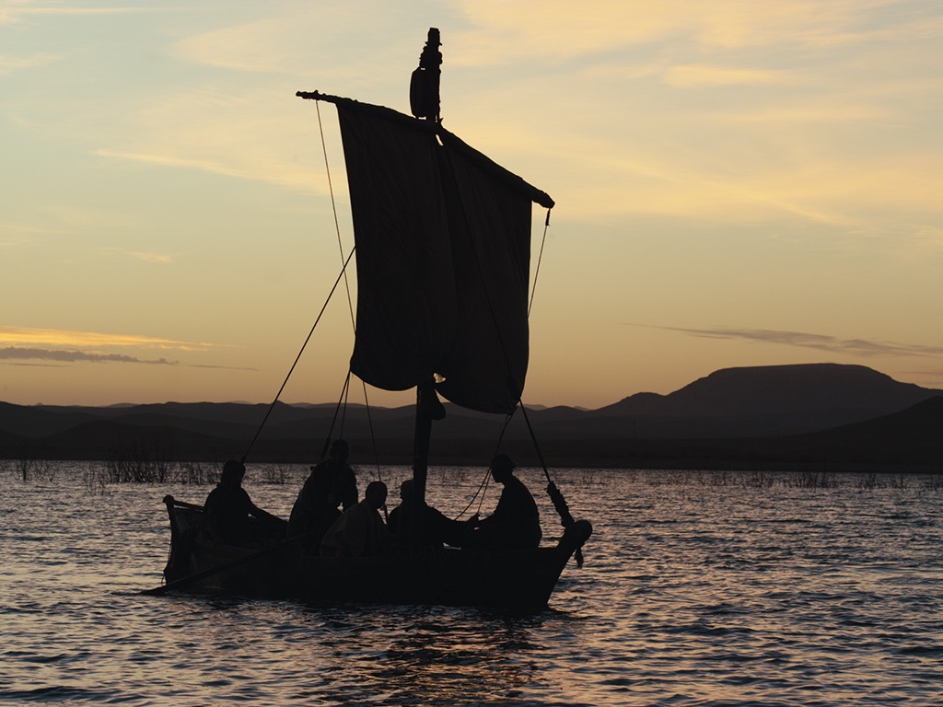

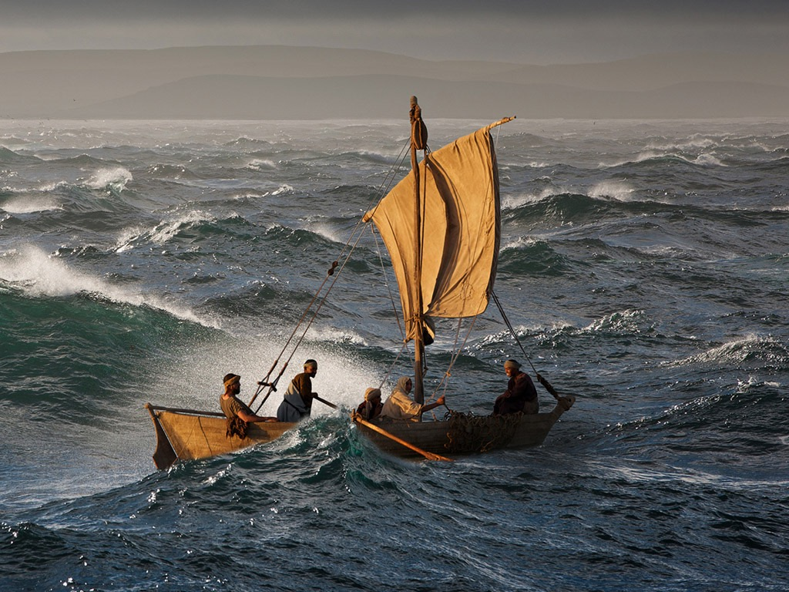
Pictures from

We’re all in the same boat
Everything feels different at the moment, doesn’t it?
Everything feels a little bit chaotic and stormy.
It’s affecting all of us. We are all in the same boat.

There’s a story in the Bible that reminds Christians that Jesus is with them in the storm and can bring calmness – we are going to tell it together:

Jesus has been teaching all day and was tired.
He said to his disciples ‘Let’s take a boat and go to the other side of the lake’ (Huddle close together like you are in a boat)
Jesus was so tired that the gentle rocking of the boat sent him to sleep. (Gently rock together, but don’t fall asleep yet!)
Soon the weather changed. The wind started to blow. The waves grew bigger and the boat rocked.
The storm grew worse, the waves were lashing the boat, the wind was howling and the boat was tossed from side to side. (make as much noise as you can – and keep going until you hear the word ‘STOP!’)
The rain pelted down and thunder and lightning lit up the sky.
The disciples thought the boat might capsize or sink, they were terrified.
They shouted for Jesus to wake up and save them.
Jesus opened his eyes, he saw the storm, the waves lashing and the wind howling, and he said ‘STOP! Be still!’
Immediately the wind and the waves were calm. Silence!
As quickly as it had come the storm had disappeared.
The disciples were amazed.
Jesus had been with them the whole time in the boat and he had the power to bring calm to the situation.

