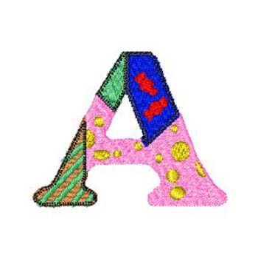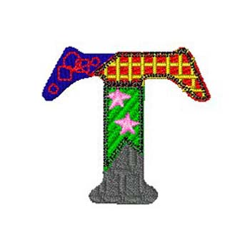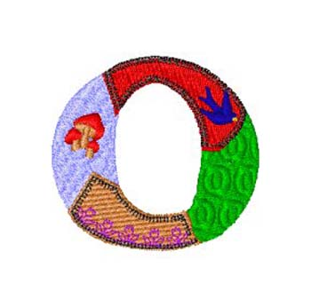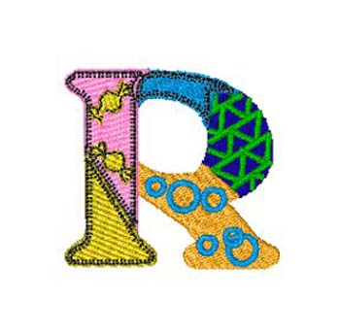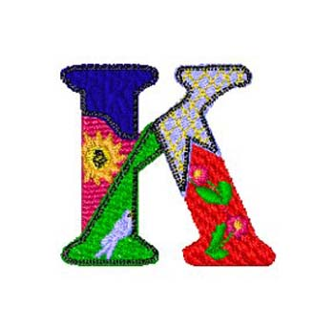

PRIVATE

CHILDCARE

The Haven, Skates Lane, Sutton-on-the-Forest
Tel: 01347 811655 / Mrs. Laura Foster
admin@patchworkchildren.com

After careful planning and thought following the government announcement yesterday afternoon (18/03/20) that schools would be closed as of Monday (23/03/20) we have had to take the decision to follow government advice meaning we will also be closed from Monday until further notice to all children except those of key workers and vulnerable children. We would ask any key worker or vulnerable children parents still requiring childcare to get in touch with us as soon as possible.

We will also be offering space for any key worker/vulnerable children even if they do not currently come to Patchwork so please if you are struggling then get in touch.

Obviously, this will be a very challenging time, and with current food and supplies shortages we would ask if any children still coming to Patchwork could bring a pack up for lunch, we will still provide the usual snacks and tea.

Please keep an eye on your e-mails and the Patchwork Facebook group, as we will keep everyone updated with as much information as we know and will publish the government’s latest advice there also.

We would like to thank everyone for their words of support, and wish everyone well until everything returns to normal, please feel free to call, e-mail or message should you require anything, we will continue to do all we can to help.

We understand that this will be a very difficult and challenging time for everyone, and we hope everyone keeps happy and healthy and hopefully we will be back to normal very soon!

Kind regards,

Laura Foster

Director

Patchwork (York) Ltd

