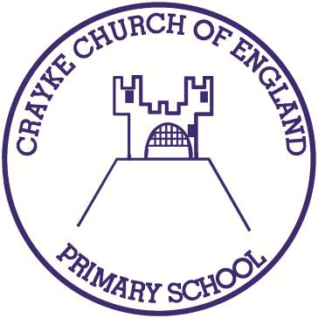

Crayke Church of England Primary School
Easingwold Road
Crayke
North Yorkshire YO61 4TZ
Tel/Fax: 01347 821767
Email: admin@crayke.n-yorks.sch.uk
Website: craykeschool.org

Headteacher – Mrs Judi Jackson

Thursday 19 March 2020

Dear Parents/Carers,
School Closure due to Coronavirus Outbreak
Update as at 19.03.2020

As you will not doubt be aware from the UK government Education Secretary’s announcement yesterday, all schools in England will be closing until further notice with effect from tomorrow, Friday 20th March 2020 at 3:30pm, due to the ongoing Coronavirus outbreak, apart from for children of key workers and vulnerable children.

Any school closure causes significant disruption in many ways, and this one is on a scale unseen in peace times. We have been working very hard to prepare for this announcement, and I would like to reassure you again all that through these uncertain and challenging times we will do all that we can to support our families. We would like to take this opportunity to thank you for your lovely comments so far – your words of kindness and support are greatly appreciated, and I will be sure to communicate these with staff.

Arrangements for children of key workers and vulnerable children
As you will have heard on the news, special arrangements are being put in place for children of key workers and for vulnerable children. Like all schools, we are still awaiting the official list of key workers and further instructions from the government. We will communicate this when we receive it.

Contacting school during the closure
School will be contactable as usual during the closure, but please note that response times may be slower at times as there may be fewer staff in school. Please keep a close eye on your emails, as this will be our main source of communication.

School work during the closure
Staff have worked incredibly hard this week to ensure home learning is ready for children to access, to ensure the continuity of their education. We sent learning packs home with all children who were in school today. Online learning packs will be published on the school website as soon as possible. Should you have any issues accessing home learning, please do not hesitate to contact us at school. I would also urge caution with expectations surrounding school work relating to the age, ability and wellbeing of your children. There are many other vital learning activities which can take place within your home and would ask that you do not put undue pressure on either your child or yourselves during this already stressful time.

Will SATs tests take place this year?
The Education Secretary announced yesterday that the 2019/20 national curriculum assessments will NOT take place due to the Coronavirus pandemic. Primary school performance measures will not be published for the 2019/20 academic year. This means the following assessments planned between April and July 2020 are cancelled:
• end of Key Stage 1 and Key Stage 2 assessments (including tests and teacher assessments)
• Phonics screening check
• Multiplication tables check
• Science sampling tests
• All statutory trialling

When will school re-open?
At the moment, we do not know when schools will be re-opening. We will follow government guidance at all times. Any updates regarding school re-opening and children returning to school will be fully communicated to parents/carers by email in the usual manner. We understand that this is an unsettling and worrying time for everybody, and we hope that you all stay safe during this difficult time, and that we can get back to normality as soon as possible.

If, at any time, you feel you need support for any reason, please do not hesitate to contact us - there will always somebody available to help. Crayke CofE Primary School is an extremely supportive and caring community, and I know we can all pull together, be kind, and look out for our most vulnerable members.

Please remember, our contact details whilst school is closed are as follows:
Mrs Sheppard – class1@cayke.n-yorks.sch.uk
Mrs Dobson – class2@crayke.n-yorks.sch.uk
Mrs Rayner – class3@crayke.n-yorks.sch.uk
Mrs Chandler – class4@crayke.n-yorks.sch.uk
Mrs Jackson – headteacher@crayke.n-yorks.sch.uk

Should you have any further questions regarding any issues raised in this letter, please do not hesitate to contact me.

Yours sincerely,

Judi Jackson
Headteacher

