
Crayke C of E Primary School
‘TRY YOUR BEST IN EVERYTHING YOU DO’
Respect Friendship Forgiveness Determination

Dear Parents and Carers,
It seems unbelievable that we have already reached the end of the first half term of 2020! As I reflect on the children’s experiences and achievements over the past six weeks, it is brilliant to consider how much learning has happened not only in the classroom, but also in our outdoor learning environment, during collective worships, extra-curricular clubs, educational visits and when welcoming visitors into school. I am grateful for the support from parents and carers, for the positive attitudes of all staff, for the involvement from the governors and local community and for the determination, curiosity and resilience of our children. What a team! It was lovely to welcome a group of parents into school this week for the “Meet and Greet” session and we discussed matters ranging from homework to behaviour. Next half term promises to be equally busy and enjoyable. We will be continuing to focus on our value of courage alongside learning more about Lent in the lead up to our Easter Service at the end of term. In the Summer Term we will be looking to further investigate these matters with a view to launching an updated Behaviour Policy from September, as well as focussing on our school Vision Statement. I will keep you informed of, and involved with, these developments. We are also very much looking forward to our new caretaker Mr Tom Trotter joining the team after half term and I am sure he will be a valuable asset to the Crayke family. Wishing you all an exciting and enjoyable half term break!
Mrs Judi Jackson headteacher@crayke.n-yorks.sch.uk
Highlights of the week

In Class 1 we have started to learn to tell the time and to understand how exercise keeps us healthy. Class 2 children have written recounts of their amazing trip to Millers and explained how the company promotes sustainability – please ask them about it! Class 3 have been using chocolate in science to discover how sedimentary, metamorphic and igneous rocks were formed. Class 4 have been working hard learning about how the 4 stages of life, according to the Hindu religion, help Hindus in their life journey. They also reflected on the things in their life journeys which have a positive impact. The children have also been learning about Puja, the Hindu daily act of worship.

 Stars of the Week
Class 1 | Class 2 | Class 3 | Class 4
Alfie Burnett Armstrong | William Swan | Lillie Barker | Alfie Pinchon-Watson
Alfie Burnett Armstrong | Leonard Liddell | Odin Dawson | Freya Hunt

School Lunch Menu – W/C 24 February 2020
WEEK ONE | Main course | Dessert
Monday | Ham & Pineapple Pizza with chips | Fresh Fruit or Yoghurt
Tuesday | Chicken Korma & Rice | Arctic Roll and Mandarins
Wednesday | Minced Beef & Yorkshire Pudding | Fresh Fruit, Yoghurt or Cheese & Crackers
Thursday | Tomato Pasta | Berry Sponge & Custard
Friday | Fish Fingers & Tomato Ketchup | Rice Pudding & Sultanas

Diary Dates – February/March 2020

Wednesday 26th February 2020 | CHASA meeting 3:45pm | All welcome
Thursday 27th February 2020 | Educational Visit – Centre for Life | Class 3
Wednesday 4th March 2020 | Bikeability - Playground | Year 6 - all
Thursday 5th March 2020 | World Book Day | Whole School
Thursday 5th March 2020 | KS2 SATs Meeting 6pm | Year 6
Friday 6th March 2020 | Achievement Worship | Class 2
Tuesday 10th March 2020 | Easingwold Library Visit | Year 5
Tuesday 10th March 2020 | Parent Consultation Evening 1/2 | Whole School
Wednesday 11th March 2020 | Bikeability - Roads | Year 6 Group A
Wednesday 11th March 2020 | Parent Consultation Evening 2/2 | Whole School
Friday 13th March 2020 | Bikeability - Roads | Year 6 Group B
Friday 13th March 2020 | CHASA Film Night 4pm | All welcome £5 per ticket

Extra-Curricular Clubs – Week Commencing 24 February 2020
Monday | Choir (no charge)  3:15pm – 3:45pm  Years 3 – 6  Mrs Halliday
Tuesday | Forest Schools (no charge)  3:30pm – 4:15pm  Year 3/4  Mrs Helfferich | Multi-sports (Fee paid direct)  3:30 – 4:45pm  Year 1-6  Mr Cromack | Italian (no charge)  3:30 – 4:15pm  Year 3-6  Mrs Aristizabal
Wednesday | School Council (no charge)  3:30pm – 4:15pm  Councillors  Mrs Jackson | Sewing (no charge)  3:30pm – 4:15pm  Year 2/3  Mrs Dobson | Tag Rugby (no charge)  3:30pm – 4:15pm  Year 4/5/6  Mr Warriner
Thursday | Construction (no charge)  3:30pm – 4:15pm  Year 1/2  Mrs Sheppard | Homework (no charge)  3:30pm – 4:15pm  Year 5/6  Mrs Chandler | Book Club (no charge)  3:30pm – 4:15pm  Year 3/4  Mrs Rayner
Friday | Unique Sports (£2.50 per child)  3:30 – 4:15pm  Years 2-6  Simon Carson Sports School
Run a Mile club - Tuesday and Thursday morning at 8:30am – Mrs Jackson
**PLEASE NOTE: Clubs will run unless you are notified otherwise**

 Where’s Church this half-term?

Sunday 16th February
10.30am Morning Service at Brandsby, followed by lunch at Brandsby Hall. All welcome - no need to book or pay.
Sunday 23rd February
10.30am Holy Communion at Yearsley and 6.30pm Holy Communion at Crayke
Wednesday 26th February
Our Ash Wednesday Service of Holy Communion is at 7.30pm at Crayke.
Best wishes
Revd Liz

Half Term Activity

Half Term Coppicing training – Thursday 20 February 2020 10am – 1pm Millfields Wood
Activities on the day include – having a go at simple coppicing of thin stems making woodland crowns, learning about woodland wildlife and making habitat piles. For more information, please contact egscommunitygroup@gmail.com
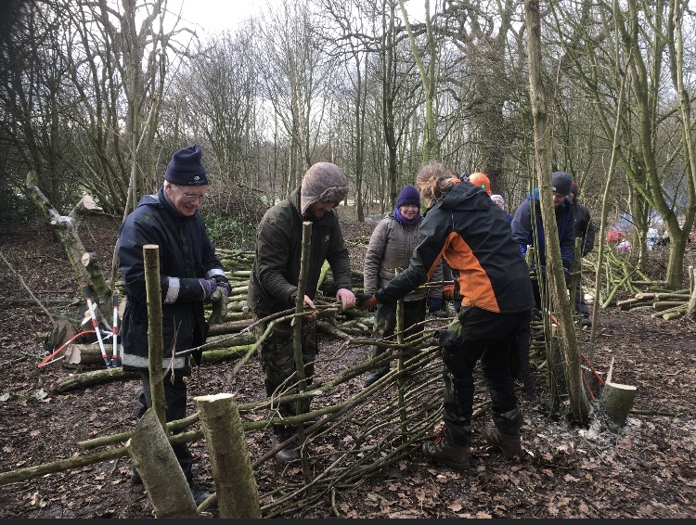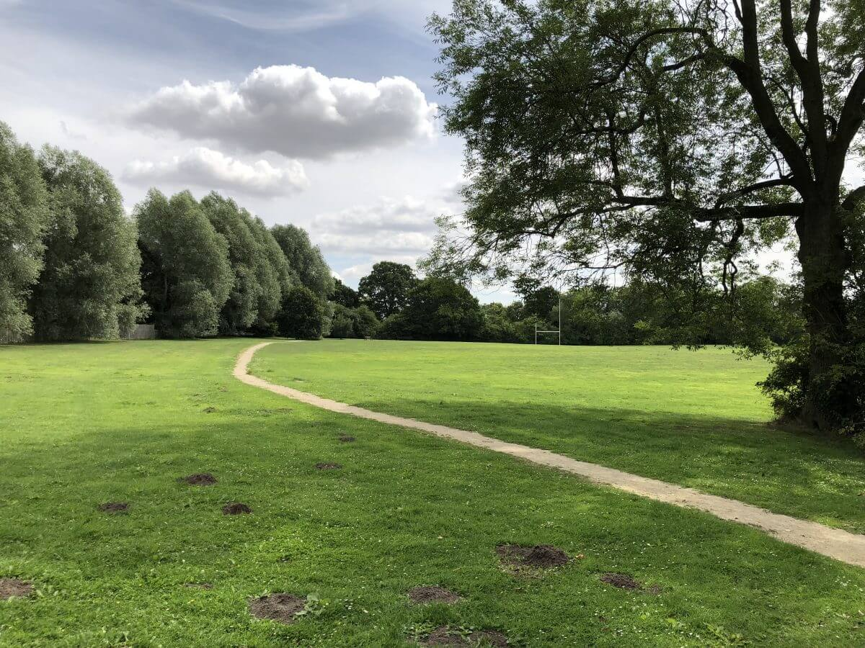
World Book Day – Thursday 5 March 2020
As you will have seen from the website post, Mrs Rayner has got some exciting plans in place for Word Book Day, with a focus on the theme of ADVENTURES. I am sure that children will enjoy designing their masks at home using the template provided. All of the children will be in full school uniform on the day, but need to bring in their mask and adventure book/poem to share. We will also be having a Book Swap and Drop event on the afternoon.

And finally…

We are delighted to inform you that the Educational Visits Advisory Team would like to use Class 2’s recent visit to Miller’s Fish and Chips as a Case Study for North Yorkshire. As you will have seen from the website post, the children had a fabulous time and had the chance to build on their knowledge about sustainability through this first-hand learning opportunity. This was confirmed by Mrs Lunn who accompanied the children on the visit; she couldn’t believe how much the class already knew about the topic. Well done and thanks to all involved, especially to Mrs Dobson who spent a considerable amount of time planning to ensure that the children would get the most out of both the pre-visit into school and the actual visit.


