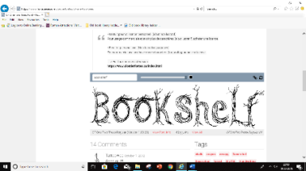

**Communication, Language & Literacy**

* **Using blending skills to read simple sentences and books**
* **Using segmenting skills to begin to write simple words and phrases**
* **To use language to explain your thinking**

**Theme: All about me**

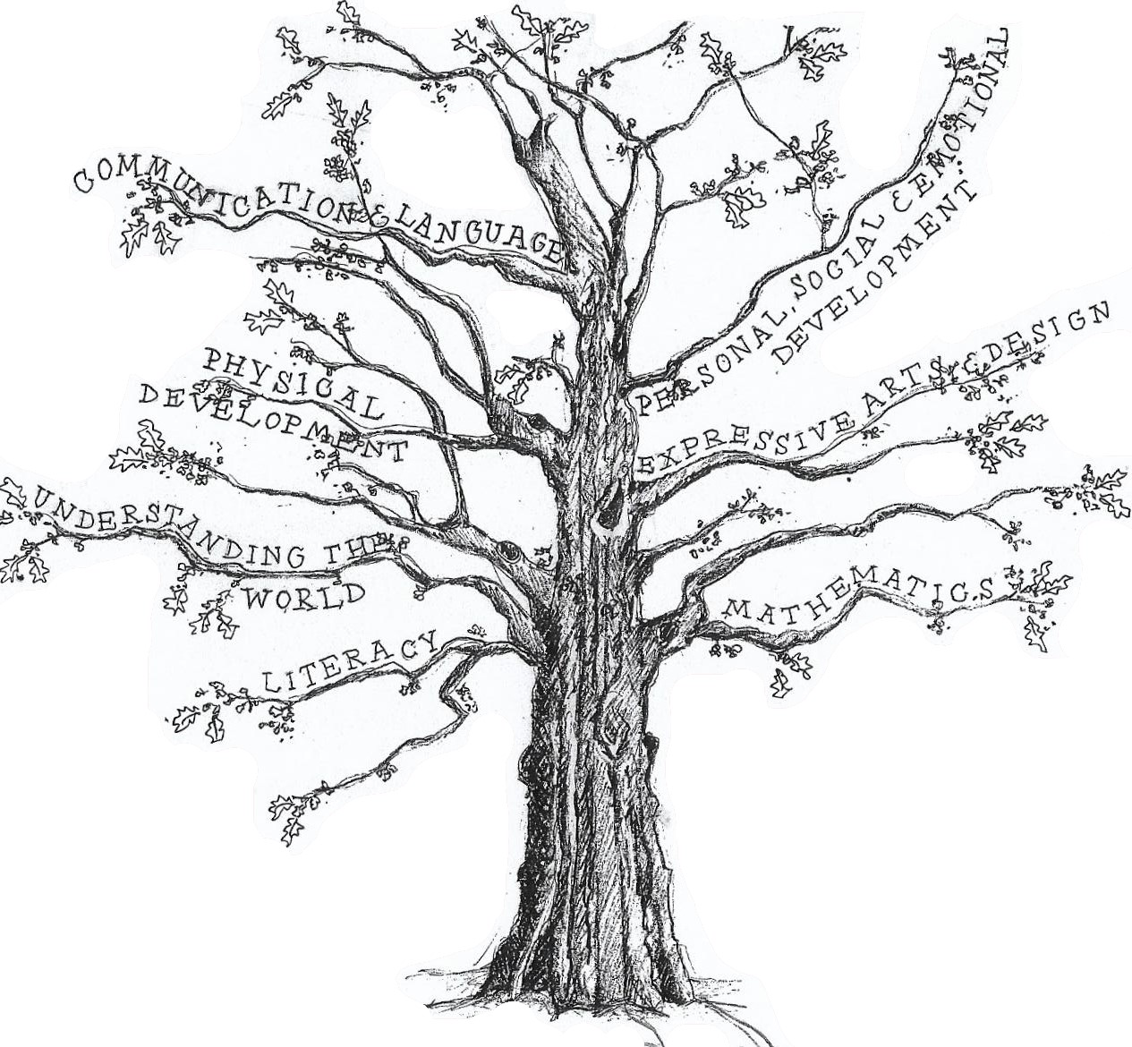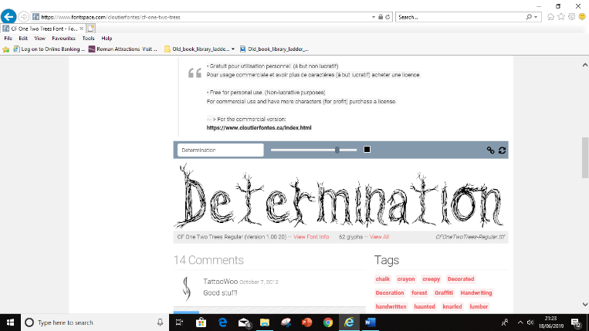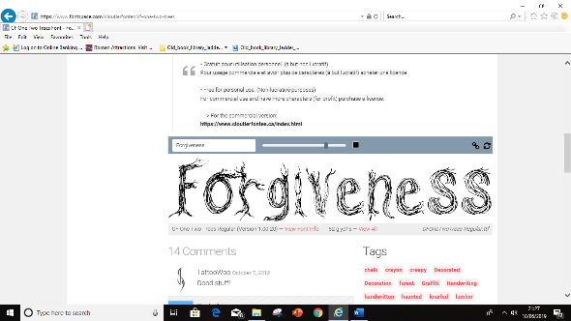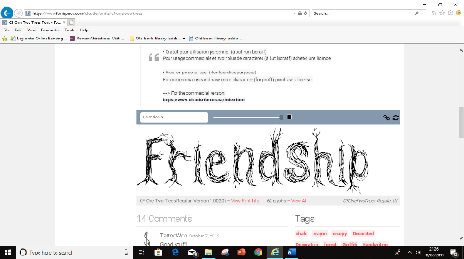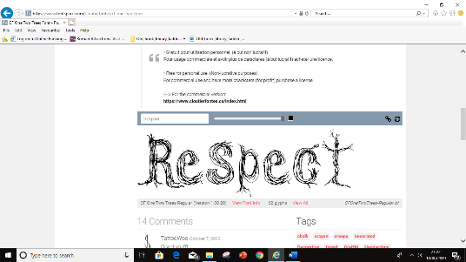

**Personal, Social & Emotional Development**

* **Making and keeping friends**
* **Understanding and accepting difference**
* **Being motivated and independent learners**

**Expressive Arts & Design**

* **Playing imaginatively with friends**
* **Using media and materials**
* **Learning simple songs and rhymes and using instruments**
* **Dressing up and performing**

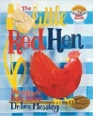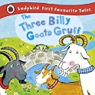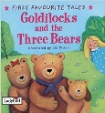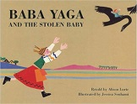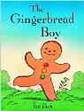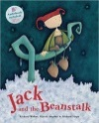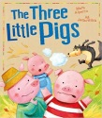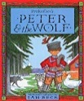

**Mathematics**

* **Reading, writing ordering numbers to 20**
* **Concept or more and less**
* **Simple addition and subtraction**
* **Telling the time, using money**
* **3d shapes**

**Physical Development**

* **Using classroom tools**
* **Learning to write and draw**
* **Using bodies in dance, gymnastics and athletics**

**Understanding the World**

* **What am I like?**
* **How can I keep healthy?**
* **How do I use my senses?**
* **What is it like in cold countries?**

**RE**

* **What is a Christian church like?**
* **Why is Easter important to Christians?**