Drop in session for parents/carers with the Inclusive Education Service (IES), Communication and Interaction Team (C&I).

Alverton Children’s Centre, Mount Road, Northallerton DL6 1RB

Wednesday afternoons between 1.30 pm – 4.00 pm
Dates: 12.02.20; 04.03.20 & 18.03.20

Members of the C&I team will be available to offer guidance and support on the following areas:

Language and Communication

Social Skills and Understanding

Peer Interaction

Emotional Regulation

Sensory Processing
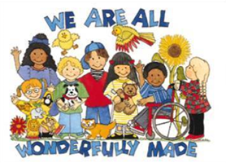

If you would like further support and advice please come along.
We look forward to meeting you.

Contacts: Claire.Forgan@northyorks.gov.uk
Mandy.Ewers@northyorks.gov.uk
Kathy.Pajak@northyorks.gov.uk

