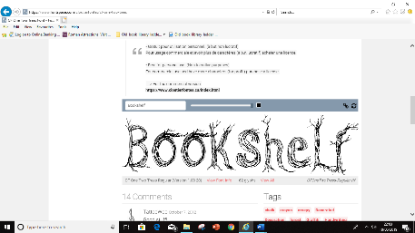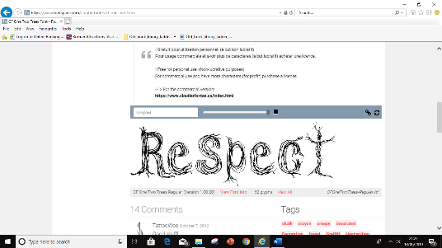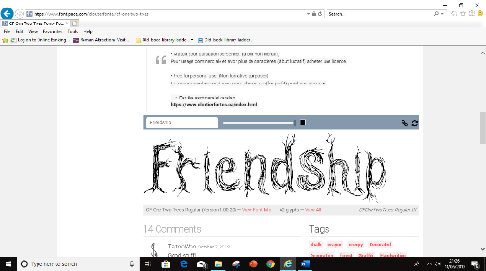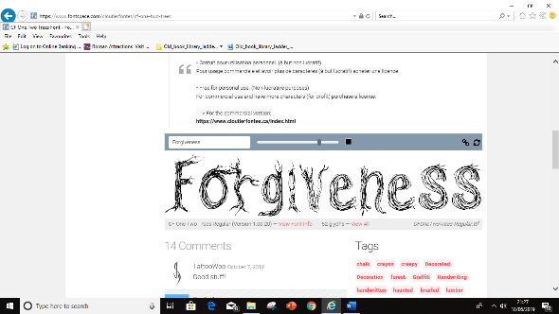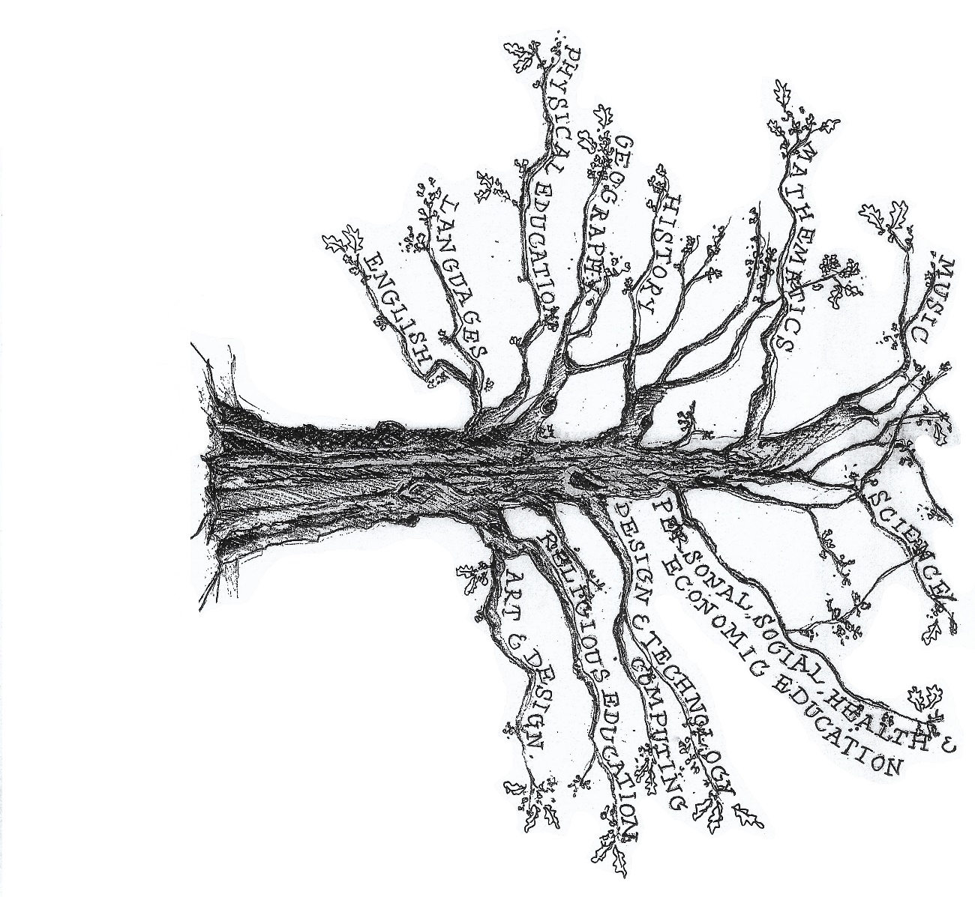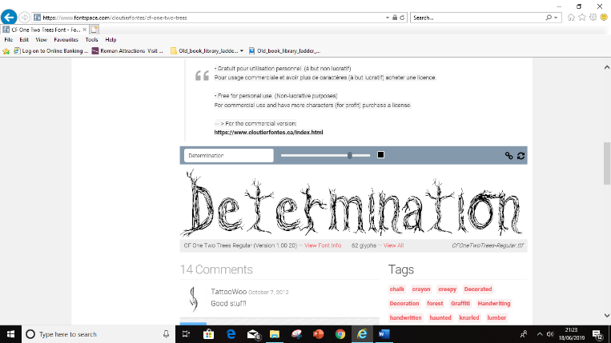

P.E: Gymnastics, net & wall games, orienteering, hockey

Religious Education

How and why do Hindus, Muslims and Christians see life as a journey? (NY)

*What difference does the resurrection make for Christians?* *(Understanding Christianity)*

Science: Animals including humans

Describe the changes as humans develop from birth to old age

Living Things

-Explain differences in life cycles of 5 animal groups

-Life process of reproduction in plants and animals

Design Technology:

Build a Burger!

English

*Instructions – Build a Burger*

*Persuasive writing*

Maths: Coverage across the year of:

* Number and Place Value
* Addition and Subtraction, Multiplication and Division
* Fractions (including decimals and percentages)
* Measurement
* Geometry – properties of shape & position and direction
* Statistics, algebra, ratio and proportion
* Ratio and proportion
* Algebra

Computing

Databases, Game Creator (Purple Mash)

Languages (French)

‘Celebrations’ then ‘Portraits’

PSHE

Keeping myself safe.

Geography:

The Amazing Americas

**Theme:Journeys**

Music

Linked to Journeys