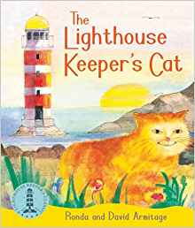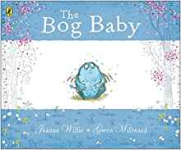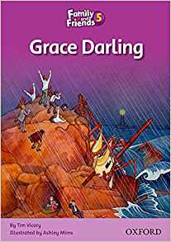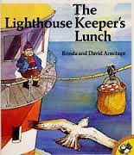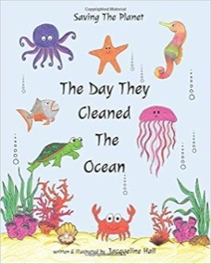

History & Geography

Grace Darling and other great

sea rescues

Continents and Seas

Treasure Maps/Compass Directions

Looking after the Ocean

**Theme: Oh I do like to be beside the seaside…….**

Science

Animals and Humans

Seasonal Changes

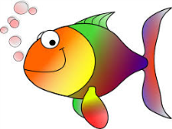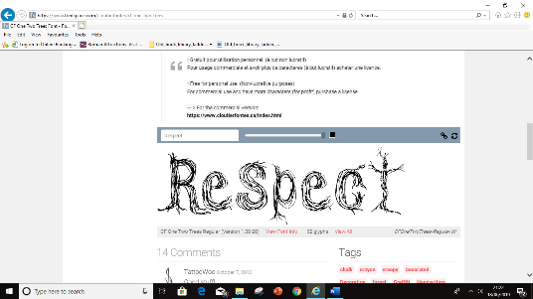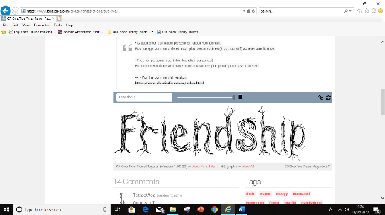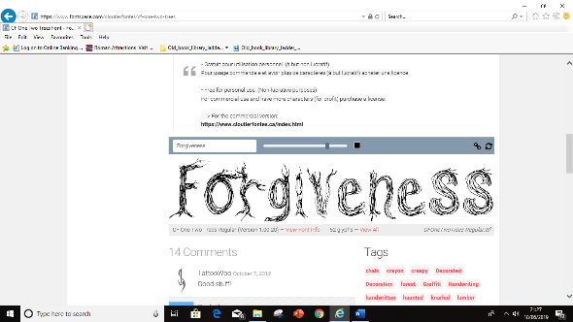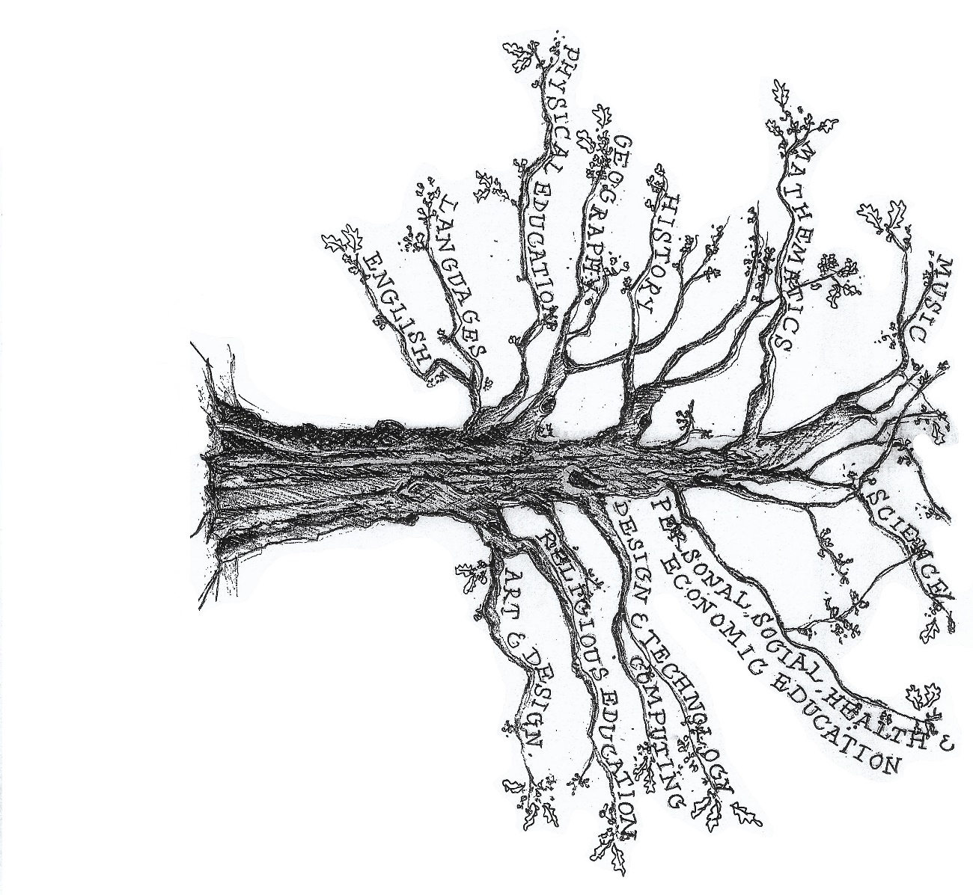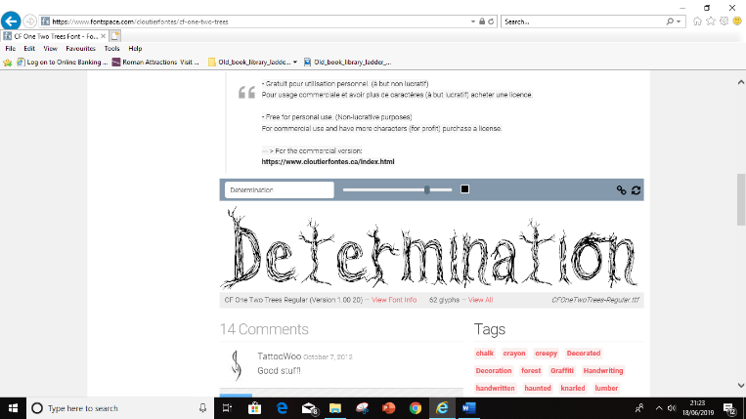

Computing

Creating pictures

Spreadsheets

Art & Design Technology

Design and make an island

Pictures in the style of Janice McGloine

Music

Songs, chants and activities linked to the seaside topic.

Religious Education

Talking about God

What do Christians believe God is like?

Special Meals

English

Stories by the same author – The Lighthouse Keeper’s Lunch

Riddles

Non-fiction Report – Grace Darling

Seaside Poetry

Maths

Counting, Place Value and Sequencing

Addition & Subtraction

Multiplication and Division

Fractions, Data Handling and Time

2D/3D Shape Position and Movement

P.E

Dance

Tennis

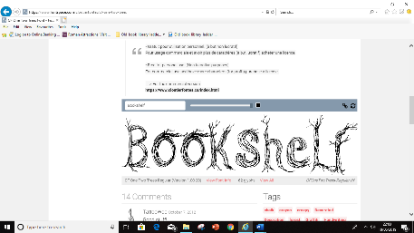

PSHE

Good to be me

Rights and Responsibilities



[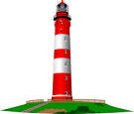](http://www.google.co.uk/url?q=http://www.clipartlord.com/category/structures-clip-art/lighthouse-clip-art/&sa=U&ei=3pm6U6K-AYXJ0AWshYDIDA&ved=0CDQQ9QEwDzgU&usg=AFQjCNEOZ1Ol_HEL_NvBtCXf6r_cD_o-Tw)