Class 4 Homework Spring Term (1st half)
Weekly activities: Spelling activities, independent reading (15-20 minutes each night recorded in reading diaries), practise multiplication tables, in random order and at speed and maths activity.
‘Compare Myself’  Print off/draw and add pictures of yourself as a baby and one of you now.  List the similarities and differences below in the table.  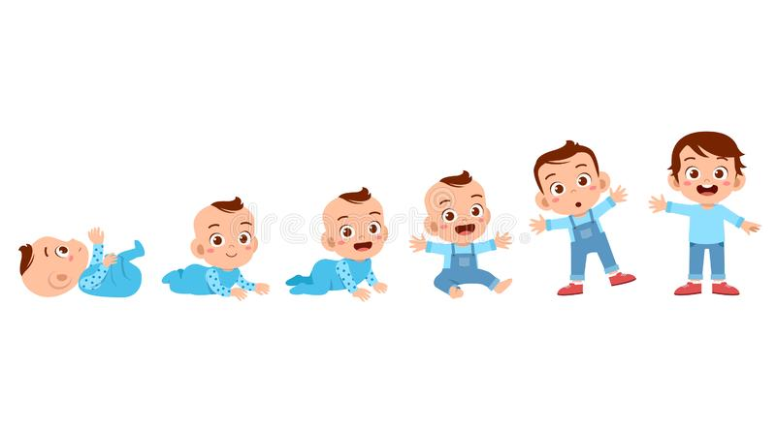  (Due by 17th January 2020) |  |   Tell me about your favourite film!  Who is in it? What happens? Why do you love it? How does it make you feel? |  | ‘Creatures of North America’  There are many different creatures living in Everglades, Alaska and even in Death Valley...  Find out more about one of them using information books or the internet and create an animal factfile.  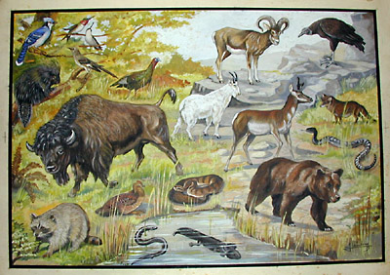  (Due by 31st January 2020)
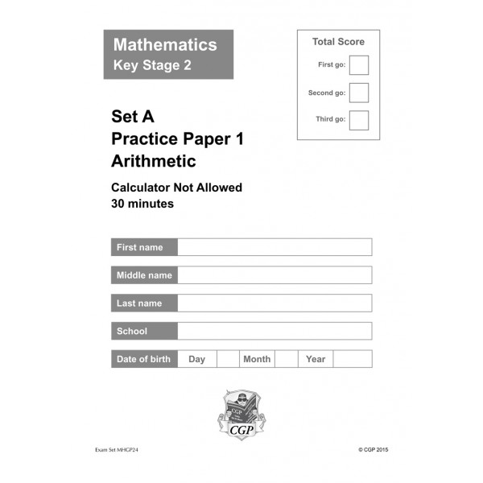Year 6: 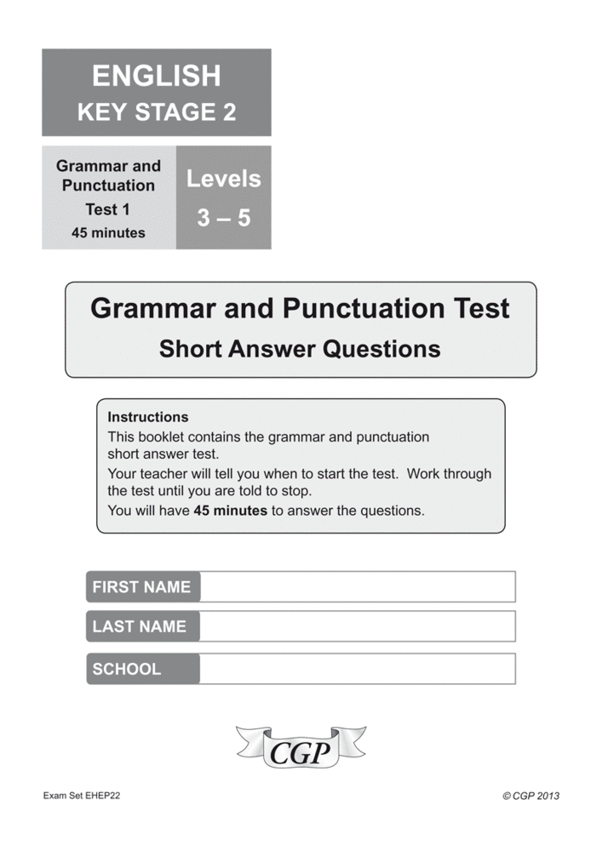  Continue to complete your CGP papers.  Class 4:  Continue to learn your spellings, practise your times tables and read regularly. I know you’re all busy but this is really important! |  | Family Activity:    Visit Life Science Centre, Newcastle  Life is a special place. Don't expect to yawn in front of static displays – enjoy hands-on science, explore REAL phenomena and have the time of your life. |  | ‘Totem Poles’  Native Americans are the indigenous people of the USA. They live in tribes. Some tribes designed and created totem poles in the places they lived; they showed images of local animals.  Design your own totem pole to represent where you live and things that are important to you.  (Due by 14th February 2020) 
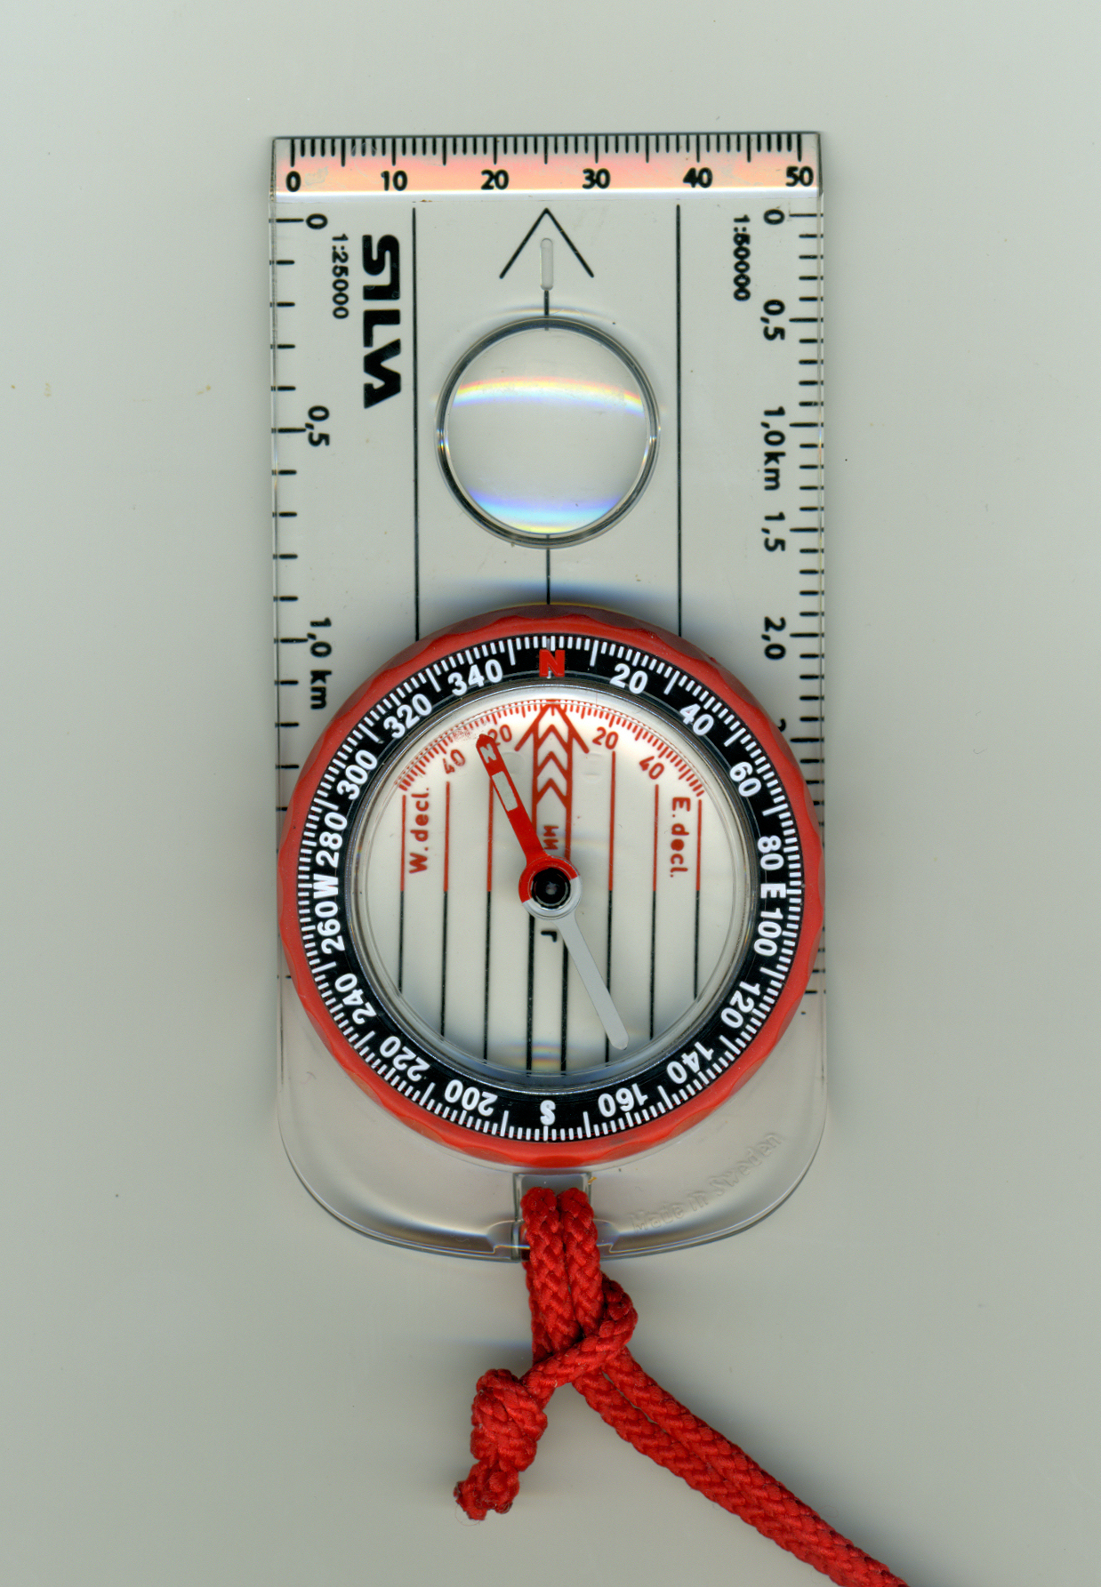Find your way with a map and compass…  (Taken from 50 things to do before you're 11¾ National Trust). | Practise your times tables skills for 55 Club using the links provided on the School Website, Purple Mash and TT Rockstars. |  | Practise your Year 5/6 spellings using the website www.spellzone.com/word_lists/lists_folder.cfm?Folder=63

