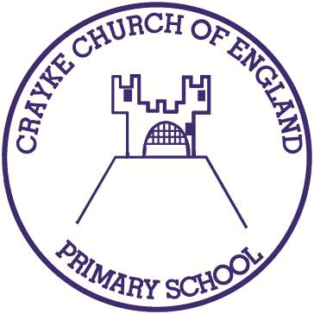

**Crayke Church of England Primary School**

**Easingwold Road**

**Crayke**

**North Yorkshire YO61 4TZ**

Tel/Fax: 01347 821767

E.mail: [admin@crayke.n-yorks.sch.uk](mailto:admin@crayke.n-yorks.sch.uk)

Website: craykeschool.org

**Headteacher – Mr. Andrew Buttery** BA (HONS), PGCE, NPQH

18/12/2019

Dear Parents/Carers, it has been my privilege to serve as Headteacher of Crayke Church of England Primary School since September 2014.

It has been a great pleasure to have worked in and served our school community. The school is very dear to my heart and I will leave with many fond memories of children, staff, parents and Governors (past & present).

Crayke is an outstanding school with a commitment to the Children who wear our uniform and share our values and aspirations. Pupils who attend Crayke have access to a broad and balanced curriculum where they are encouraged to be independent thinkers and make informed choices about their learning. The aforementioned is something I am exceptionally proud of.

There are a great many people who are associated with Crayke Church of England Primary who will guide the school community through the next phase of its journey and I have the utmost confidence that the school will continue to thrive.

I would like to thank you for the support you have given to me and the school during my time here.

On behalf of all of the staff, I would like to wish you a restful and happy Christmas, as well as a prosperous New Year...

Yours sincerely,



Mr. Andrew Buttery

Headteacher