**Crayke Chronicle**

**Friday 29th November**

**Yellow Team**

**Christmas Cards**

Our Christmas Post Box will be available from **Monday 2nd December.** If your child would like to send cards, could you please ensure that they write the recipients full name and class on the envelope. Pupils in Class Four will deliver the cards on a daily basis.

**Minster FM Toy Appeal**

Please remember that any donations should be brought into school by the morning of **Wednesday 11th December** so that they can be collected later that day. As stated on the Minster FM website the toy must be brand new and unwrapped so that it can be given to a child of the correct age.

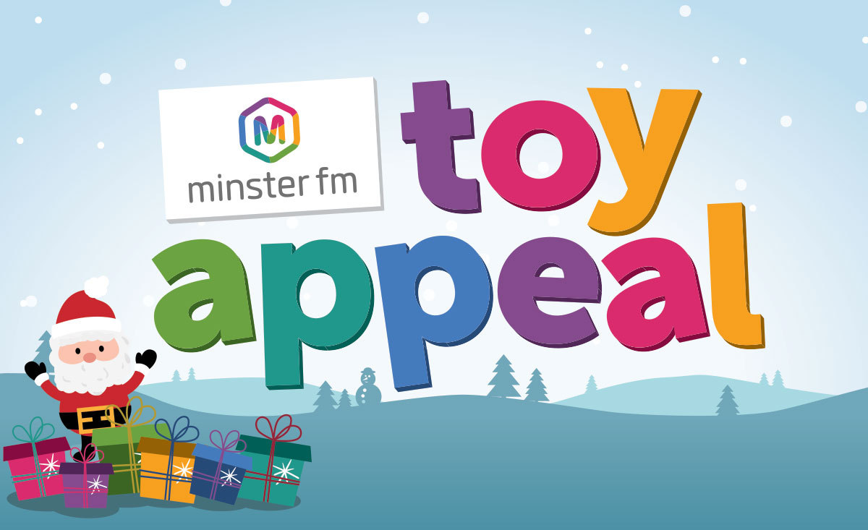

**Christmas Tree**

Children throughout the school have enjoyed a range of different art and craft activities this week. This resulted in each child making a decoration which they will place on the tree next week...

**Sports Hall Athletics**

Congratulations to all the boys and girls from Class Four, who worked together as an impeccably well behaved team, to finish a gallant second in the Cluster Sports Hall Athletics.

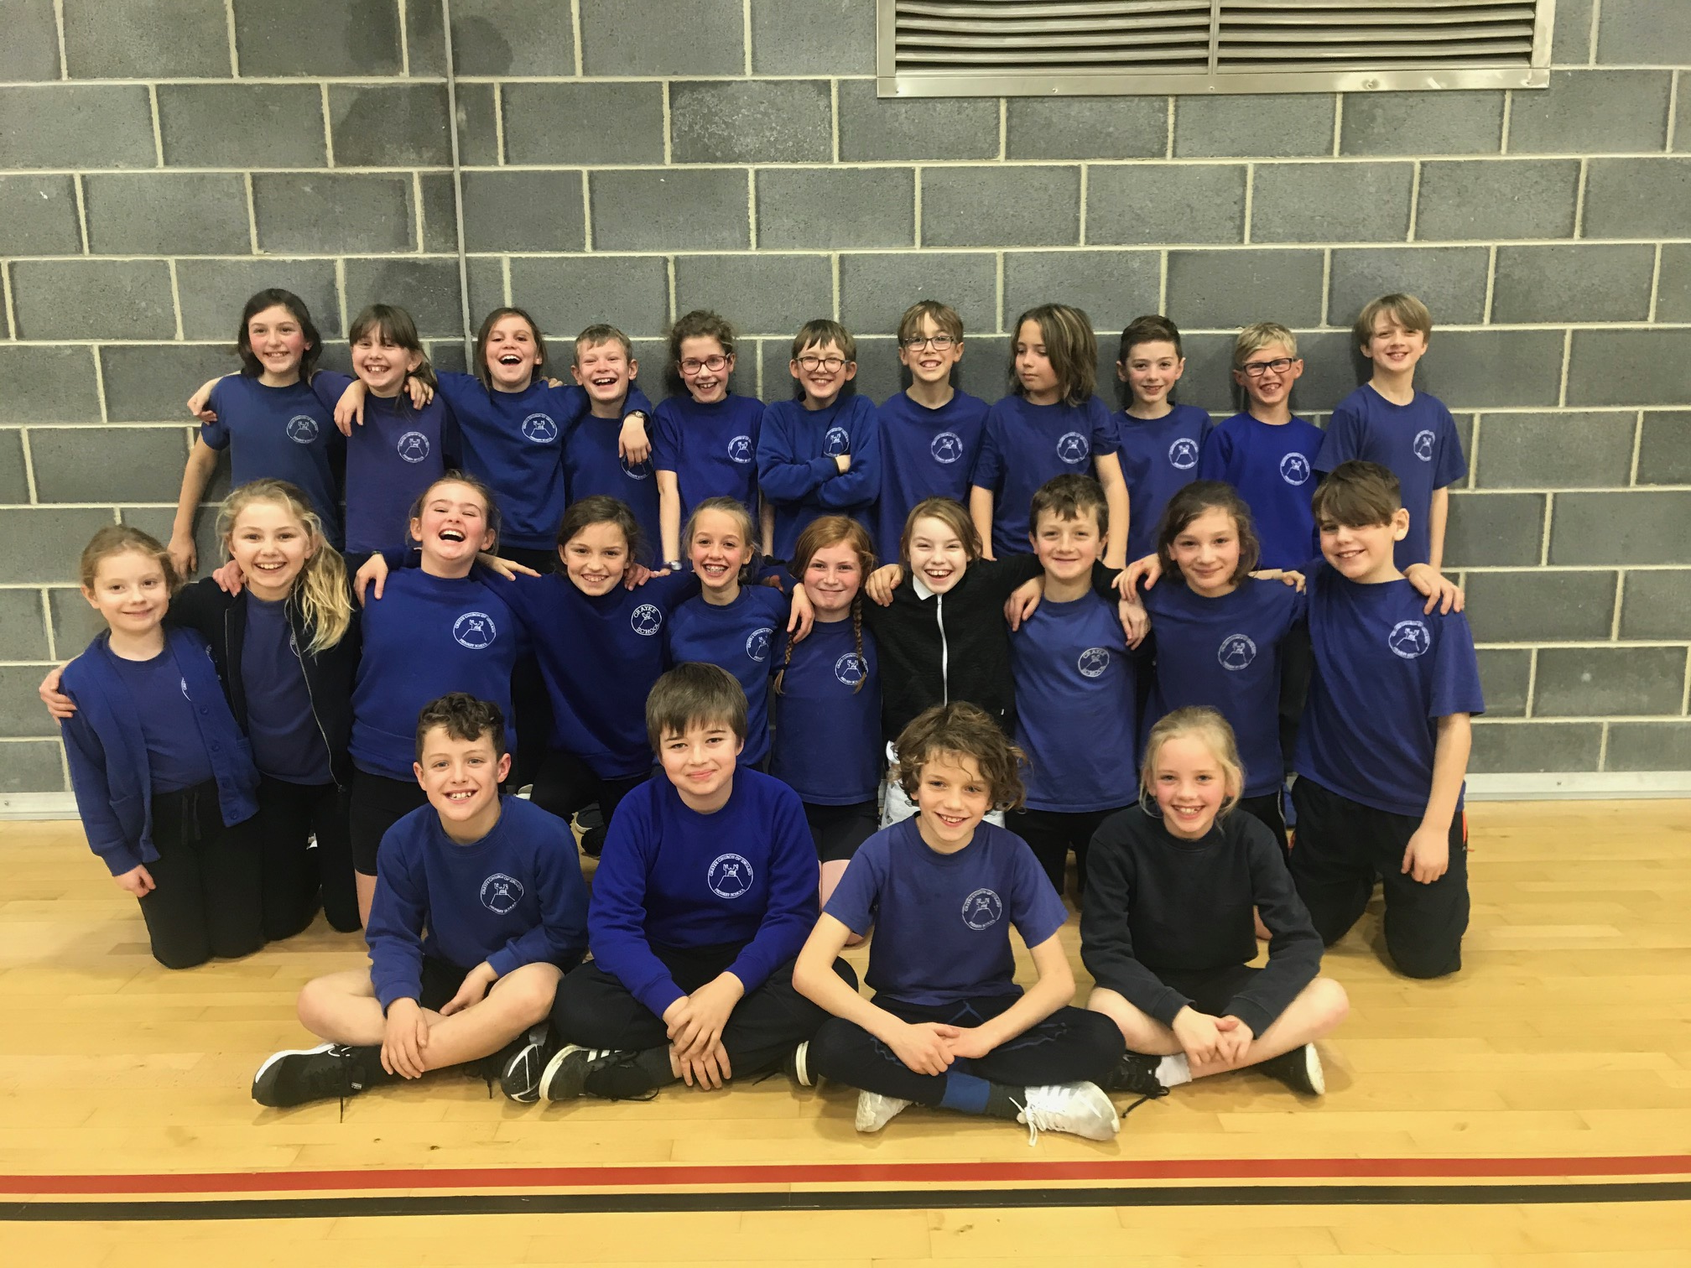

**Where's Church this week?**

**Sunday 1st December - Advent Sunday**

10.30am Holy Communion at Brandsby and 10.30am Family Service at Crayke Church (there will be snacks, songs, prayers and an introduction to advent).

Best wishes, Revd Liz



In Class 1, the children will be able to be acknowledged as Whizz of the week...

**Whizz of the Week**

**Class 1 – Rosanna Seligman**

Each week a child will be selected from our classes to receive the title of *Maths Whizz* of the Week or *English Expert* of the Week. Congratulations to this week’s children...

**Maths Whizz of the Week**

**Class 2 – Florence Hindley**

**Class 3 – Ted Hill**

**Class 4 – Edward Lowther**

**English Expert of the Week**

**Class 2 – Isaac Copley**

**Class 3 – Isaac Waite**

**Class 4 – Christopher Rangeley**

**Team Points**

This week’s winners are:

