**Crayke Chronicle**

**Friday 8th November**

**Class 4 Trip to the Danelaw Village**

Class 4 had a wonderful trip to Murton Park Danelaw Village yesterday; they really felt what it was like to be an Anglo-Saxon villager (even the weather helped them have an authentic experience!) Activities included making an oil lamp, grinding wheat using a quernstone, collecting wood and even protecting the village from attackers! They had a traditional Saxon banquet where jokes were told for entertainment and an unfortunate slave was punished in the stocks!

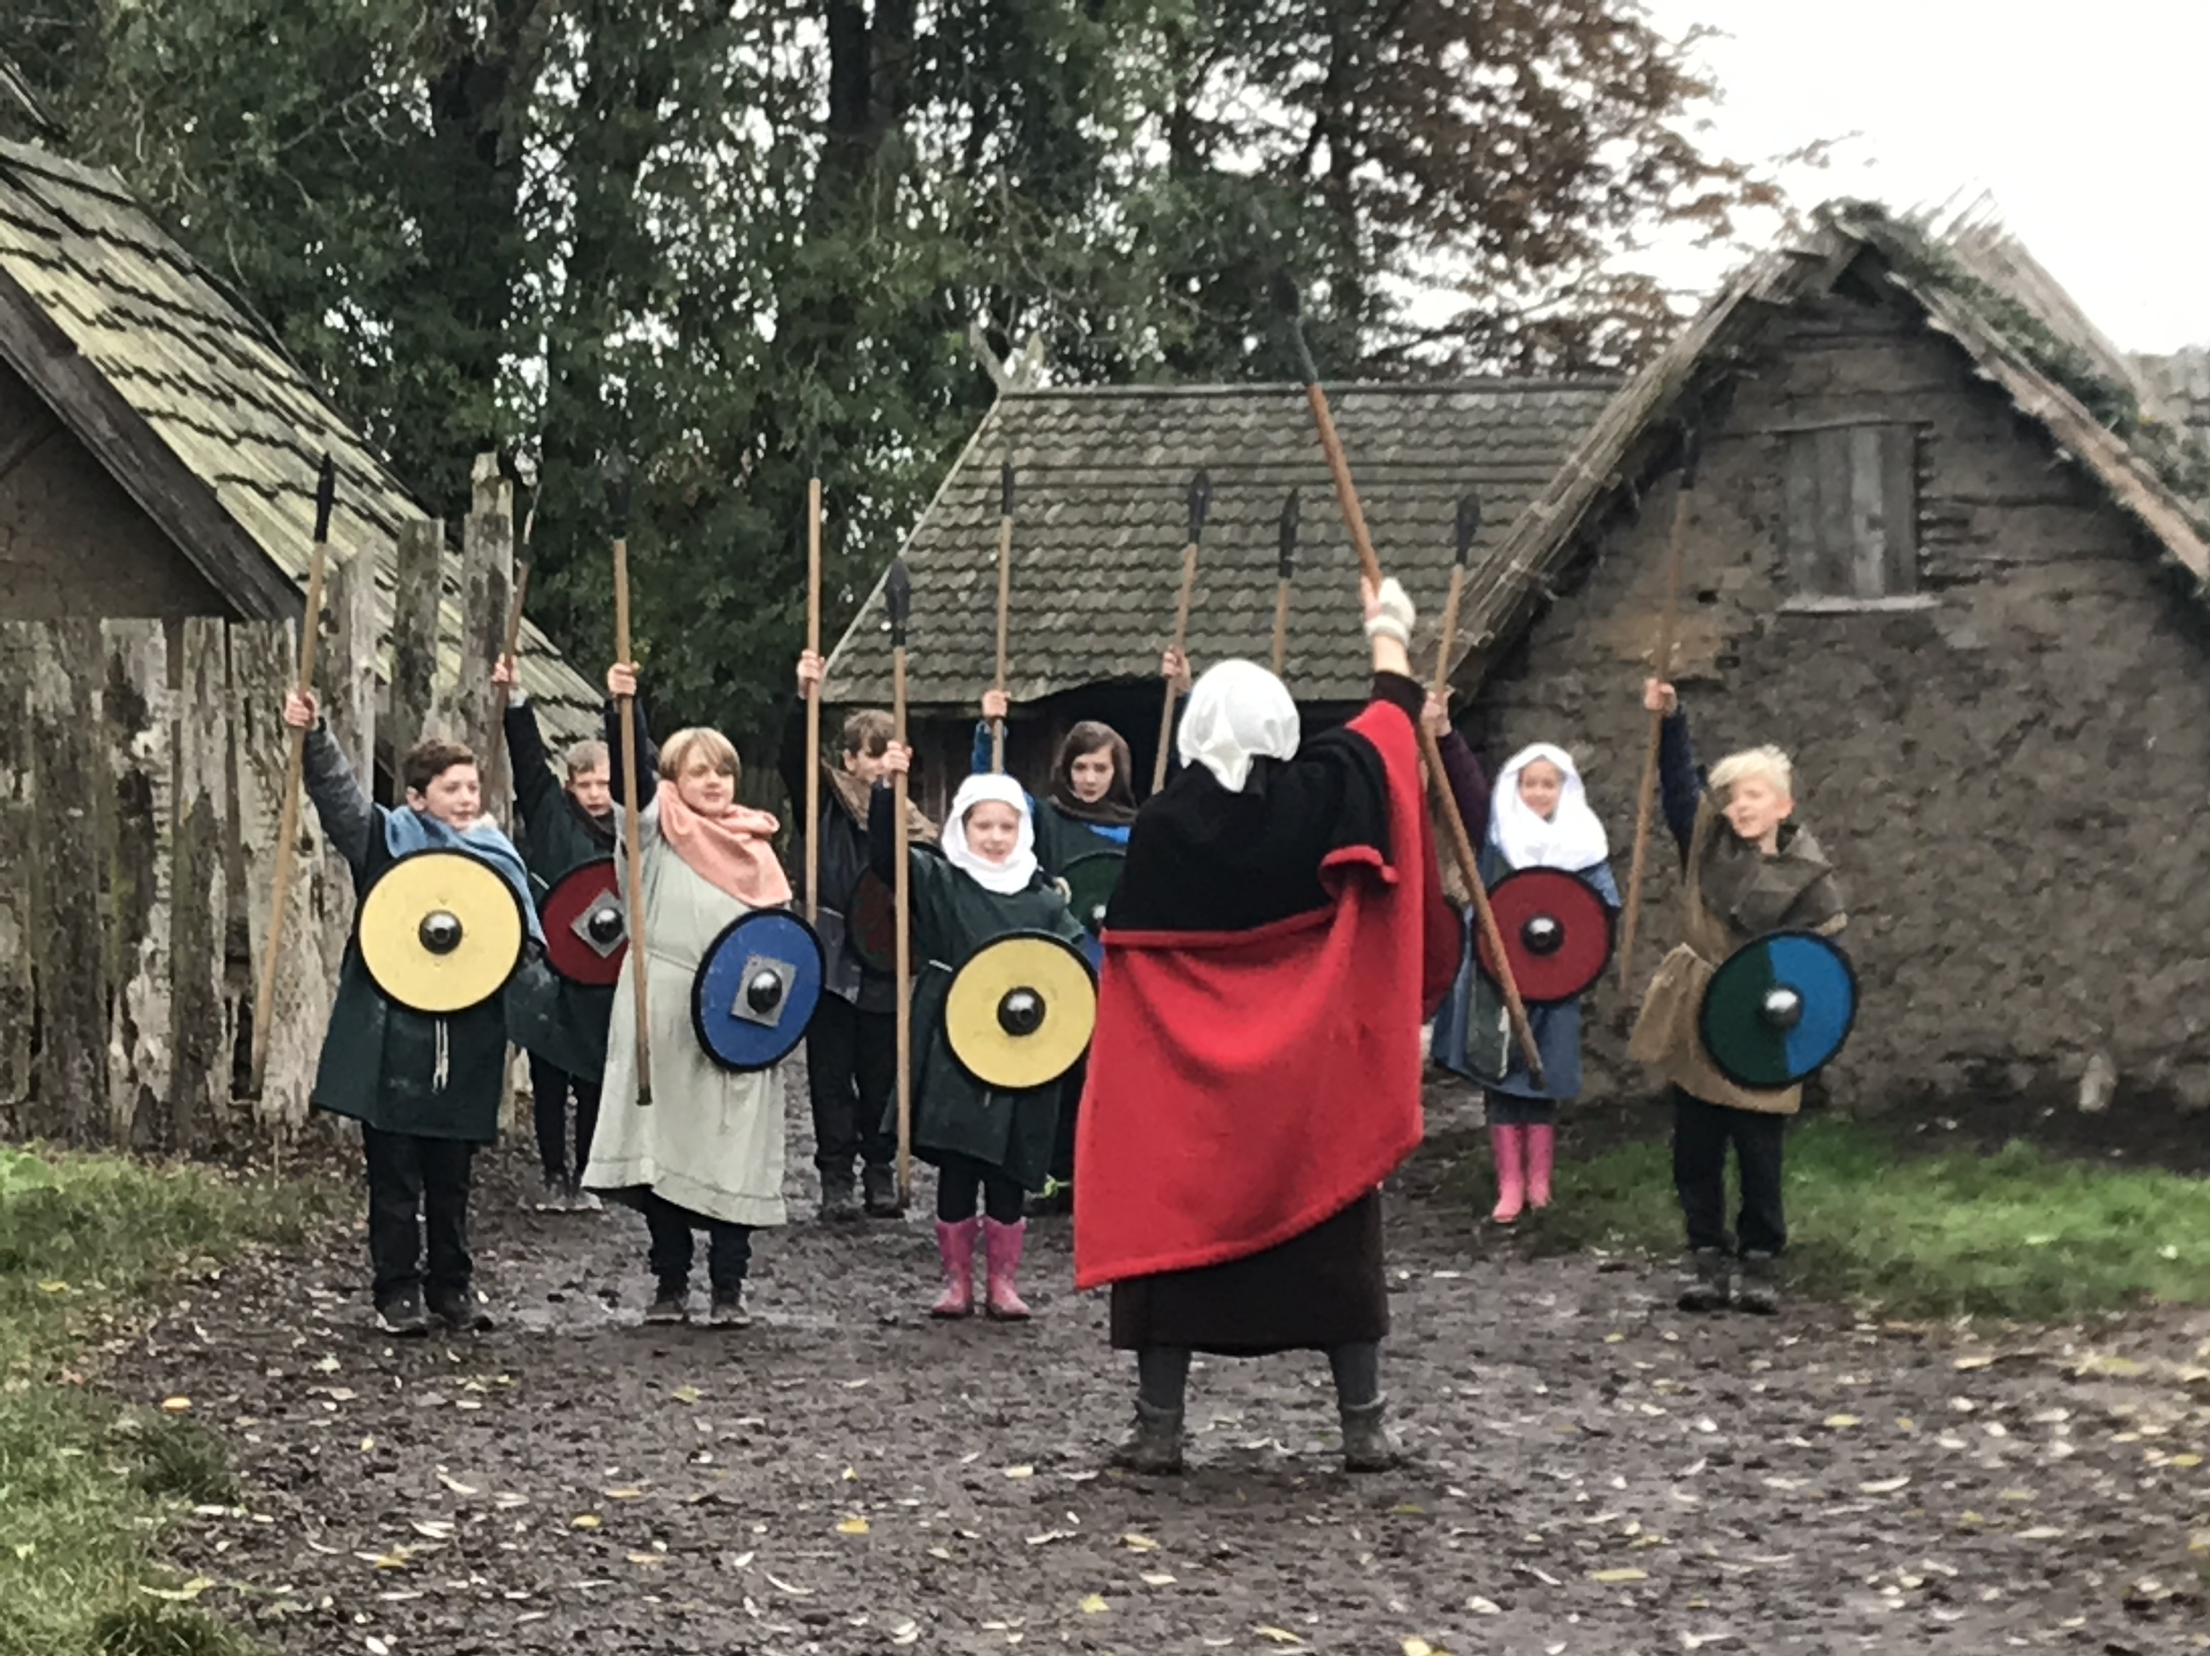

**Cross Country Success**

A massive well done to Martha Brookes, who represented our school so successfully in the North Yorkshire Sport Finals at Dalby Forest on Tuesday. Martha put a huge amount of effort into her race in very wet and muddy conditions, coming 9th out of 50.

**BBC Children In Need**

On Friday 15th November children are invited to attend school in non-uniform for Children In Need in return for a suggested donation of £1. In the afternoon, pupils from Class 4 will be running a variety of stalls, to raise even more money.  Each class will have the opportunity to visit the stalls and a range of prizes will be available (each stall will cost no more than 50p for a turn).

**Where's Church this week?**

**Sunday November 10th - Remembrance Sunday**10.30am Holy Communion with an act of Remembrance at Crayke and 3pm All Age Remembrance Service at Carlton Husthwaite.

Looking forward to seeing you there.

Revd Liz

**Yellow Team**



In Class 1, the children will be able to be acknowledged as Whizz of the week...

**Whizz of the Week**

**Class 1 – Dexter Bird**

Each week a child will be selected from our classes to receive the title of *Maths Whizz* of the Week or *English Expert* of the Week. Congratulations to this week’s children...

**Maths Whizz of the Week**

**Class 2 – Anecie Tomkinson**

**Class 3 – Isaac Waite**

**Class 4 – Evie Marwood**

**English Expert of the Week**

**Class 2 – Cyrus Saeedi**

**Class 3 – Seb Hindley**

**Class 4 – Eleanor Ward**

**Team Points**

This week’s winners are:

