Crayke Church of England Primary School
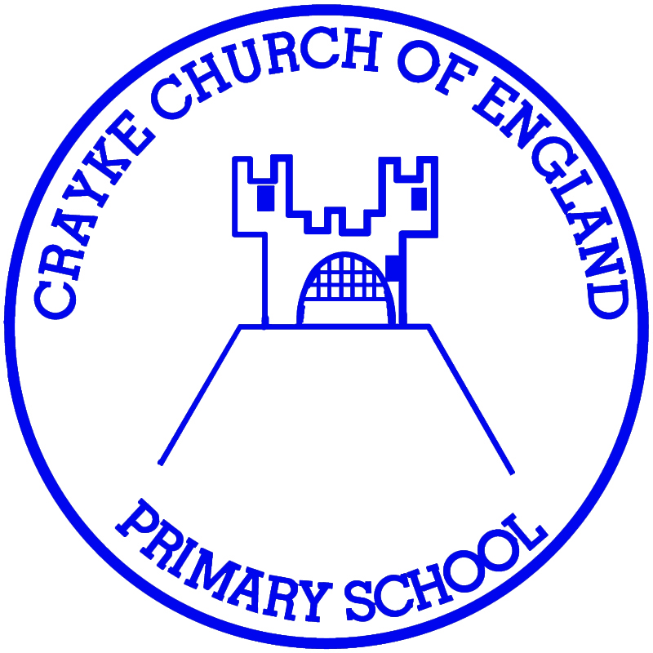
Easingwold Road
Crayke
North Yorkshire YO61 4TZ
Tel/Fax: 01347 821767
E.mail: admin@crayke.n-yorks.sch.uk
Website: craykeschool.org

HEADTEACHER – Mr. Andrew Buttery

Annual Report for the Year ended 31st March 2019

The Crayke Church of England School Fund is governed by a Constitution and is a registered charity no. 1051985. Its address is at Crayke Church of England Primary School, Easingwold Road, Crayke. YO61 4TZ. The charity trustees during the year to 31st March 2019 were the governors of the school namely -

Mr. Hugh Porter Chair
Mr. Daniel Curtois Vice Chair
Mr. Norman Jackson
Rev. Liz Hassall
Mrs. Ann Chappell
Mr. Peter Wilson
Mr. Andrew Buttery
Mrs. Aniko Sheppard

The object of the fund is to advance the education of the pupils of the school by providing or assisting the provision of education, recreational and other charitable facilities in augmentation of such facilities financed by the Local Authority.

During the year the main activities of the fund were school trips and petty cash. The school fund has no restricted funds.

Hugh Porter - Chair
14.11.19
on behalf of the Board of Governors

CRAYKE CHURCH OF ENGLAND SCHOOL FUND

Income and Expenditure for
April 2018 – March 2019

Income 2018/19 2017/18
Petty Cash 1509.65 3162.71
School Trips 3456.14 1820.05
Residential Trips 1821.72 2200.00
Sweatshirts 40.00 561.50
Photographs/Books 497.50 Donations 1650.00
Swimming
Young Voices 713.00 1235.00
CHASA 2000.00
7540.51 9861.48
Expenditure

Petty Cash 1806.20 2214.03
School Trips 4185.20 3752.80
Residential Trips 2452.90 1899.25
Sweatshirts 78.41
Books 112.43 1051.02 Donations 0.00
Swimming 0.00
Young Voices 718.00 1259.50 CHASA 265.50
9274.73 10085.81

Excess of Expenditure over income - £1,734.22

