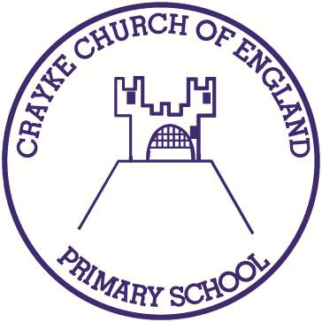

Crayke Church of England Primary School
Easingwold Road
Crayke
North Yorkshire YO61 4TZ
Tel/Fax: 01347 821767
E.mail: admin@crayke.n-yorks.sch.uk
Website: craykeschool.org

Headteacher – Mr. Andrew Buttery BA (HONS), PGCE, NPQH

11th October 2019

Dear Parents and Carers
Appointment of New Headteacher

I am delighted to tell you that the Governing Body has appointed Mrs Judi Jackson to be the Headteacher of Crayke CoE Primary School with effect from 1 January 2020.

Mrs Jackson is currently Deputy Head at Applegarth Primary School, Northallerton. She is also a Specialist Leader in Education for the Swaledale Teaching Alliance covering 60 schools.

She is delighted to be appointed as our Headteacher. She is really looking forward to working closely with parents, carers, staff and the pupils. She hopes to be able to meet as many of you as possible soon after she takes up post.

As Mr Buttery is not leaving until the end of term he is keen to collaborate with Mrs Jackson to ensure a smooth handover.

I would like to thank my fellow governors on the appointment panel for their hard work throughout this process. We look forward to supporting Mrs Jackson in building on the many achievements of our happy and successful school.

Yours

Hugh Porter
Chair of Governors

