**Crayke Chronicle**

**Friday 27th September**

**Yellow Team**

**Harvest Festival**

I would like to invite everyone to join us at the Church of St Cuthbert in Crayke, for our Harvest Festival, on **Tuesday 15th October** starting at 1.30pm.

As the Service is taking place earlier than usual, it will not be possible for parents/carers to collect their children directly from Church. Collection will be at the normal time – all after school clubs will run as normal.

This year we will be asking for donations which will go to the **York Foodbank**, run by the Trussell Trust. Any donations of non-perishable foods and the other items listed below would be really welcomed. By donating to the foodbank you will help families in our own community who are in need.

If possible please choose an item from this list to bring to school on the morning of our Harvest Celebration:

* Packets of Biscuits
* Tinned Fruit
* Sponge Puddings (Tinned or Plastic Pots)
* Tinned Meat (Stews. Curries, Chillies, Mince, Ham etc.)
* UHT Milk
* Tinned Fish
* Jars of Coffee
* Cartons of Long Life Fruit Juice
* Packs of Toilet Rolls
* Tinned Tomatoes

More information can be found at [www.york.foodbank.org.uk](http://www.york.foodbank.org.uk)



**Where's Church this week?**

**Sunday September 29th**

10.30am Joint Service of Holy Communion at Brandsby Church.

Don’t forget that next week will be the first Sunday in the month (6th October) and so is our family service at Crayke. It will also be the Harvest festival.

Best wishes,

Revd Liz



In Class 1, the children will be able to be acknowledged as Whizz of the week...

**Whizz of the Week**

**Class 1 – George Ritchie**

Each week a child will be selected from our classes to receive the title of *Maths Whizz* of the Week or *English Expert* of the Week. Congratulations to this week’s children...

**Maths Whizz of the Week**

**Class 2 – Seb Parris**

**Class 3 – Harry Shepherd**

**Class 4 – Jessica Unsworth**

**English Expert of the Week**

**Class 2 – Asa Champion**

**Class 3 – Lillie Barker**

**Class 4 – Sam Pearce-Hogg**

**Team Points**

This week’s winners are:





*At Crayke Church of England Primary School, we have our own news team, 'The Roving Reporters.' The team is made up of children from School Council. The Roving Reporter’s articles will be included in the Crayke Chronicle.*

**Roving Reporters**

At Crayke Church of England Primary School, we have our own news team, 'The Roving Reporters.' The team is made up of children from the School Council. The Roving Reporter’s articles will be included in the Crayke Chronicle.

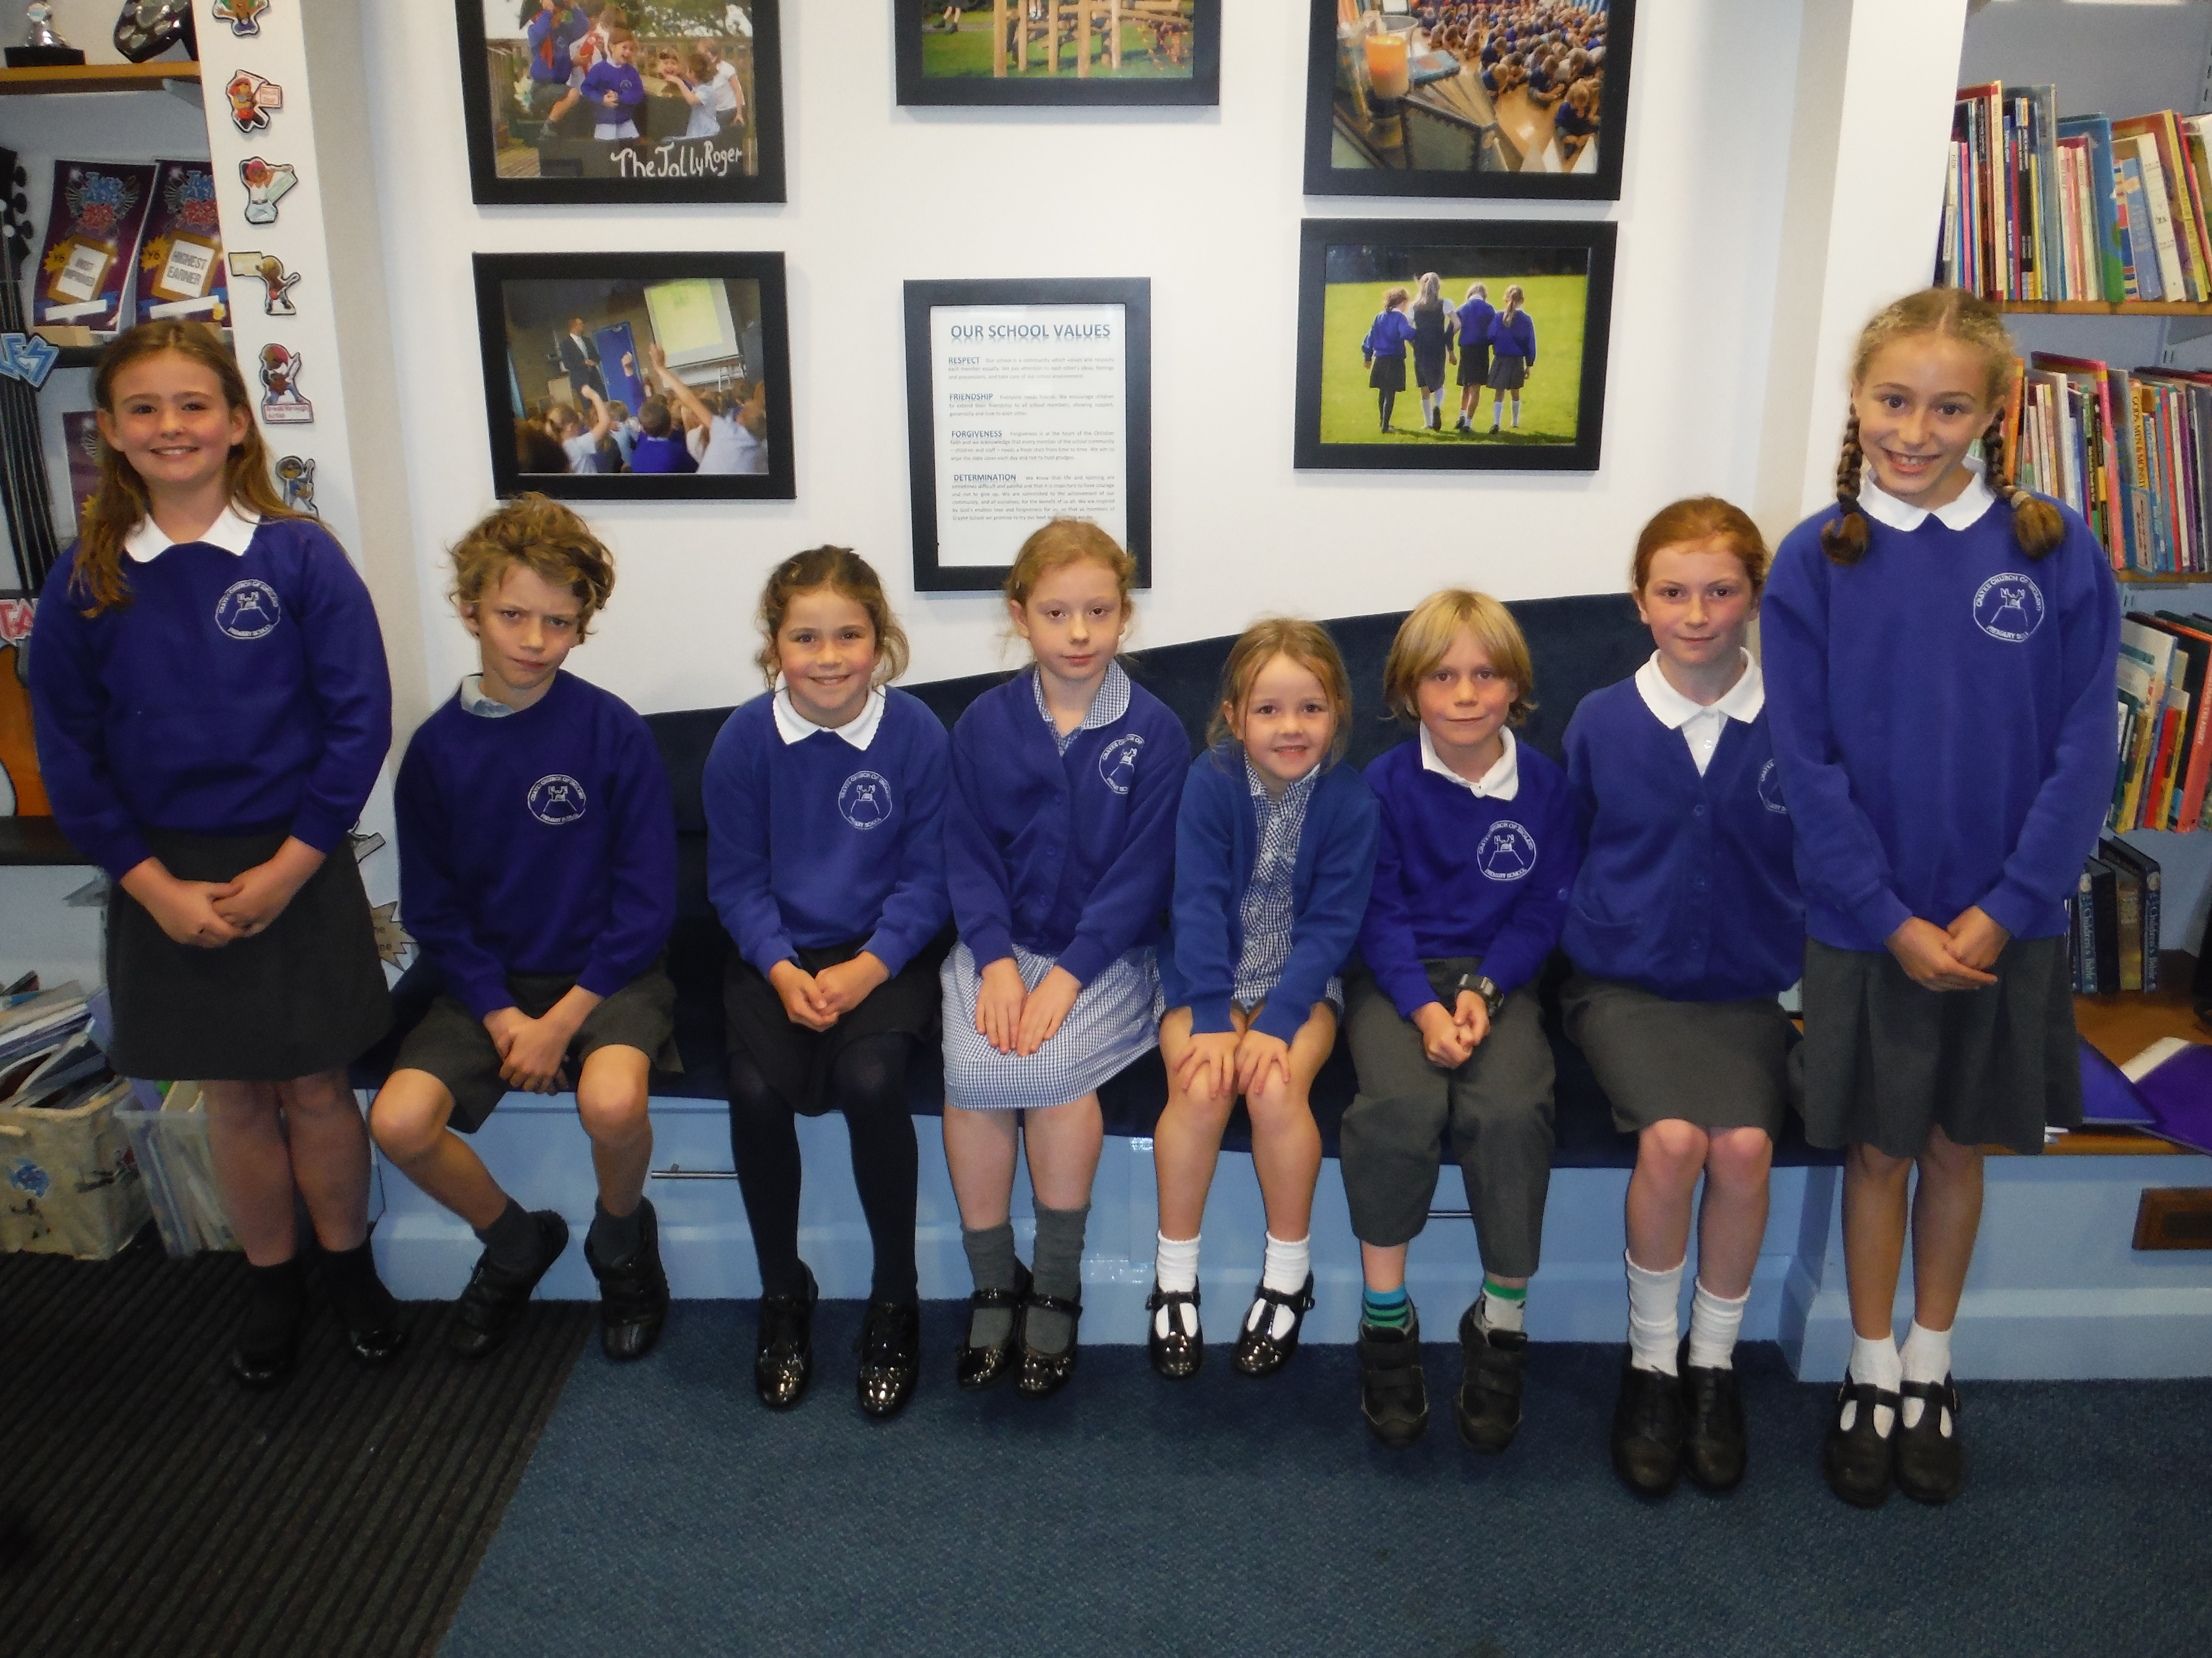

Hi, we are the new School Council and we will be your Roving Reporters for the year.

Look out for our Roving Reports here on the Crayke Chronicle and remember that pupils can put suggestions in our ‘School Council Suggestion Box’ in the hall.