**Crayke Chronicle**

**Friday 20th September**

**Yellow Team**

**Admissions - important dates…**

There are a number of important dates that you need to be aware of if you are applying for a school place.

**Admission to Reception Class**

If your child was born between 1st September 2015 and 31st August 2016 they are due to start in reception class in September 2020, you must submit their application form by the closing date **15th January 2020**.

**Primary to Secondary School Transfer**

If your child was born between 1st September 2008 and 31st August 2009, they are due to transfer to secondary school in September 2020, you must submit their application form by the closing date **31st October 2019**.

For more information please visit:

<https://www.northyorks.gov.uk/timelines-and-important-dates-schools-admissions>

Applications for the aforementioned will open on **Tuesday 1st October**.

**Cross Country**

A massive well done to all the children who represented the school so successfully, at the Easingwold Cluster Cross Country Competition.

All the children put a huge amount of effort into their races and were a real credit to our school. Children who finished in the first six will compete in the regional finals – details to follow…

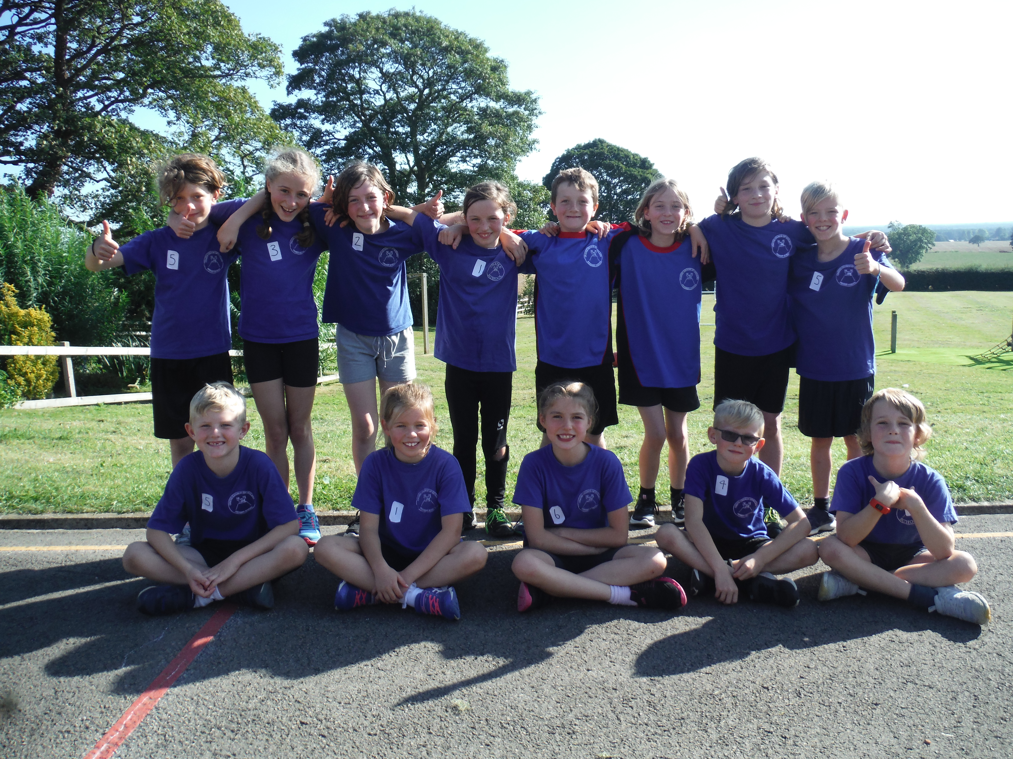

**Where's Church this week?**

**Sunday September 22nd**

10.30am Harvest Holy Communion at Yearsley.  
6.30pm Evening Prayer at Crayke.

With best wishes,

Revd Liz



In Class 1, the children will be able to be acknowledged as Whizz of the week...

**Whizz of the Week**

**Class 1 – Wynter Brierley**

Each week a child will be selected from our classes to receive the title of *Maths Whizz* of the Week or *English Expert* of the Week. Congratulations to this week’s children...

**Maths Whizz of the Week**

**Class 2 – Oskar Braidwood**

**Class 3 – Tom Ward**

**Class 4 – Mani Brown**

**English Expert of the Week**

**Class 2 – William Swan**

**Class 3 – Seb Hindley**

**Class 4 – Holly Brierley**

**Team Points**

This week’s winners are:

