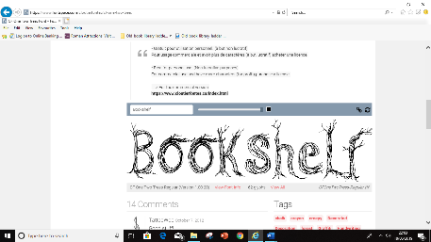

**Theme: Food Glorious Food**

**Communication, Language & Literacy**

* **Reading, writing and blending letters of the alphabet in order to begin reading and writing.**
* **Building up listening skills**
* **Building up talking skills**

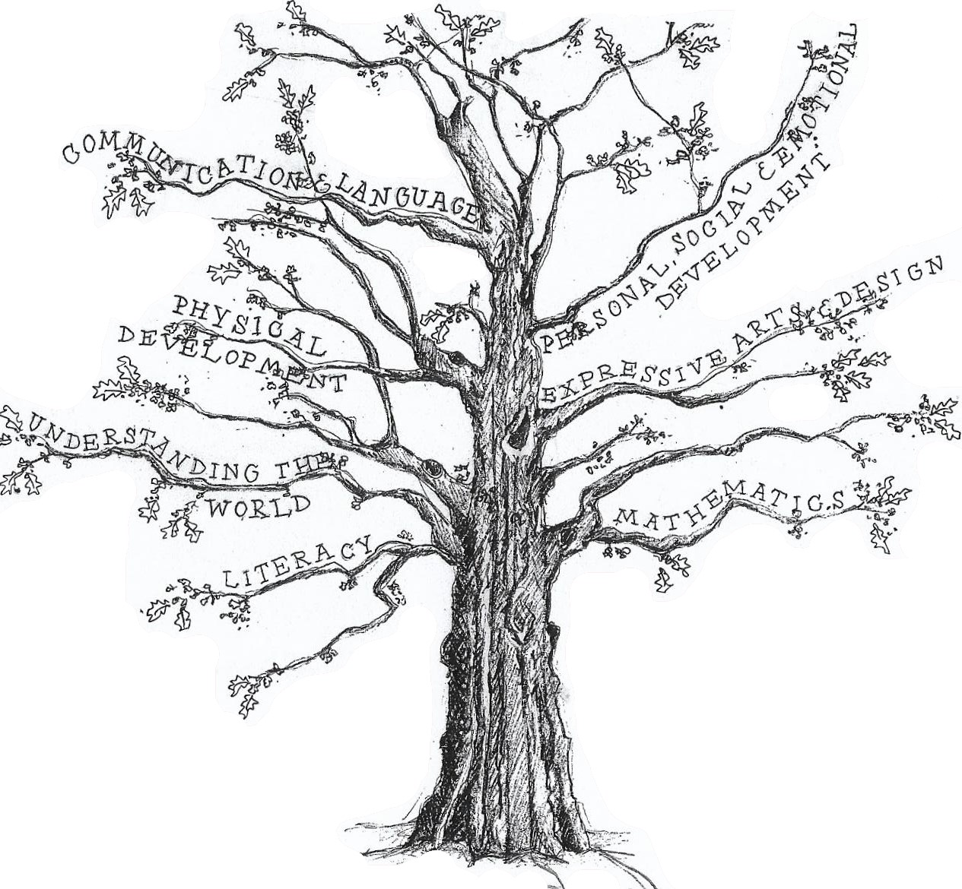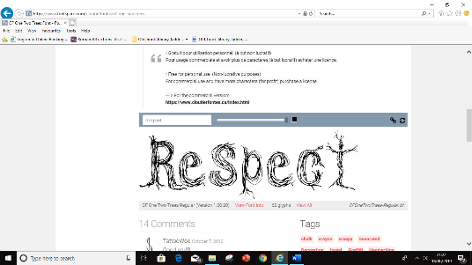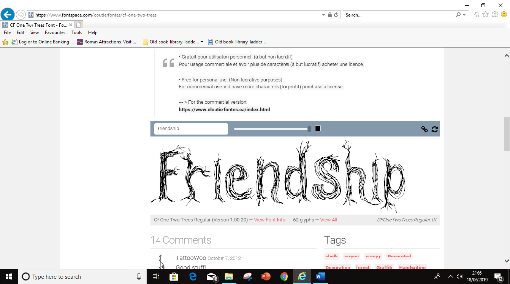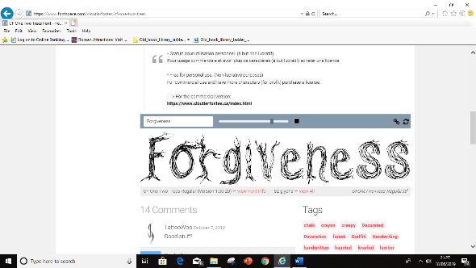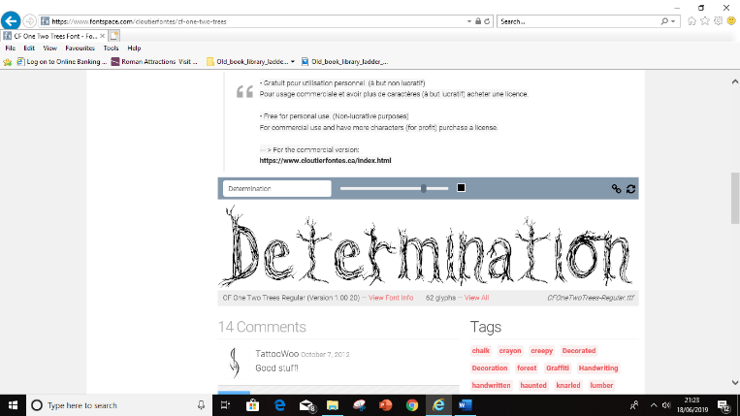 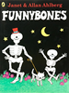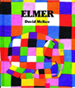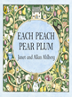 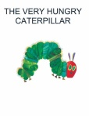 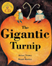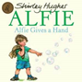

**Mathematics**

* **Counting objects**
* **Reading, writing ordering numbers to 10**
* **Concept or more and less**
* **Weighing, measuring, sorting**
* **2d and 3d shapes**

**RE**

* **Celebrations: Harvest, Christmas, birthdays, festivals of light**
* **What is special about our world**

**Expressive Arts & Design**

* **Playing imaginatively with friends**
* **Using media and materials**
* **Learning simple songs and rhymes and using instruments**
* **Dressing up and performing**

**Personal, Social & Emotional Development**

* **Making and keeping friends**
* **Understanding and accepting difference**
* **Being good learners**

**Understanding the World**

* **What grows around us?**
* **What do we eat and drink**
* **Learning in our environment**

**Physical Development**

* **Using classroom tools**
* **Learning to write and draw**
* **Using bodies in dance, gymnastics and athletics**