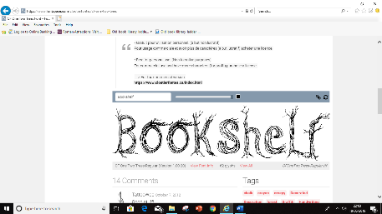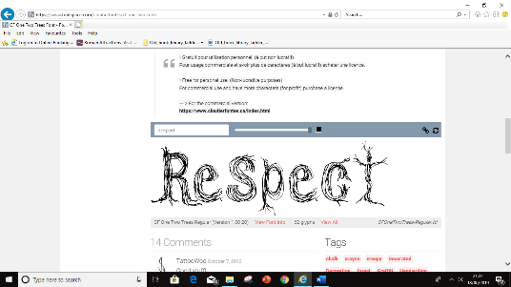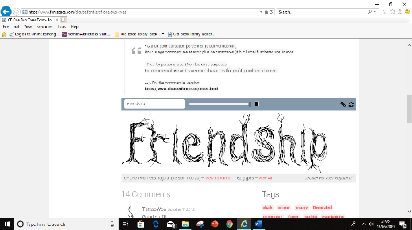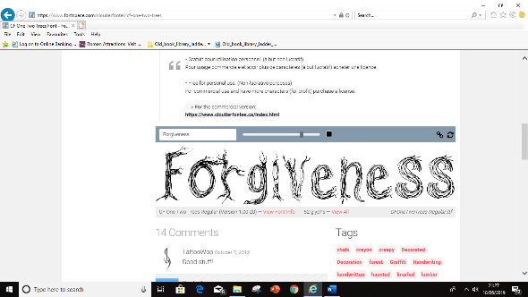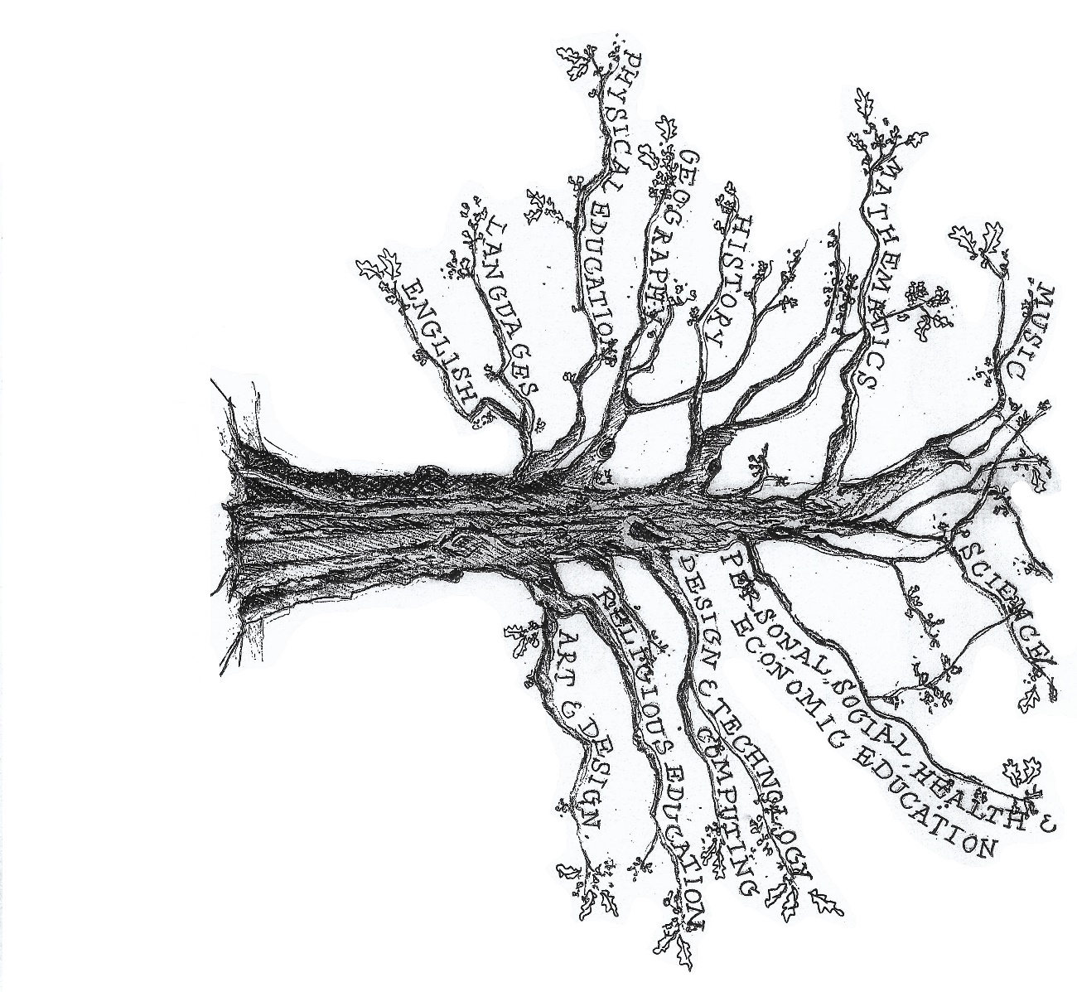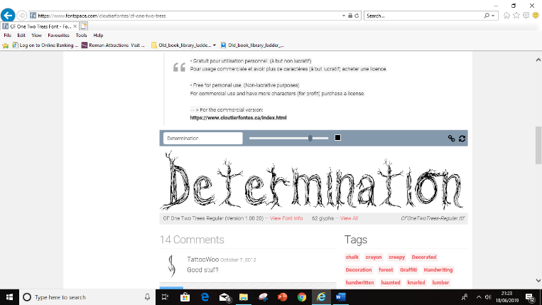

Art & Design Technology:

Anglo Saxon brooches and Beowulf thrones

Religious Education

*Creation and Science; Conflicting or Complementary?*

*(Understanding Christianity)*

Science

Earth and Space

-Movement of Earth, planets and moon -Rotation of Earth and effect on day and night

Maths: Coverage across the year of:

* Number and Place Value
* Addition and Subtraction, Multiplication and Division
* Fractions (including decimals and percentages)
* Measurement
* Geometry – properties of shape & position and direction
* Statistics, algebra, ratio and proportion
* Ratio and proportion
* Algebra

Computing

Coding, online safety and spreadsheets

Languages (French)

‘All about me’ and ‘Games and songs’

PSHE

Archbishop of York Youth Leadership Project

P.E

Rugby, invasion games, swimming

History: The Dark Ages:

Anglo - Saxons

**Theme: Into the darkness...**

English

Fiction – Flashback stories

Fiction *– suspense stories*

Non-chronological report – Anglo Saxons

Poetry - (Narrative) – Anglo-Saxons

Music

Linked to Anglo-Saxons and Earth & Space.