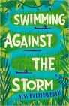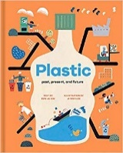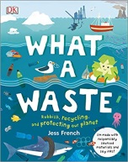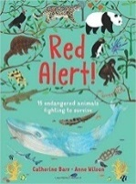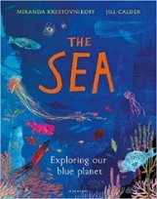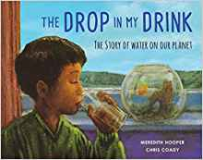

Music

Skills taught throughout the year.

Focus on ‘River Journey,’ ‘Storm’ by Benjamin Britten to inspire composition and ‘Aquarium’ from the Carnival of the Animals.

**Theme: Our Blue Planet**

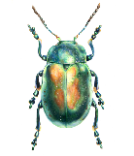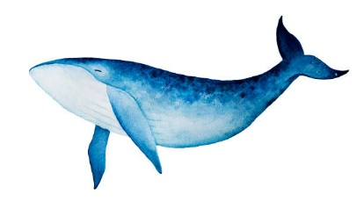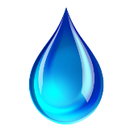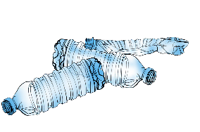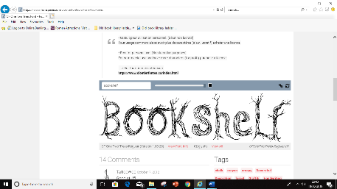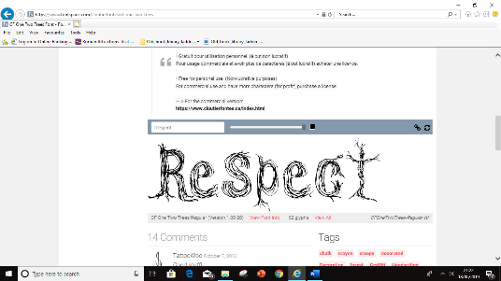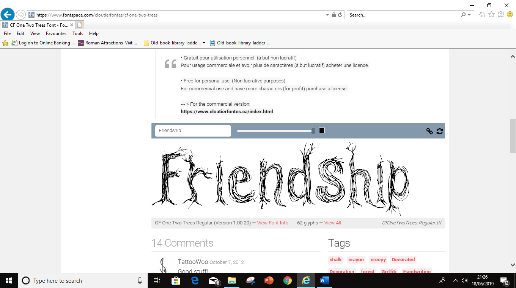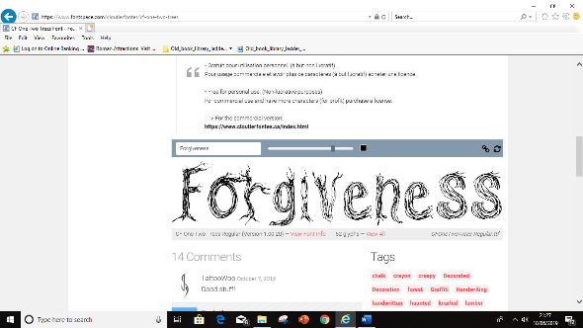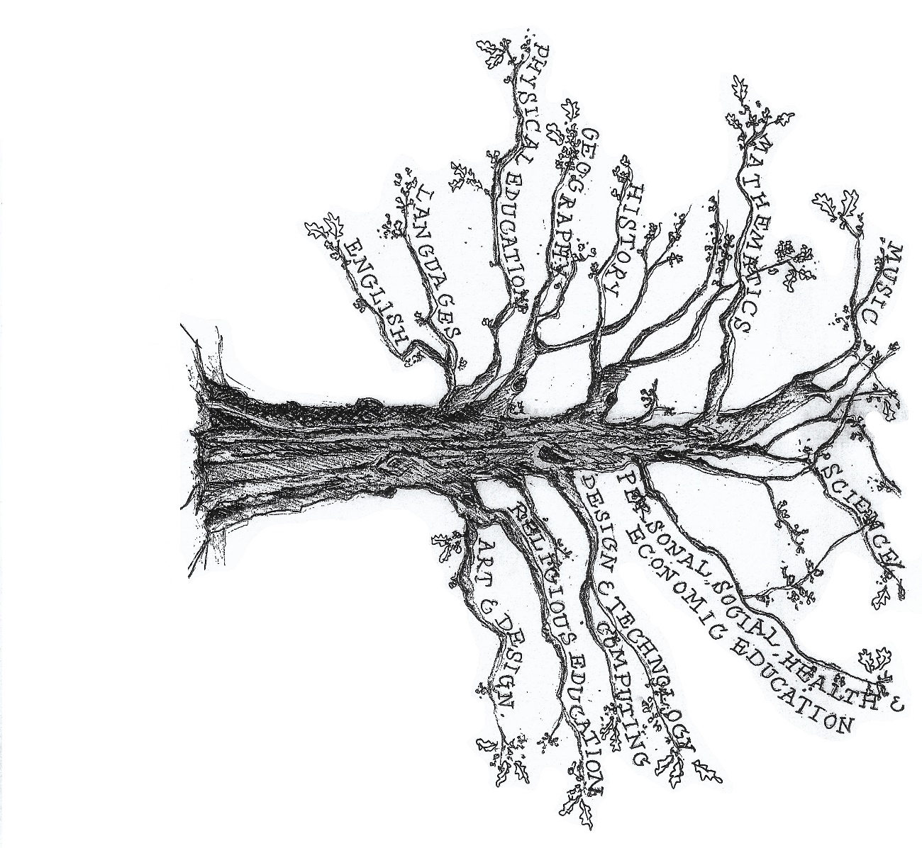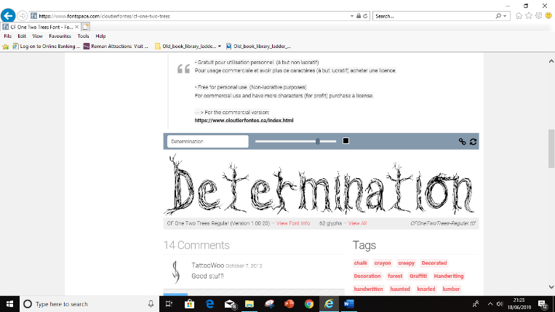

English

Poetry and poetic devices

Reading and understanding biographies

Newspaper reports

Explanation texts

Letter writing

*SPaG and reading comprehension taught throughout the year.*

P.E

Basic skills & cross-country

Football, Gymnastics

Art & Design Technology

Art – Recycled Sculptures inspired by Jason Scarpace.

D.T – Eco-friendly packaging linked to 3D shapes and nets.

Religious Education

What is it like to follow God?

What is the trinity/incarnation?

Advent and Christmas around the world.

Languages (French)

On y va! (All Aboard!)

L’argent de poche (Pocket Money)

Science

Changing states.

Living things & their habitats.

*Skills in ‘working scientifically’ developed throughout the year.*

Computing

Coding, Online Safety & Introduction to Spreadsheets

PSHE

New beginnings.

Getting on & falling out.

Maths

Number & place value, addition and subtraction written methods and mental strategies.

Statistics, multiplication written methods.

3D shape & nets taught through design technology.

*Arithmetic and times tables taught throughout the year.*

History & Geography

Geography focus:

Rivers, Oceans and the distribution of water around the world.

Map study: European map.