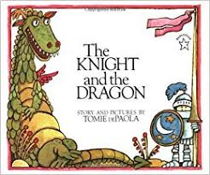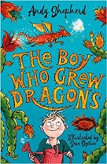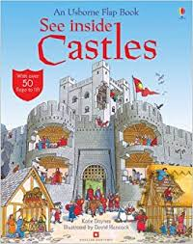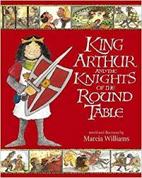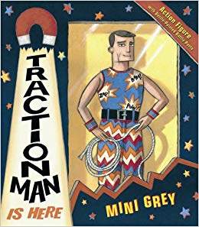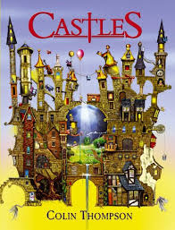

**Theme: Once upon a time……**

Science

Everyday/Changing Materials

Potions

Seasonal Changes

History & Geography

Life in a Castle

Medieval Times

King Arthur and the Round Table

Castle Maps/Compass Directions

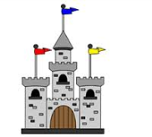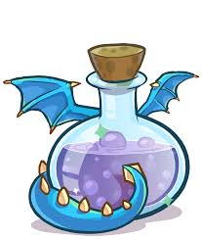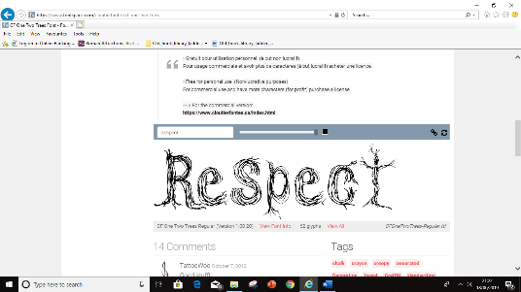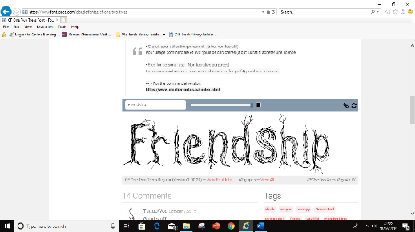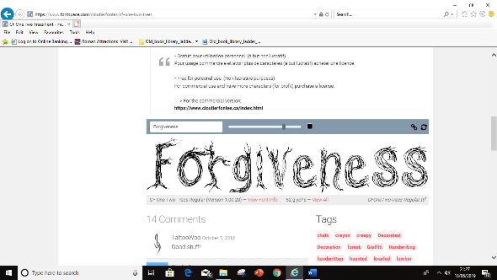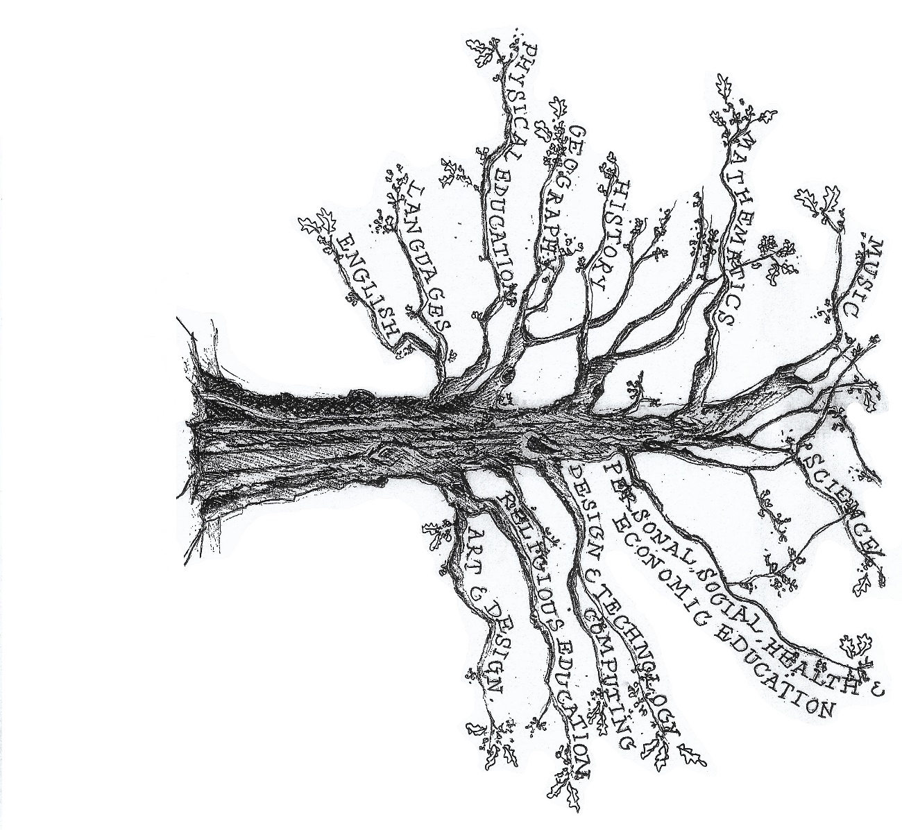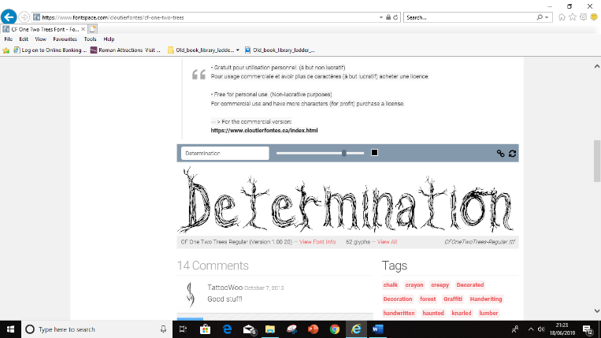

Computing

Online Safety

Exploring Purple Mash

Maze Explorers

Questioning

Art & Design Technology

Design and make a 3D castle

Tapestries

Cooking – Medieval Feasts

Music

Songs, chants and activities linked to traditional tales.

PSHE

New Beginning

Getting on & falling out

Religious Education

Creation and Thanks Giving

Who made the World?

What is the significance of gifts at Christmas?

English

Traditional Tales

Letter Writing

Magical Poetry

Talk for Writing – ‘Peace at Last’

Diary Entries

Instructions

Maths

Counting, Place Value and Sequencing

Addition & Subtraction

Multiplication and Division

Fractions, Data Handling and Time

Position and Movement

P.E

Gymnastics

Winter Competitive Games

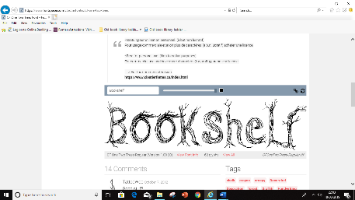

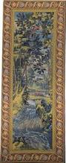

[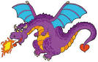](http://www.google.co.uk/url?q=http://www.2muchvector.com/showcatcols.php?CategoryID=36&SubcategoryID=40&sa=U&ei=4pi6U6SxKuKt0QXZvYDADw&ved=0CCwQ9QEwCw&usg=AFQjCNH51xAiZylRyhx71OQvgEIkw2aDeg)

