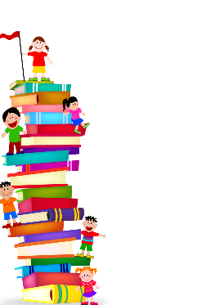
Autumn Term
Crayke C of E Primary School Reading Newsletter
Author Spotlight  A message to our school from Jenny McLachlan! |  |  |  |  |  |  |  |  | Easingwold Library Opening Hours
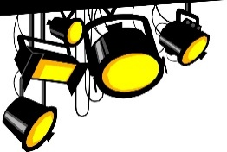  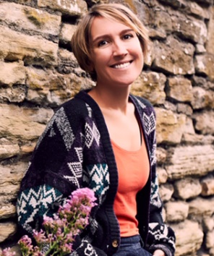 | To the lovely students of Crayke . . . welcome back! I’ve had the best summer because my new book, ‘The Land of Roar’, was published. It’s about two children who discover something very surprising in their grandad’s attic . . . a folding camp bed! OK, that’s not particularly surprising, but it’s what’s inside this camp bed that makes it so special.  When Rose and Arthur were little they used to play an incredible game that began when they crawled through the bed. It involved ninja wizards, mer-witches, and dragons, and it all took place in a world they called Roar. Rose is convinced Roar was just a game, but Arthur isn’t so sure, especially when he sees something strange standing in the window of Grandad’s attic . . .  I’ve been thinking about The Land of Roar since I was your age. I used to love playing big, elaborate games that were so exciting I felt I could almost step inside them. I found reading, drawing and writing were other ways of letting my imagination run wild. I used to draw for hours!  Whenever you pick up a pen or open a book there’s a chance you’re about to go somewhere incredible. I hope you all have some amazing reading adventures this term. Who knows? Maybe you’ll find your very own Roar. |  |  |  |  |  |  |  | Monday, 10am to 5pm  Tuesday, 2pm to 5pm  Wednesday, closed  Thursday, 1pm to 6pm  Friday, 9.30am to 5pm  Saturday, 10am to 12.30pm  Sunday, closed
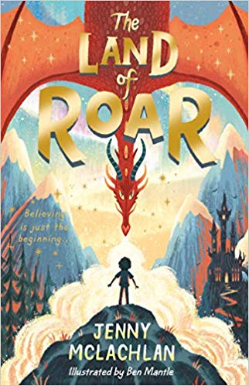 |  |  |  |  |  |  |  |  | Book Club
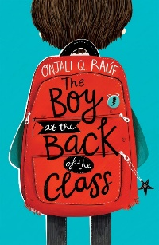

This term, Mrs Rayner is running a book club with years 4, 5 & 6.
They are reading ‘The Boy at the Back of the Class’ by Onjali Q. Rauf.
Have you been to…?
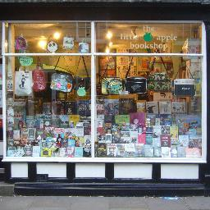
The Little Apple Bookshop, 13 High Petergate, York
A friendly, local bookshop with a wide range of fiction, children's books and signed copies. The Little Apple also runs a regular reading group and are the official supplier of books to the York Literature Festival. They are really knowledgeable about books – definitely worth a visit!
Fiction: What’s New…
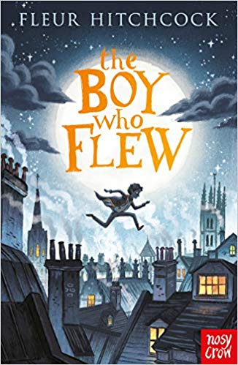 |  | ‘The Boy who Flew’ by Fleur Hitchcock  Aimed at: Year 5 & 6 readers.  If you enjoy mystery and excitement, then this book is for you! Athan Wilde dreams of flight. When his friend, Mr Chen, is murdered, Athan must rescue the flying machine they were building together and stop it falling into the wrong hands. But keeping the machine safe puts his family in terrible danger. What will Athan choose - flight or family?
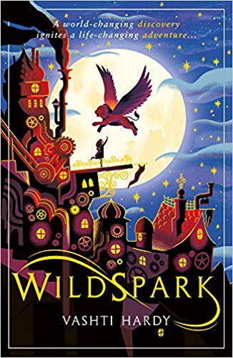 |  | ‘WILDSPARK’ by Vashti Hardy  Aimed at: Year 4, 5 & 6 readers.  Wildspark is set in a world of incredible technology where the spirits of the dead can be given a second chance at life within animal-form mechanical bodies. Prue, with her aptitude for the mechanical, takes her brother’s place at the school of mechanical science in the city of Medlock. Prue’s secret goal is to find a way to bring back her brother, complete with the memories that other second-lifers lack.
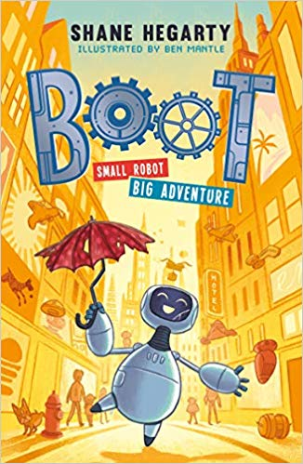 |  | ‘BOOT: Small Robot, Big Adventures’ by Shane Hegarty  Aimed at: Year 3 & 4 readers.  When toy robot, Boot, wakes up at a scrapyard, it has no idea how it got there and why it isn't with its owner, Beth. It only has two and a half glitchy memories, but it knows it was loved, which means something important to humans. With new friends by its side, Boot is determined to find Beth and the gang set off on a dangerous adventure. Everything Boot thought it knew about the world is changing and things aren't as simple as it remembers…
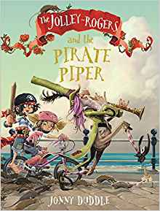 |  | ‘The Jolley Rogers and the Pirate Piper’ by Jonny Duddle  Aimed at: Year 2 & Year 3 readers.  One morning the townspeople of Dull-on-Sea wake to find that their town is overrun with rats. Just when everyone is at their wit's end, a nautical stranger who plays the pipe turns up and offers to get rid of the rodent problem - for a fee. Once that rats have gone, the greedy mayor refuses to pay - so the Pirate Piper plays an enchanted tune and leads the children away. It's up to Matilda, Jim and Nugget to save their friends.
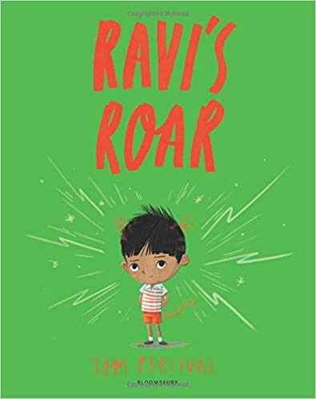 |  | ‘Ravi’s Roar’ by Tom Percival  Aimed at: Reception, Year 1, Year 2.  Most of the time Ravi can control his temper but, one day, he lets out the tiger within. Being a tiger is great fun at first - tigers can do ANYTHING they want! But who wants to play with a growling, roaring, noisy, wild tiger who won't share or play nicely? Ravi is about to discover something very important about expressing his feelings and making amends.
Non-Fiction
With the 50th anniversary of the successful Apollo landing on the Moon earlier this year, take a look at these wonderful books all with a ‘Space’ theme!
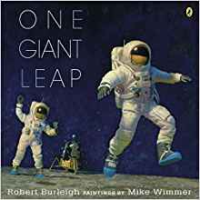 |  |  | 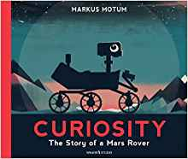 |  |  |  |  | 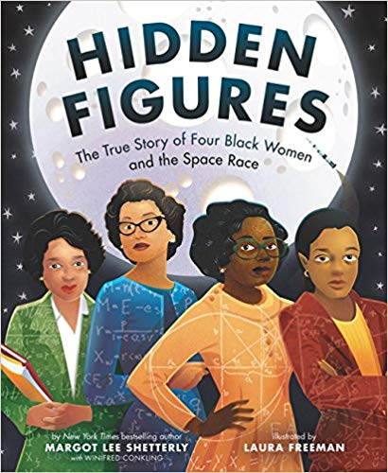
One Giant Leap: A Historical Account of the First Moon Landing by Robert Burleigh |  |  | Curiosity: The Story of a Mars Rover by Markus Motum |  |  |  |  | Hidden Figures: The True Story of Four Black Women and the Space Race by Margot Shetterly
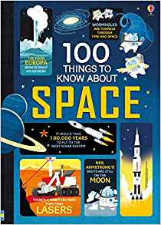 |  |  |  |  | 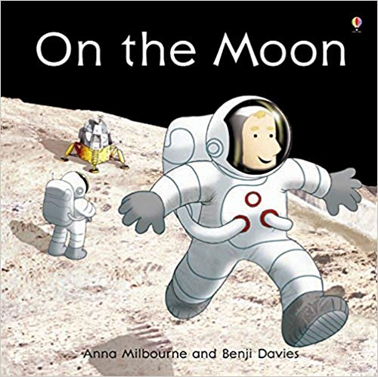
100 things to know about Space by Alex Frith et al. |  |  |  |  | On the Moon (Usborne Picture Books) by Anna Milbourne
Have you tried…?
Class 1  ‘The Bumblebear’ by Nadia Shireen  Class 2  ‘There’s a Tiger in the Garden’ by Lizzy Stewart  Class 3  ‘The Dragon in the Library’ by Louie Stowell  Class 4  ‘Beetle Boy’ by M.G Leonard |  |  |  |  |  |  | What are YOU reading?  Have you read a book you’d love to recommend in the newsletter?  Write a recommendation with the title, author, your name and a reason why you’d recommend it, to be in with a chance of it being featured in our next newsletter in the spring! Please pass your recommendation onto Mrs Rayner in Class 3.
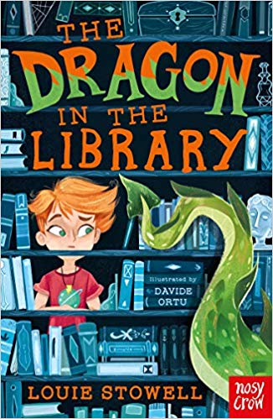

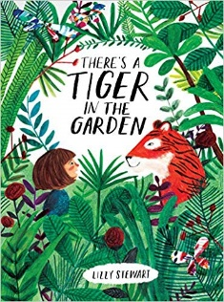
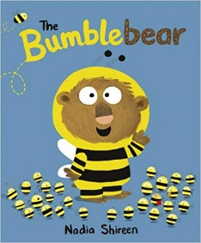
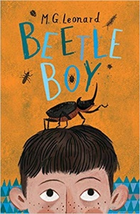

Poetry
A message to our school from poet Brian Moses…
I love poetry for its’ rhythms and for the way it works as a snapshot of an experience or thought. It is also something that can be so powerful, it can stay with you a lifetime.

“What advice would you give to anyone who wants to write?” First of all, I reply, if you want to write, then write. Don’t talk about it, do it. So many people talk about writing a book one day but never do. Secondly, keep a writer’s notebook. Write down what you see, hear, jokes people tell you, thoughts about strange situations, odd signs. It will, as time goes on, become a treasure chest of ideas to refer to again and again. I have notebooks going back many years and they still prove useful. Finally, train yourself to be an observer. Look, listen, note it down. Be receptive to anything and interested in everything. Spot possibilities. Be an ideas detective and read. Read everything you can, anytime, anywhere. Good readers make good writers. Reading is the cornerstone of education. It can also bring huge pleasure. A book is a ticket to an adventure. You’ll never be bored with a book. And who knows… one day, you could walk into a book shop and see your name on the front cover of a book. It’s quite possible.
Walking with my Iguana  I’m walking  With my iguana  I’m walking  With my iguana  When the temperature rises  To above eighty-five,  My iguana is looking  Like he’s coming alive.  So we make it to the beach,  My iguana and me,  Then he sits on my shoulder  As we stroll by the sea…  And I’m walking  With my iguana  I’m walking  With my iguana  Well if anyone sees us  We’re a big surprise  My iguana and me  On our daily exercise,  Till somebody phones  The local police  Says I’ve got an alligator  Tied to a leash  When I’m walking  With my iguana |  |  |  | I’m walking  with my iguana  It’s the spines on his back  That make him look grim,  But he just loves to be tickled  Under his chin.  And I know that my iguana  Is ready for bed  When he puts on his pyjamas  And lays down his sleepy head.  And I’m walking  With my iguana  Still walking  With my iguana  With my iguana…  With my iguana…  And my piranha  And my chihuahua  And my chinchilla,  And my gorilla,  My caterpillar…  And I’m walking…  With my iguana…  With my iguana…  With my iguana…  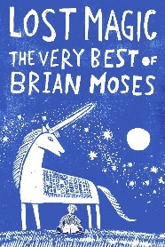  Taken from the book ‘The Lost Magic’ with kind permission from Brian Moses ©  Why not try reading it for yourself…  and visit brianmoses.co.uk
Important Dates, Events & Competitions
September
Big Red Book Bus visits our school!  Thursday 19th September | We have invited ‘The Book People’ to bring their ‘Big Red Book Bus’ to Crayke. You will be able to browse and buy books, helping to raise money towards new books for school at the same time, too!
Easingwold Community Library:  Stop-motion film club | Throughout September and October, Easingwold library are running a stop-motion film club for7 to 10-year-olds every Friday.  Contact the library for more details!
Harrogate Waterstones – Story Time | Every Sunday at 2pm until December, Waterstones in Harrogate are running Storytime. This is aimed at younger children and is simply one of their staff reading a lovely story.
Roald Dahl Day  13/09/19 | 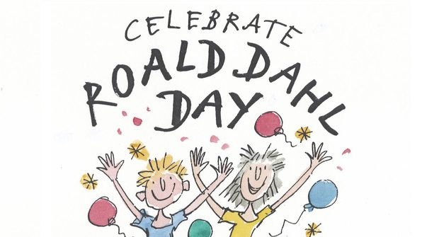  September is Roald Dahl’s birth month and this year on the 13th, a wonderful mixture of events will be taking place. If Roald Dahl were alive today, he’d be 102 this year. That’s a ripe old age, much older than Grandpa Joe, who was only ninety-six and a half. The entire month will be filled with different activities, taking place all over the world.
Never Such Innocence Writing Competition  September | For the 2019/20 academic year, the Never Such Innocence competition will be bigger than ever! There is a new speechwriting category. The age range is 9-18. The Never Such Innocence competition invites young people to write a poem, speech, or song, or create a piece of art responding to war or conflict.  https://www.neversuchinnocence.com/2019-20-competition
October
National Poetry Day  03/10/19 | National Poetry Day is a UK-wide celebration of poetry taking place every October. Each year there’s a different theme and in 2019 the theme is Truth. National Poetry Day generates an explosion of activity nationwide, thousands of amazing events across the UK – in schools, libraries, bookshops and hospitals, on buses, trains and boats – all celebrating poetry’s power to bring people together. 2019 is the 25th anniversary of this day. www.nationalpoetryday.co.uk
Libraries Week  07/10/19 - 12/10/19 | Libraries Week is a celebration of the nation’s much-loved libraries. In 2019 we are celebrating the role of libraries in the digital world. Libraries Week 2019 will celebrate and explore how libraries are engaging communities through technology, building digital skills and confidence, encouraging digital participation and inclusion, supporting health, wellbeing and education and supporting local business and enterprise. http://www.librariesweek.org.uk
Harrogate Waterstones:  Harry Potter Quiz 10/10/19 | On 10th October, Waterstones in Harrogate are holding a Harry Potter Quiz (suitable for families). Full details are here: https://www.waterstones.com/events/the-triwizard-quiz/harrogate
York Waterstones  October Half Term | Half term activities to be confirmed nearer the time. Take a look at  https://www.waterstones.com/events/search/shop/york to see what’s happening.
Harrogate Waterstones October Half Term | Over Half Term the Harrogate store has a themed activity on every weekday (as well as the usual Sunday Storytime).  These run from 2pm -3pm and include colouring sheets, stories, and more. Each day is themed as follows:  Mon 28 - Pug (from the books by Laura James)  Tue 29 - Peppa Pig  We 30 - Julia Donalson  Thu 31 - Halloween  Fri 1 Nov - Oi Frog.
Easingwold CommunityLibrary ‘Yarnorama’  29/10/19 | As part of the Family Learning Festival, Easingwold library are hosting their very own ‘Yarnorama.’ This is a chance to learn new woolly crafts: plaiting, finger-knitting, French knitting and pom-pom making etc. Get in touch with the library for more details.
Wicked Young Writer Awards (opens October  2019, deadline March 2020) | The "prestigious Wicked Young Writer Awards" (The Times) was established by the longrunning musical WICKED to link the important messages of the production with a competition that would inspire young people to use creative writing to look at life a little differently. The Award recognises excellence in writing, encourages creativity, and helps develop writing talent in young people between 5-25 years old from all backgrounds and areas of the UK.  www.wickedyoungwriterawards.com
November
The Blue Peter Book Award (shortlist announced, winner announced on World Book Day 2020) | Since 2000, the enormously popular and influential Blue Peter Book Awards have been recognising and celebrating the best authors, the most creative illustrators and the greatest reads for children. The Blue Peter Book Awards 2019 celebrates children's books published in the last year in two categories: the Best Story and the Best Book with Facts.  https://www.booktrust.org.uk/what-wedo/awards-andprizes/currentprizes/blue-peterbook-awards/
Costa Book Awards (shortlist in November, winner announced in Jan 2020) | The Costa Book Awards honours books written by authors based in the UK and Ireland. There are five categories: First Novel, Novel, Biography, Poetry and Children's Book, with one of the five winners chosen as Book of the Year. The 2018 winner was Bart van Es for his novel The Cut Out Girl (Fig Tree). The winner is announced every January.  www.costabookawards.com
December
Letter to Santa deadline  Early December | Each year, Santa's elves at the Royal Mail can help you get a letter from Santa, if kids write  to him by early December.  https://www.royalmail.com/letters-tosanta/

