SMSC and Fundamental British Values evidence for Crayke Church of England Primary School 2018–19
Event, details & photographs… | SOCIAL |  |  |  | MORAL |  |  |  |  | SPIRITUAL |  |  |  |  | CULTURAL
 | Developing personal qualities & using social skills | Participating, co-operating and resolving conflicts | Understanding how communities and societies function | Develop an understanding of the Fundamental British Values of democracy and the rule of law. | Developing and expressing personal views or values | Moral codes and models of moral virtue | Recognising right and wrong and applying it | Understanding the consequences of actions | Investigating moral values and ethical issues | Developing personal values and beliefs | Experiencing fascination, awe and wonder | Exploring and respecting the values and beliefs of others | Understanding human emotions and feelings | Using imagination and creativity in learning | Exploring, understanding and respecting diversity | Participating in and responding to cultural activities | Understanding and appreciating personal influences
Church Service: Harvest Festival -  Pupils looked at a range of different issues effecting people in economically developing countries. Through a range of different activities, sufficient money was raised to purchase three toilets. |  | * |  |  |  | * |  |  | * | * | * | * |  | * | * | *
School council: the school council voted to hold a bake sale to raise money for a new outdoor bin. They raised over £55 towards it and voted on the best bin for the purpose. |  | * |  |  | * | * |  |  | * |  |  |  |  | *
Church Service: Christmas  All children celebrated Christmas through performing poems and singing carols at the Church of St Cuthbert in Crayke. |  |  |  |  | * |  |  |  |  | * | * |  | * | *
Minster FM Toy Appeal  Please see website for more information.  http://www.craykeschool.org/2018/minster-fm-toy-appeal-2018-2/ | * | * |  |  | * | * |  | * |  |  | * |  |  | *
Children in Need stalls:  Class 4 ran Children in Need stalls (all organised, promoted and resourced by themselves) to money for Children in Need. This was or charity event for our Archbishop of York Young Leaders project. | * | * |  |  | * |  |  | * | * | * |  |  | * |  |  |  | *
Whole School Armistice Art Project  To mark 100 years since the Armistice agreement, each child in our school has created a poppy using a plastic bottle. I am sure you will agree that finished display looks really effective.  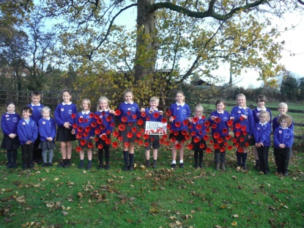 |  |  |  | * |  |  |  |  |  |  |  | * | * |  |  | *
Antibullying week Pupils thought about their own friendships and how they can be good friends  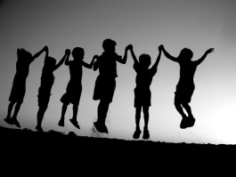 | * | * | * |  | * | * | * | * | * | * |  | * | * |  | *
Forest Schools In Forest Schools activities pupils are required to cooperate and abide by simple safety rules. Our beautiful school grounds and setting help them to be inspired by the natural world.  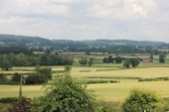 | * | * |  | * |  |  | * | * |  |  | * |  |  | *
EYFS Curriculum Expressive Arts and Design Pupils are given opportunities to respond imaginatively and creatively to a range of activities and experiences  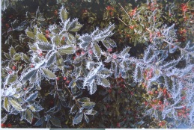 |  |  |  |  | * |  |  |  |  |  | * |  | * | *
EYFS Curriculum Personal, social and emotional awareness Developing pupils’ sense of themselves and others as moral and responsible people runs through all learning and relationships in Class 1. No opportunity is wasted.  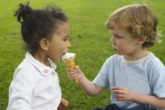 | * | * | * | * | * | * | * | * | * | * |  | * | * | * | * | * | *
Christmas nativity Classes 1 and 2 joined together to perform the school’s nativity.  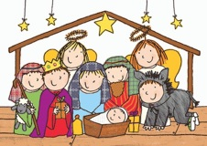 | * | * |  |  |  |  |  |  |  |  |  | * | * | * | * | *
Spring Term RE What makes a place special? Starting with our own special places we thought of what makes religious buildings special to people of all faiths.  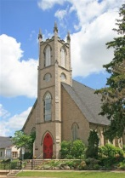 |  |  | * |  | * |  |  |  |  |  |  | * |  |  | *
What Price Peace? Barnabas RE Day  Children throughout school learned more about the key events of World War I (including the Battle of the Somme) and the powerful beliefs associated with it.  Following whole school Collective Worship on Tuesday morning, pupils worked in class groups. To make the content accessible the workshop leader used storytelling, mime, drama and other activities to:  • dramatise how World War I started  • re-enact what it was like to be recruited as a soldier and go to war  • retell the story of how the Western Front became bogged down in trench warfare  • explain how poppies became a symbol for remembrance of ‘the fallen’  • immerse pupils in Bible stories and poetry of particular significance for the time  • reflect on the way some Christian ideas about God changed as a consequence  • encourage pupils to ask searching questions.  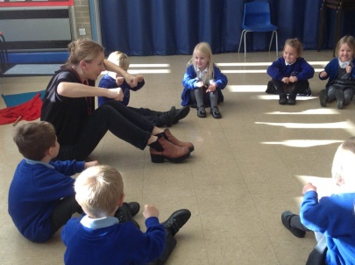 | * |  | * |  | * |  |  |  | * | * | * | * | * | * | * | * | *
Visit to the Mandir  Children across both key stages enjoyed a visit to the Mandir in Bradford. We had a tour of the temple and saw the different gods. Children tried on different Hindu outfits and explored the Mandir. They enjoyed learning more about the religion and asking lots of questions.  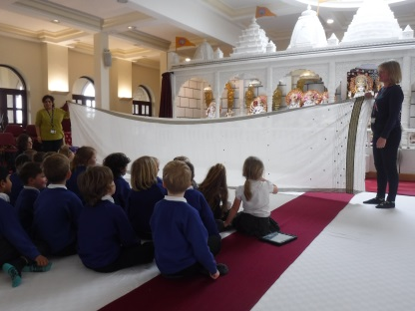 | * |  | * |  | * |  |  |  | * | * | * | * | * | * | * | * | *
Fabulous Finish – WW2 – Class 4  Children in Class 4 celebrated the end of our topic with a theme day where we dressed up as WW2 evacuees and experienced what it was like to be chosen by a host family when our parents joined us in the afternoon. We performed songs and dances to immerse ourselves in the experience.  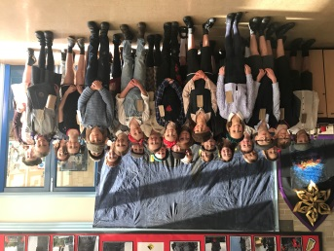 | * | * | * |  | * |  |  | * | * | * | * | * | * | * |  | * | *
Visit to Eden Camp – Class 4  Children in Class 4 enjoyed a visit to Eden Camp to explore our topic of WW2 further.  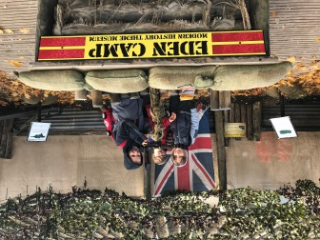 | * |  |  | * | * | * | * | * | * | * | * | * | * |  | *
Young Voices 2019  A small group of children and teachers attended the Young Voices concert in Sheffield in January 2019.  We rehearsed during the day and performed to a large audience in the evening.  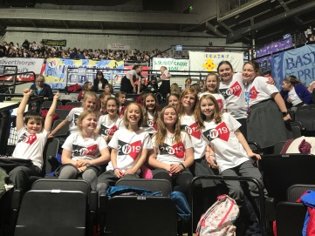 | * | * |  |  | * |  |  |  |  |  | * |  | * | * |  | *
Autumn Term RE – What and how do we celebrate? Pupils discussed celebrations and traditions that were meaningful to them and we held our own class celebration. We visited the local church to witness a ‘baptism ‘ and compared it to a Sikh naming ceremony. |  |  | * |  | * |  |  |  |  | * |  | * | * |  | * | * | *
Class 2 R.E Topic – Big Questions  We thought about the different types of questions we can ask. Some questions can be answered easily, others might have different answers and others we may not be able to answer at all. We thought about questions we could ask God and how he might answer them.  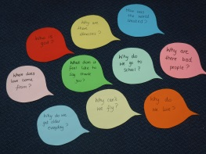 | * |  | * |  | * |  |  |  |  | * |  | * | *
Valuing All God’s Children at Crayke Church of England Primary School  The Church of England is committed to an education that enables people to live life in all its fullness and fulfils the words of Jesus in John 10:10 – “I came that they might have life, and have it abundantly.” John 10:10  Central to Christian theology is the belief that every single one of us is made in the image of God. Every one of us is loved unconditionally by God.  How this shapes our school community and its work  At Crayke Church of England Primary School, we believe that we must avoid diminishing the dignity of any individual child, family or colleague to a stereotype or a problem. Our school offers a community where everyone is a person known and loved by God. We support each other so that we can learn about and celebrate our own intrinsic value. We celebrate the Christian message of love and joy, celebrating our own unique humanity without exception or exclusion.  We are very proud that our school community has a mix of faiths and families within it. We work hard to understand our differences and celebrate them together.  The Church of England’s Vision for Schools can be found by following this link: Valuing All God’s Children | * | * | * |  | * |  |  | * | * | * | * | * | * | * |  | * | *
Class 2 R.E Topic – Where do I belong?  We discussed different groups we belong to including family, friends and clubs. We thought about belonging to the church and how people are welcomed in to church through a baptism. We discussed godparents and how they support us. We thought about the roles of children, parents, godparents and God.                            

