Curriculum Intent Statement
Ensuring access to a rich, broad and balanced curriculum is at the heart of Crayke's provision…

Rationale:
The fundamental aim of Crayke Church of England Primary School is to provide opportunities for children to develop as independent, confident, successful learners with high aspirations; creating citizens of the future who know how to make a positive contribution to their community and the wider society.
Expectations:
We aim for all learners to enjoy their education and make sustained progress in all areas of the curriculum. Pupils’ at all academic levels are helped to achieve their potential. Those who are most able are challenged and supported through appropriate extension activities. Those who find aspects of their learning challenging are encouraged and given targeted support to embed skills, to develop at their own pace or simply to learn in a style that best suits their individual needs.
Knowledge and skills:
The school’s focus on curriculum development has been carefully designed to ensure coverage and progression. It provides pupils with memorable experiences, in addition to diverse and rich opportunities from which children can learn and develop a range of transferable skills. The children's own community is frequently used as a starting point for engaging interest. A primary focus of our curriculum is to raise aspirations (Crayke’s Growth Mindset), engender a sense of personal pride in achievement, resilience and provide a purpose and relevance for learning.
Cultural Capital:
At Crayke there is a significant focus on developing children’s moral, spiritual, social and cultural understanding. We aim to combine high quality teaching with enjoyment of learning, whilst developing and preserving the Christian character of Crayke Church of England Primary School. High professional standards, Christian values and strong links with our local community are the basis on which we seek to work with our extended school family, recognising and responding to the special worth, needs and potential of each individual. We are a Christian foundation serving the whole community, embodying our school values of Respect, Determination, Friendship and Forgiveness in our nurture and encouragement of all.
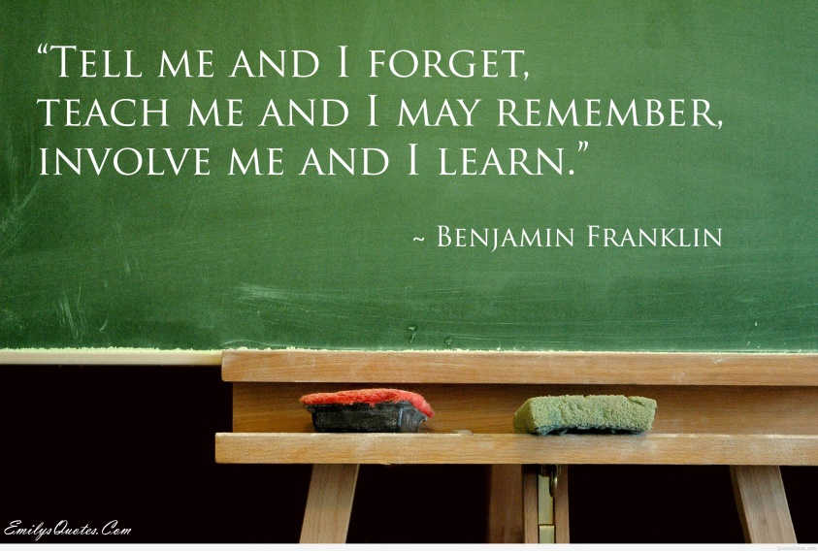
Our Principles for Learning and Teaching
As a staff, we believe our curriculum enables:
- All children to be engaged in their learning and to be active learners; discovering and investigating.
- All children to understand what they have achieved and know what to do to make progress.
- All children to be independent, enthusiastic and self-motivated learners; raising their own questions.
- All children to time to evaluate and reflect on their learning.
- All children to receive teaching that inspires their learning.
- All children to receive teaching that encourages them to be creative.
- All children to be challenged and enjoy their learning.
- All children to develop spiritually, morally and as members of their community and the wider community.
Our children would like a curriculum that…
…is: active, creative and includes problem solving
…is: social and collaborative
…creates: opportunities to work with friends
…offers: opportunities to learn in different situations/environments
…promotes: friendship, forgiveness, success and achievement
…feels: rewarding, personal and fun!
…feels: magical!
Curriculum implementation:
Crayke engages all learning styles using a variety of resources which support the teaching of the curriculum. The wider learning culture is promoted through our school values of ‘Determination, Respect, Friendship and Forgiveness’ and through a culture of our aspirational ‘Crayke Growth Mindset’.
Curriculum Design:
Our curriculum is built through a thematic, topic-based approach which makes connections in skills and knowledge within a variety of subject areas.
Where appropriate, we block learning in order to immerse children fully. Where relevant and possible, we offer enrichment activities to motivate, excite and inspire pupils in the form of ‘Stunning Starts’, ‘Marvellous Middles’ and ‘Fabulous Finishes’ – these may take the form of trips, visitors, theme days, achievement assemblies, exhibitions etc..
We link our topics to key texts that will enrich language and provide context to learning; our topics will be learning challenges based around a key question ‘the big question’ as a starting point e.g. ‘What was it like to be a child during WW2?’, ‘What impact does plastic pollution have on our planet?’ Creatively produced topic books give children a sense of pride in the presentation of their work.
Our curriculum design is represented as a tree with our school values as the roots:
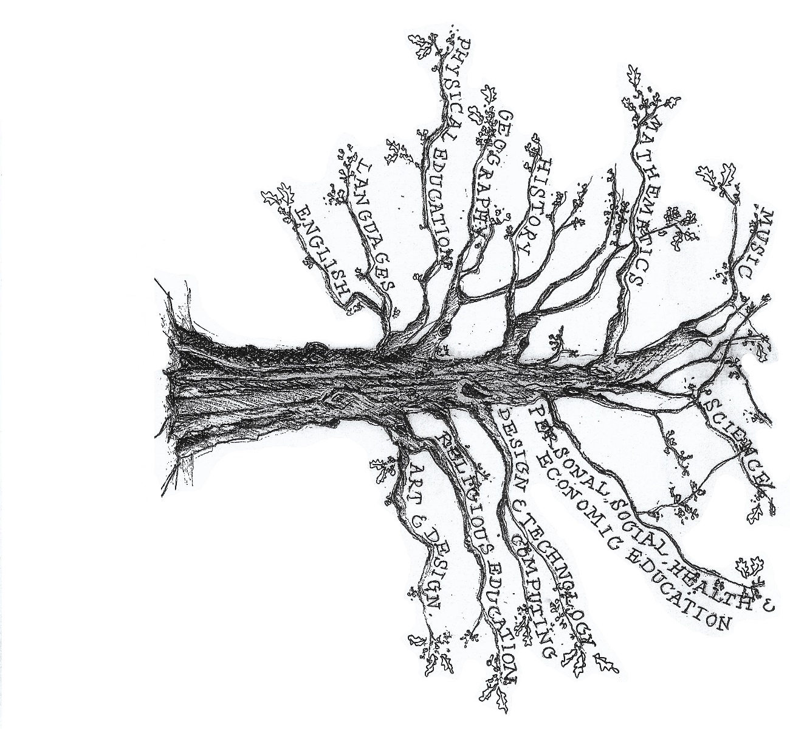
Art & Design Technology:
Anglo Saxon brooches and Beowulf thrones
Religious Education
Creation and Science; Conflicting or Complementary?
(Understanding Christianity)
Science
Earth and Space
-Movement of Earth, planets and moon -Rotation of Earth and effect on day and night

Computing
Coding, online safety and spreadsheets
Languages (French)
‘All about me’ and ‘Games and songs’
PSHE
Archbishop of York Youth Leadership Project
P.E
Rugby, invasion games, swimming

History: The Dark Ages:
Anglo - Saxons

Theme: Into the darkness...
English
Fiction – Flashback stories
Fiction – suspense stories
Non-chronological report – Anglo Saxons
Poetry - (Narrative) – Anglo-Saxons

Music
Linked to Anglo-Saxons and Earth & Space.
Maths: Coverage across the year of:
- Number and Place Value
- Addition and Subtraction, Multiplication and Division
- Fractions (including decimals and percentages)
- Measurement
- Geometry – properties of shape & position and direction
- Statistics, algebra, ratio and proportion
- Ratio and proportion
- Algebra

