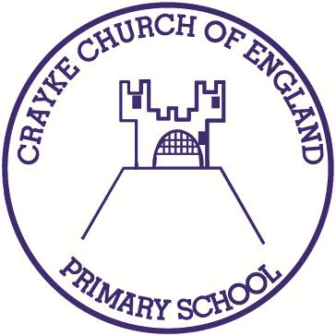

Crayke Church of England Primary School
Easingwold Road
Crayke
North Yorkshire YO61 4TZ
Tel/Fax: 01347 821767
E.mail: admin@crayke.n-yorks.sch.uk
Website: craykeschool.org

Headteacher – Mr. Andrew Buttery BA (HONS), PGCE, NPQH

Headteacher Appointment

Dear Parents/Carers,
As you may be aware the Governing Body advertised Mr Buttery's post at the start of this month with a view to interviewing suitable candidates in July. The applications deadline has now passed but we have not had sufficient quality of response to proceed to the next stage. The governors have therefore decided to re-advertise the post at the start of the autumn term. As Mr Buttery is with us until Christmas we have time for a second round.
I appreciate this will be a disappointment to some parents and children who would like to know who will be in charge as soon as possible. However I'm sure all parents would like us to appoint the best possible Headteacher even if it takes some time. This is what the governors are determined to do. I will keep you informed of future developments but if I can be of further assistance in the meantime please let me know.

Yours faithfully
Hugh Porter
Chair of Governors

