**Crayke Chronicle**

**Friday 7th June**

**Green Team**

**Carlton Lodge**

Mrs. Chandler, Mrs. Shirley and Mrs. Bramall said it was a pleasure to take the Year 5 children to Carlton Lodge earlier this week. We have received lots of positive feedback from both children and parents. In addition, the centre staff were extremely impressed with the attitude and skills our pupils demonstrated.

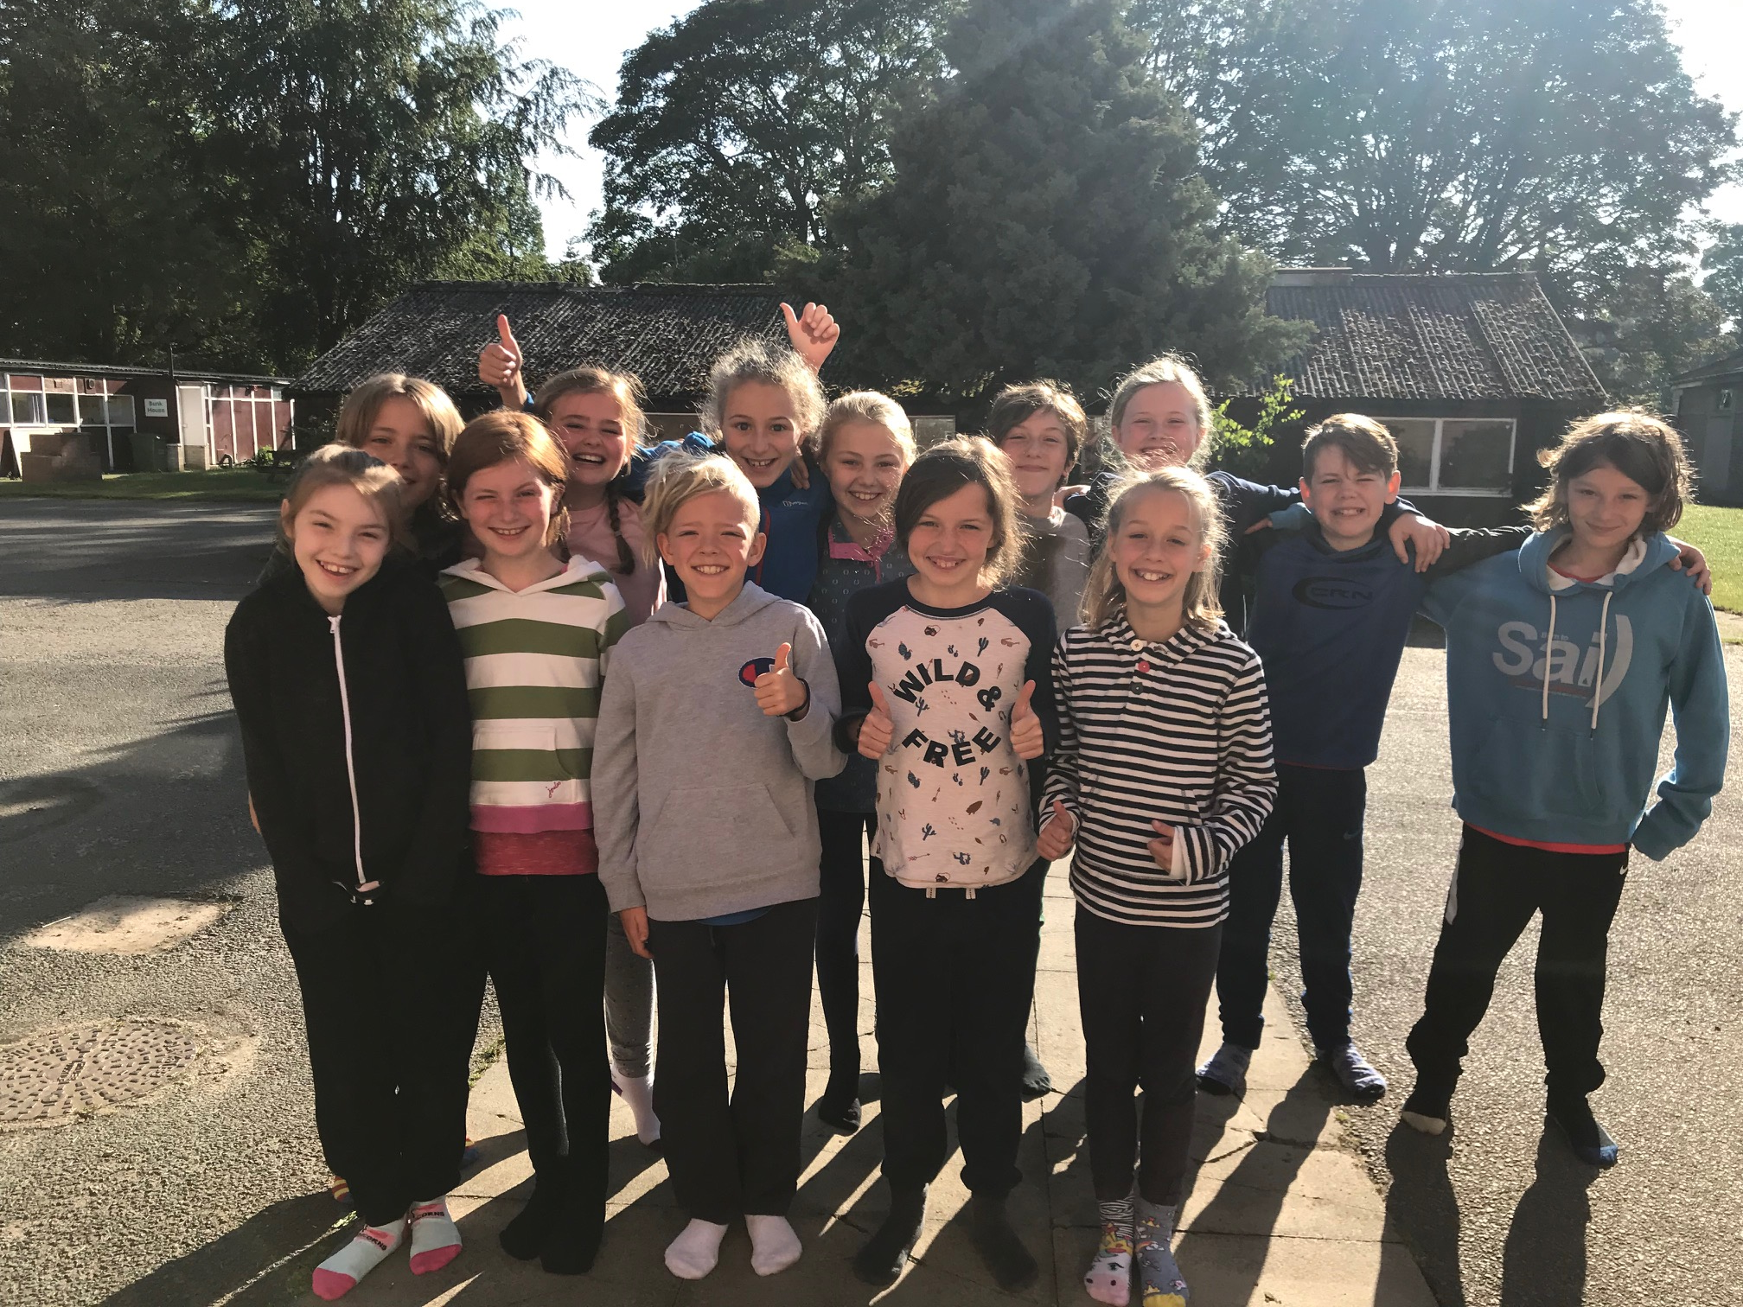

I will be updating the digital photo frame to show a selection of pictures from the visit – please call into school if you would like to view them.

**East Barnby**

I would like to make parents/carers aware that as I am accompanying Crayke's Year 6 pupils to East Barnby next week, there will be no Touch Rugby or Run a Mile clubs. In addition, the next Crayke Chronicle will not be posted until Friday 21st June.

**Where's Church this week?**

**Sunday 9th June - Pentecost! -** 10.30am Holy Communion at Crayke. Come and hear about the Holy Spirit and the birthday of the Church. Also, there's still time to reply about the **Pentecost Party** which is tomorrow 8th June at Brandsby Hall (behind the church) 3-5pm. For children accompanied by their carers/parents. Food - Fun - Activities - Songs Treasure hunt - Prizes – Crafts. With Rev Liz Hassall RSVP 07930 380918 (& to find out more)

Best wishes,

Revd Liz



In Class 1, the children will be able to be acknowledged as Whizz of the week...

**Whizz of the Week**

**Class 1 – Joah Brown**

Each week a child will be selected from our classes to receive the title of *Maths Whizz* of the Week or *English Expert* of the Week. Congratulations to this week’s children...

**Maths Whizz of the Week**

**Class 2 – Maiya Rosa-Keyter**

**Class 3 – Daisy Ritchie**

**Class 4 – All of Year 5 for amazing problem solving whilst at Carlton Lodge.**

**English Expert of the Week**

**Class 2 – Aiden Simpson**

**Class 3 – Marley Walker**

**Class 4 – All of Year 5 for communicating effectively with each other at Carlton Lodge.**

**Team Points**

This week’s winners are:





*At Crayke Church of England Primary School, we have our own news team, 'The Roving Reporters.' The team is made up of children from School Council. The Roving Reporter’s articles will be included in the Crayke Chronicle.*

**Roving Reporters**

**KS1 Swimming Lessons**

On Thursday 6th June, Classes 1 and 2 went swimming. We went to the Thirsk pool but in the little pool. We started by showing what we could do by crossing the pool to the other side. We got to play some games, too. Some children got to cross past each other like sharks. We played a game where you 'catch' the ladies. We had a really fun time and we can't wait for swimming again next week.

By Emma and Ava

You can unsubscribe

CA

