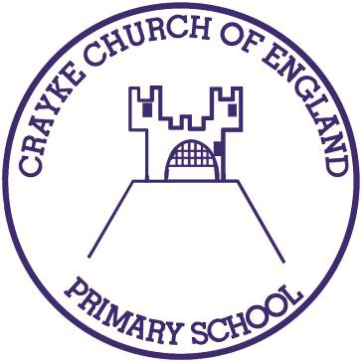

Crayke Church of England Primary School
Easingwold Road
Crayke
North Yorkshire YO61 4TZ
Tel/Fax: 01347 821767
E.mail: admin@crayke.n-yorks.sch.uk
Website: craykeschool.org

Headteacher – Mr. Andrew Buttery BA (HONS), PGCE, NPQH

14/05/2019
Dear Parents and Carers
I am writing to inform you that Mr Buttery will be leaving our school on 31 December 2019. He has been appointed to the headship at Elvington C of E Primary School. I know that he will be leaving Crayke with a heavy heart and we will be sad to lose him. He has given us outstanding service for 5 years and wishes to take up this new challenge for professional and family reasons. As his departure is some time away we will have opportunities at a later date to thank him for all that he has done for our children.

I realise this news may come as a surprise to parents and children. Change can be unsettling and you may be concerned about the effect this will have on your children's education. I would like to reassure parents that the Governing Body is sensitive to this. Your children will continue to have the teachers they expected in the autumn term. We are fortunate in having an excellent staff with a high level of expertise in the school. This will not change.

Governors will begin working with North Yorkshire County Council and the Diocese of York straight away on the process to appoint a new Head Teacher. We want to make an excellent appointment at the earliest opportunity. Although the new head will not take up post until 1 January 2020 there will be plenty of time to prepare for a smooth transfer of leadership.

Crayke is a relatively small school. We have been lucky to have Mr Buttery as our Head. Changes of headship often take place after 3 or 4 years in schools our size. It should be seen as an opportunity to refresh the school's leadership bringing a fresh perspective and new energy. Governors are well aware of the special characteristics of our school and parents can rest assured that we will be seeking an appointment that is in sympathy with our ethos and keeps the best of what we currently have.

Mr Buttery or I will keep you informed of developments. If you would like to discuss this news with myself or other governors please let me know through Mrs Bacon at the school. In the meantime the work of the school will continue as usual and governors will seek out the best possible candidate to lead us into the future.

Yours sincerely,
Hugh Porter
Chair of the Governing Body

