**Crayke Chronicle**

**Thursday 20th December**

2020

**Yellow Team**

**Happy Christmas**

I would like to take the opportunity to thank you for your support throughout this term. I feel that our pupils have worked really hard and made an excellent start to the academic year, both in lessons as well as in the multitude of extra-curricular clubs and activities which have taken place.

I would like to wish all of our pupils, parents, carers and community a restful and happy Christmas, as well as a prosperous New Year.

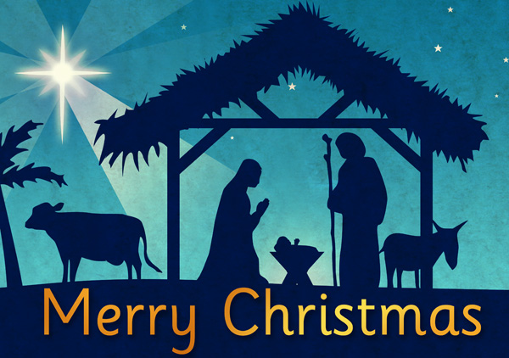

We look forward to starting a successful 2019, when we return for the new term on Tuesday 8th January 2019.

**Carol Service**

Thank you to all of those who attended our Carol Service at the Church of St Cuthbert. The children really enjoyed singing carols and reading a range of poetry.

**School Admissions - Final Reminder**

If you have a child who is due to start school next academic year (i.e. who will be four years old before 1st September 2019) please ensure you have applied for a school place in time. The closing date for first time admission applications is the 15th January 2019 for the September 2019 intake.

All applications are made to the Local Authority; you can apply online at [www.northyorks.gov.uk/apply-primary-or-junior-school-place](http://www.northyorks.gov.uk/apply-primary-or-junior-school-place)

If the aforementioned does not apply to you, please feel to forward this document to anyone you believe could find this information useful.

**Advance Notification/Reminders**

**Young Voices** – Tuesday 8th January

**Senior Citizens Lunch** – Wednesday 9th January (Class 4 to assist and entertain)

**Ancient Britain Day in Class 3** – Monday 14th January

**Anandini Yoga** – alternating weeks for all classes, from Tuesday 15th January to Tuesday 9th April

**Key Stage Two rearranged Cluster Cross County** – Wednesday 16th January

**Where's Church this Christmas?**

There's a wide variety of Christmas services in our villages - everyone is welcome to come. I include here the selection for Crayke, Brandsby and Yearsley. If you live in one of our other villages, you should find  
the details of Christmas services by going to [www.achurchnearyou.com](http://www.achurchnearyou.com/) and putting your village name in the search box. Click through to the calendar to see everything that is happening.

**Sunday 23rd December**  
10.30am Baptism at Brandsby

**Christmas Eve**  
4pm Nativity at Crayke - nativity costumes optional  
11.30pm Midnight Communion at Crayke

**Christmas Day**  
9am Family Holy Communion at Yearsley  
10.30am Family Holy Communion at Brandsby

**Sunday 30th December**  
10.30am Holy Communion at Crayke

Don't forget that the first family service of the year is at Crayke on 6th January at 10.30am. Come and celebrate Epiphany and get ready for the new term.

With best wishes for a very happy Christmas,

Revd Liz

**Team Points**

This half term’s winners are:

