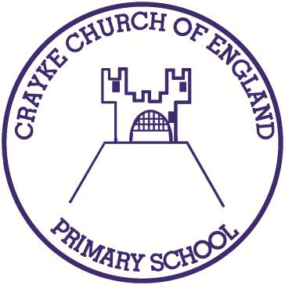

**Crayke Church of England Primary School**

**Easingwold Road**

**Crayke**

**North Yorkshire YO61 4TZ**

Tel/Fax: 01347 821767

E.mail: [admin@crayke.n-yorks.sch.uk](mailto:admin@crayke.n-yorks.sch.uk)

Website: craykeschool.org

**Headteacher – Mr. Andrew Buttery** BA (HONS), PGCE, NPQH

10/10/2018

Dear Parent/Carer,

**The NSPCC’s *Speak out. Stay safe.* programme is visiting our school to make sure our pupils have the knowledge and understanding they need to stay safe.**

I’m pleased to tell you that we will be working with the NSPCC, the UK’s leading children’s charity, who’ll be delivering their ***Speak out. Stay safe.*** programme on Monday 22nd October 2018. This is a nationwide programme for every primary-school-aged child in the UK and Channel Islands. With the help of their friendly mascot Buddy, they’ll be presenting an assembly to the children in our school as well as a workshop for Years 5 and 6.

**"NSPCC has helped me to build the confidence to tell people about my worries and problems." Child’s feedback**

As a charity, the NSPCC can only provide these vital resources thanks to the financial support and generosity of their supporters. Which is why I am delighted to say that our school has chosen to support the valuable work of the NSPCC by taking part in a fundraising event, and I would really value your support and encouragement. More information on how you can support their work will follow their visit to our school.

**What is the *Speak out. Stay safe.* programme?**

Through child-friendly, interactive assemblies and workshops their specially trained staff and volunteers will give our children information about how to keep themselves safe from harm and how to get help if they have any worries, sensitively discussing issues like bullying and sexual abuse, without using scary words or adult language.

We have studied the content of the materials and heard from other schools who have participated and are extremely confident that they are appropriate for primary-school-aged children. By the end of their visit, we’re convinced children will feel empowered – knowing how they can speak out and stay safe.

**“My daughter thought the volunteers were fantastic, really real people, very warm and friendly.” *Sally, Prestatyn***

If you would like any more information about the ***Speak out. Stay safe.*** programme you can come in to speak to me or visit the NSPCC website **nspcc.org.uk/speakout**

**Talking PANTS with your children**

The NSPCC’s work in schools will help encourage conversations about staying safe – and they have a number of child-friendly materials to help you carry on the conversation afterwards. That includes ‘Talk PANTS’, a simple way for parents to help keep children safe from sexual abuse – without using scary words or even mentioning sex.

The guide uses the rules of PANTS to teach children that their body belongs to them and them alone. You can find out more and download the free resources at **nspcc.org.uk/pants**

If you’d like to know more about the NSPCC’s work, or take a look at the wide range of information and advice which is available for parents and carers, please visit their website **nspcc.org.uk/parents**

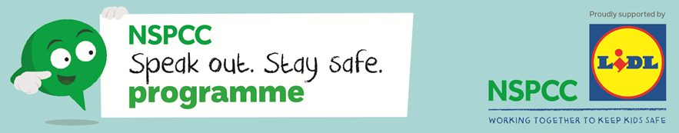

Yours sincerely,



Andrew Buttery

Headteacher