**Crayke Chronicle**

**Friday 5th October**

**Parents’ Evening**

Parent meetings will be held this term on Tuesday 23rd and Thursday 25th October (commencing at 3.50p.m.) I would be grateful if you could place your name against the most appropriate time slot, on the sign-up sheets, which will be outside the office from Monday 8th October.

Class 1’s Parents’ Evening will take place on Thursday 25th October.

**Cluster Football & Netball**

Following the first round of the Cluster football and netball tournaments, I would like to congratulate the participating children. They all played with admirable spirt and conviction; both myself and Mrs. Jackson were very proud of them.

The football team recorded one win from three games; with the netball team recording three draws and one loss…

**Harvest Festival**

I would like to remind you that our Harvest Festival will be taking place at St Cuthbert’s Church on Tuesday 9th October, starting at 2.30pm; as always everyone is welcome…

As you can see the children really enjoyed adding their one and two pence coins to a themed piece of art.

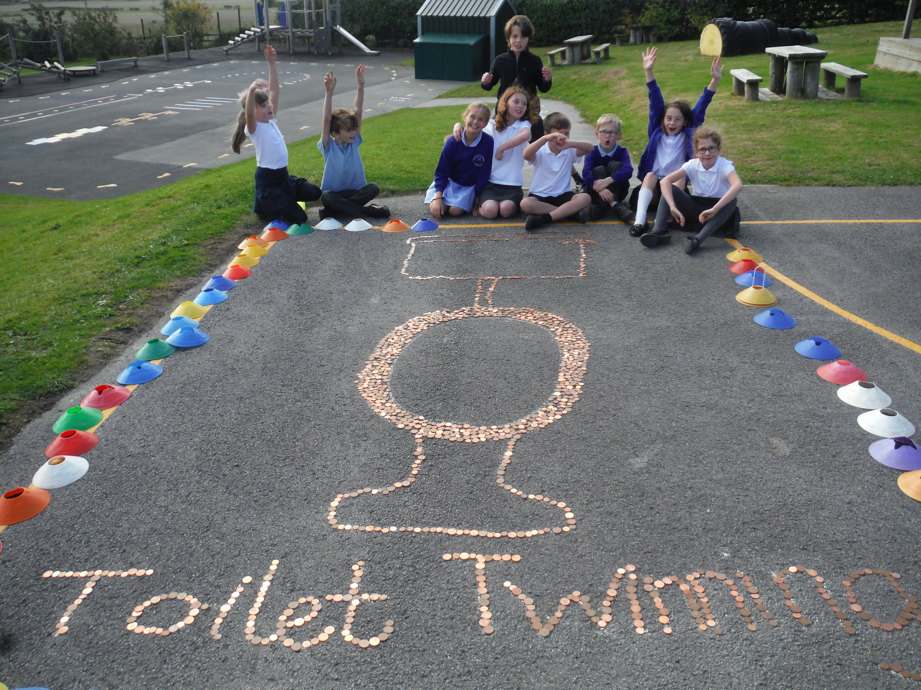

**Where's Church this week?**

**Sunday October 7th**

10.30am Holy Communion at Brandsby  
10.30am Harvest Festival Family Service at Crayke  
6.30pm Discussion and prayer at Husthwaite

For further details about our Harvest Festival at Crayke, please see the separate ‘Where’s Church this week?’ post.

Best wishes,

Revd Liz

**Red Team**



In Class 1, the children will be able to be acknowledged as Whizz of the week...

**Whizz of the Week**

**Class 1 – Sebastian Parris**

Each week a child will be selected from our classes to receive the title of *Maths Whizz* of the Week or *English Expert* of the Week. Congratulations to this week’s children...

**Maths Whizz of the Week**

**Class 2 – Asa Champion**

**Class 3 – William Gilleard**

**Class 4 – Toby Helfferich**

**English Expert of the Week**

**Class 2 – Toms Andersons**

**Class 3 – Edward Lowther**

**Class 4 – Alex Moore**

**Team Points**

This week’s winners are:





*At Crayke Church of England Primary School, we have our own news team, 'The Roving Reporters.' The team is made up of children from School Council. The Roving Reporter’s articles will be included in the Crayke Chronicle.*

**Roving Reporters**

Hello, it’s Georgia and Macy and welcome to our first Roving Report. We’re holding our Harvest Festival next Tuesday afternoon at Church and we’re doing a harvest appeal along with it. We are raising money for a charity called Toilet Twinning and we can’t wait to start!

We have already collected pennies and made an image of a toilet in the school playground. We are also going to run an afterschool Beetle Drive next Thursday. We hope to raise enough money to twin at least 1 toilet. It costs about £60 to fund, but it is worth every penny to make such a massive difference, to people who are struggling without a toilet in their part of the world.

Watch out for our next report. We will let you know how much we will be able to donate…

Your roving reporters,

Georgia and Macy

