

**Crayke Church of England Primary School**

**Easingwold Road**

**Crayke**

**North Yorkshire YO61 4TZ**

Tel/Fax: 01347 821767

E.mail: [admin@crayke.n-yorks.sch.uk](mailto:admin@crayke.n-yorks.sch.uk)

Website: craykeschool.org

**Headteacher – Mr. Andrew Buttery** BA (HONS), PGCE, NPQH

**Supporting Children with Spelling**

Dear Parents and Carers, as you are already aware the government introduced a revised curriculum for all schools to follow. The revised curriculum placed a greater significance on spelling (twenty out of the seventy marks available on the Year 6 SATs Spelling, Grammar & Punctuation assessment are based on spelling).

Learning to spell helps to cement the connection between the letters and their sounds, and learning high-frequency “sight words” to mastery level improves both reading and writing. The correlation between spelling and reading comprehension is high because both depend on a common denominator: proficiency with language. The more deeply and thoroughly a child knows a word, the more likely he or she is to recognise it, spell it, define it, and use it appropriately in speech and writing.

With the aforementioned in mind, from Friday, children in Years 1 to 6 will continue to receive spellings based on a scheme which covers the end of year expectations for each year group. We will continue to differentiate the spellings your child brings home; however, there will be a range of new weekly activities designed to support long term memory retention. For example:

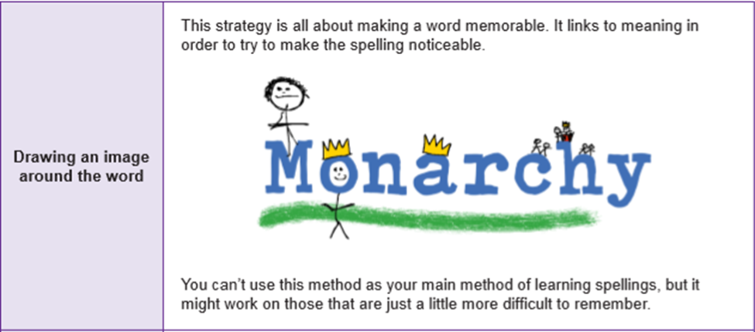

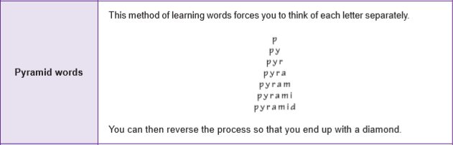

These are just two examples - your child will be aware of what is required each week and will have reviewed/practised the technique in class. They will record their work in a book; with spellings going home on Friday, before being tested the following Friday.

At Crayke Church of England Primary School we are very keen for parents to support and help their children with homework. We take the view that children are likely to get more out of an activity if parents get involved, as long as they do not take over too much. However, there are times when we will want to see what children can do on their own. It is particularly important, as they get older, for children to become increasingly independent in their learning. If a parent is unsure about what their role should be, they should discuss it with their child’s teacher.

If you have any queries or concerns regarding the aforementioned approaches, please arrange to speak to your child’s class teacher and once more thank you in advance for your efforts and encouragement at home. We appreciate that family time is precious, but the learning journey is one that should be a partnership between school and home and those children whose parents become involved in their learning really do make improved progress.

**Here are some additional spelling rules and tips…**

Rules should never be taught in isolation. They must be backed up by practical activities. Most spelling rules have exceptions.

a) Every English word must contain at least one vowel

b) No words in English end in i – we use y instead

c) The letter q is always followed by the letter u (queen; quite, quintissential)

d) The letter j is never used at the end of a word – we use ge instead

e) No complete words ends in v – we use ve instead

f) The doubling rule: words ending in f, l, s or z double the final consonant (stiff, bell, Miss, fuzzy)

**Suffix rules**

i) The lazy ‘e’ rule

Drop the ‘e’ before adding a suffix beginning with a vowel:

like – liked

hate – hating

shake - shaking

ii) The ‘e’ that isn’t being lazy

Keep the ‘e’ before adding a suffix beginning with a consonant

hope-hopeful, hopeless

iii) The lazy ‘e’ meets ‘a’

Keep the ‘e’ in words enidng in ‘ce’ or ‘ge’

orange-orangeade

manage-manageable

iiii) shun endings - There are four different ways of spelling shun – but none are spelt as they sound:

- ssion profession, progression, discussion

- tion prevention, protection, station

- cian musician, electrician

- sion decision, confusion, revision

**Fifteen common word families in English**

|  |  |
| --- | --- |
| **all** | ball call fall hall stall tall wall |
| **ing** | king ring sing wing |
| **ack** | back lack pack rack sack |
| **ay** | bay day hay lay may pay ray say way |
| **at** | bat cat fat hat mat pat rat sat |
| **op** | hop mop pop top |
| **ad** | bad dad had lad mad pad sad |
| **ill** | bill fill gill hill kill mill pill will |
| **in** | bin din fin pin tin sin win |
| **ump** | bump dump hump jump lump pump |
| **ent** | bent dent lent rent lent sent tent went |
| **old** | bold cold fold hold sold told |
| **ook** | book cook hook look took |
| **ell** | bell cell fell hell sell tell well |
| **et** | bet get jet let met pet set wet |

**Eleven more common endings**

|  |  |
| --- | --- |
| **ain** | contain, complain, brain, drain, main, pain, rain, stain, train |
| **augh(t)** | caught, daughter, naughty, slaughter, taught, laugh, laughing |
| **ful** | careful, thoughtful, painful, wonderful, resntful |
| **ight** | bright, fight, fright, light, night, right, sight, slight, tight, |
| **ite** | bite, kite, polite, satellite |
| **ous** | famous, cautious, ambitious, delicious |
| **ough** | although, cough, enough, rough, tough, thorough, though |
| **ow** | blow, follow, grow, low, slow, show, snow, yellow |
| **sion** | comprehension, confusion, decision, revision |
| **tion** | action, attraction, collection, direction, investigation, reaction, station |
| **ture** | capture, creature, fixture, furniture, future, mixture, nature, picture |

**Silent letters**

|  |  |
| --- | --- |
| **Silent letter** | **Common examples** |
| **b** | bomb, comb, crumb, doubt, thumb |
| **c** | descent, discipline, science |
| **g** | design, neighbour, sign |
| **h** | honest, honour, hour |
| **i** | business, marriage, parliament |
| **k** | knee, knife, knight, knock, know, know, knot |
| **l** | chalk, walk |
| **n** | autumn, column |
| **t** | castle, listen, whistle |
| **w** | wrong, wrap, wriggle, write, wrist, wreck, whole |

**Homophones**

|  |  |  |
| --- | --- | --- |
| **Homophones** | **Examples of use** | **Tips** |
| **to, too, two** | * We have two cars. * He is too tired. * Are you coming too? * I go to school. | * Use two when you mean the number 2 * Too: means ‘*more than enough’*, or ‘*as well’* * In all other cases use *‘to’* |
| **there, their, they’re** | * Their dog is fierce * They’re coming over * There is a willow grows askance a brook. | * Remember if there can be a ‘my’ spell their with an i. You can say ‘my house is big’, you can say ‘their house is big’. |
| **here, hear** | * I can’t hear you. * I’m over here. | You h**ear** with your **ear**. |
| **are, our** | * We are going on a trip. * Our class is going to Richmond. | This is a ‘false homophone’. Correct speech distinguishes between the pronunciation of the two words. |
| **one, won** | * I have one sister * They won a prize. | * If you can win it then it has a w. |
| **by, buy, bye** | * I go by car * I must have a new pen * He waved goodbye |  |
| **sea, see** | * I can swim in the sea. * Did you see the boy? |  |
| **meet, meat** | * I will meet you in London. * We had to eat the meat. |  |
| **no, know** | * No you don’t * Oooh I know . . ! | No belongs with yes |
| **wait, weight** | * I will wait here. * Guess the weight of the cake? |  |

**Using mnemonics**

Mnemonic – A device or system for improving memory.

Irregular words cause most trouble to children

|  |  |
| --- | --- |
| **Word** | **Mnemonic** |
| are | **A**re **r**hinos **e**legant |
| beautiful | **B**oys **e**at **a**pples **u**nder **t**ress **i**n **F**rance **u**ntil **l**unch |
| beacuse | **B**ig **e**lephants **c**an **a**lways **u**pset **s**maller **e**lephants |
| believe | Never be**lie**ve a **lie** |
| build | **u** and **i** will build a house |
| busy | This **bus** is **busy** |
| business | Do your **bus**iness in the **bus** |
| could  Same rule for should/would | **O**h **u l**ucky **d**ear or **c**ould **o**ld **u**ncle **l**ie **d**own? |
| does | **D**oes **O**liver **e**at **s**ausages? |
| friend | **i** to the **e**nd will be your friend |
| great | It is gr**eat** to **eat** |
| intelligent | **Tell** the **gent** to come in |
| island | An island **is land** |
| mother | Mother ate a **moth**  The **other** lady was his **mother** |
| piece | Eat a **pie**ce of **pie** |
| present | She **sent** a pre**sent** |
| special | A spe**cia**l agent is someone in the **CIA** |
| sure | **S**ave **u**p **r**ed **e**lephants |
| Wednesday | **Nes** was **wed** on **Wednes**day |

Yours sincerely,



Andrew Buttery

Headteacher