SMSC and Fundamental British Values evidence for Crayke Church of England Primary School 2017–18
Event, details & photographs… | SOCIAL |  |  |  | MORAL |  |  |  |  | SPIRITUAL |  |  |  |  | CULTURAL
 | Developing personal qualities & using social skills | Participating, co-operating and resolving conflicts | Understanding how communities and societies function | Develop an understanding of the Fundamental British Values of democracy and the rule of law. | Developing and expressing personal views or values | Moral codes and models of moral virtue | Recognising right and wrong and applying it | Understanding the consequences of actions | Investigating moral values and ethical issues | Developing personal values and beliefs | Experiencing fascination, awe and wonder | Exploring and respecting the values and beliefs of others | Understanding human emotions and feelings | Using imagination and creativity in learning | Exploring, understanding and respecting diversity | Participating in and responding to cultural activities | Understanding and appreciating personal influences
Church Service: Harvest Festival -  Pupils looked at a range of different issues effecting people in our local area and brought food based donations into school to support our local food bank. |  | * |  |  |  | * |  |  | * | * | * | * |  | * | * | *
Church Service: Christmas  All children celebrated Christmas through performing poems and singing carols at the Church of St Cuthbert in Crayke.  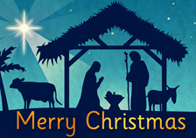 |  |  |  |  | * |  |  |  |  | * | * |  | * | *
Minster FM Toy Appeal  Please see website for more information.  http://www.craykeschool.org/2016/minster-fm-toy-appeal-2/ | * | * |  |  | * | * |  | * |  |  | * |  |  | *
Class 2 R.E Topic – Creation  We read and re-enacted the creation story. We thought about how God would want us to live in the world he created and made rules for this. We wrote harvest prayers of thanks to God for all that he gave to us and all that he does for us. | * |  |  |  | * |  | * | * |  | * | * | * | * | *
Class 2 R.E Topic – The Lost Son  We looked at a picture from the story of the lost son and discussed what the story could be about. We read the story and thought about the message of forgiveness. We related this back to our own lives. | * |  | * |  | * | * | * | * |  | * |  | * | *
R.E day:  Tree of hope  As part of our R.E day, children across the school thought carefully about their hopes for the future. Children in reception considered hopes for their own future, whilst Class 2 thought about friends, family and our school. Children in Class 3 and 4 thought about their hopes for Great Britain and the wider world.  We also discussed decorating trees in different cultures around the world. | * |  | * |  | * |  |  |  |  | * |  | * |  | * | * | * | *
R.E day:  Christingles  All children in school, made a Christingle ready for our Christingle service at the end of the day. We thought about how the different parts of the Christingle represented Jesus and God. | *` | * |  |  |  |  |  |  |  | * | * | * | * | * | * |  | *
R.E day:  Remembering Stones:  All children thought of someone or something they would like to remember. They designed a stone to show this. The stones will be diaplayed in the school grounds. | * |  |  |  | * |  |  |  |  | * |  | * | * | *
R.E day:  BIG questions:  As part of our RE Day , children worked in mixed aged groups, asking questions of our faith visitors.  http://www.craykeschool.org/2018/re-day/ |  | * |  |  |  | * |  |  | * | * | * | * |  | * | * | *
Class 3 – Joseph Rowntree Project  As part of Class 3’s history topic ‘York’s Chocolate History,’ the children have been researching one of York’s founding chocolatiers, Joseph Rowntree. They learnt about his Quaker faith, how he bought land for New Earswick to be built for his workers and was one of the first to provide health care and pensions for his employees. They researched his development of a community in New Earswick, building schools, communal meeting places and protected green spaces.  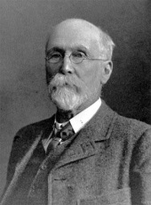 |  |  | * | * |  | * |  |  | * |  |  | * | * | * | *
Class 4 Young Leaders Award –  Through studying a number of people of faith who have helped change the world for the better, pupils reflected on how belief informs a person’s perspective on life and how it can inspire them to action. Students continually learnt about themselves through the award, identifying strengths and weaknesses and increasing their personal development as they grow in leadership skills through Archie’s challenges.  Pupils learnt about their local community and the world around them and were encouraged to be creative and imaginative in the ways in which they completed Archie’s challenges – thinking about how they can serve their community and bring about change for the better. Through their evidence scrap book the students reflect on their experiences, in particular the active citizenship aspect of the award.  Through researching a number of people of faith and charitable organisations who stand up against injustice in the world, students learn about issues of right and wrong and are able to think about this in relation to their own lives. Furthermore, the pupils become ambassadors for local charities and inevitably investigate moral and ethical issues relating to their work, in turn applying these issues of justice to their own thoughts and decisions. Through Archie’s challenges the pupils learn to work in teams, dealing with any mistakes and understanding the consequences of their actions. | * | * | * | * | * | * | * | * | * | * | * | * | * | * | * | * | *
As schools and students take on the community action projects involved in the award, opportunities can arise for them to work with people and pupils from different religious, ethnic and socio-economic backgrounds. Students learn to cooperate well with others and come up with ideas for serving the various communities in their local area.

The award explores the varying levels of community in our lives and includes case studies and practical tasks, through Archie’s challenges, relating to each one. Throughout the award the pupils are involved in community projects which function on a school, local, national and even international level, to help bring about change for the better.

The Awards focus on exploring and understanding community at a local, national and international level and encourages students to engage in community action projects. As they do this they celebrate diversity in the way they serve people from different religious, ethnic and socio-economic backgrounds.

Class 4 RE Topic: How and why do Christians, Muslims and Hindus see life like a journey?  KEY QUESTION: What does a journey mean to us?  Can I identify a way in which life is like a journey?  Can I begin to identify the impact chosen journeys have on ourselves and others?  KEY QUESTION: What journey will a Muslim like to take once in his / her lifetime??  Can I suggest simple meanings for the Five Pillars for Muslim believers?  Can I retell events of the Aqiqah ceremony?  KEY QUESTION: What journey will a Muslim like to take once in his / her lifetime??  Can I ask important questions about the joining of two people and their families in marriage?  KEY QUESTION: What journey will a Hindu take in his/her lifetime?  Can I ask questions and suggest answers about the beliefs of life for Hindus?  Can I describe the concept of a person being reincarnated?  KEY QUESTION: What 4 stages of life do Hindu people remember and celebrate?  Can I identify that there are 4 ‘Ashramas’ throughout a Hindu life?  Can I understand the role of the family in Hindu life and daily worship? | * |  | * |  | * |  |  | * | * | * | * | * | * | * | * | * | *
Biennial Diocesan visit to York Minster.  Class 4 visited the learning centre and the Minster to learn about its history and influence. We were inspired to write poems after our visit.  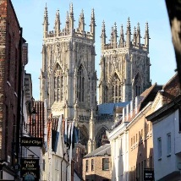 | * |  | * | * | * | * |  | * | * | * | * | * | * | * | * | * | *
Macmillan coffee afternoon  Class 4 ran a coffee afternoon to raise money for Macmillan. This was or community event for our Archbishop of York Young Leaders project. | * | * |  |  | * |  |  | * | * | * |  |  | * |  |  |  | *
Children in Need stalls:  Class 4 ran Children in Need stalls (all organised, promoted and resourced by themselves) to money for Children in Need. This was or charity event for our Archbishop of York Young Leaders project.  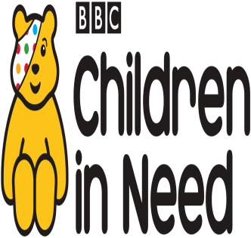 | * | * |  |  | * |  |  | * | * | * |  |  | * |  |  |  | *
Class 4 SMSC topic: The Rule of Law  We have been learning about the Rule of Law by exploring the British justice system and thinking about fairness and law through a story called ‘All at Sea’  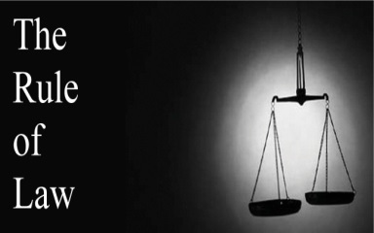 |  | * | * | * | * | * | * | * | * | * |  |  | * |  | * |  | *
Autumn Term RE – What and how do we celebrate? Pupils discussed celebrations and traditions that were meaningful to them and we held our own class celebration. We visited the local church to witness a ‘baptism ‘ and compared it to a Sikh naming ceremony. |  |  | * |  | * |  |  |  |  | * |  | * | * |  | * | * | *
Remembrance day Pupils made poppies and participated in the school’s two minutes silence.  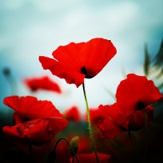 |  |  |  | * |  |  |  |  |  |  |  | * | * |  |  | *
Antibullying week Pupils thought about their own friendships and how they can be good friends  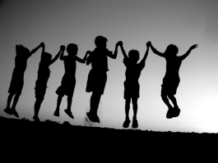 | * | * | * |  | * | * | * | * | * | * |  | * | * |  | *
Circle time- Class Collective Worship We discuss issues that have come up during the week, what is fair and unfair and how we feel about it | * | * | * | * | * | * | * | * | * | * |  | * | * |  | *
Forest Schools In Forest Schools activities pupils are required to cooperate and abide by simple safety rules. Our beautiful school grounds and setting help them to be inspired by the natural world.  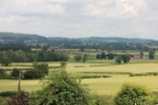 | * | * |  | * |  |  | * | * |  |  | * |  |  | *
EYFS Curriculum Expressive Arts and Design Pupils are given opportunities to respond imaginatively and creatively to a range of activities and experiences  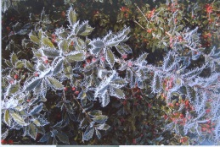 |  |  |  |  | * |  |  |  |  |  | * |  | * | *
EYFS Curriculum Personal, social and emotional awareness Developing pupils’ sense of themselves and others as moral and responsible people runs through all learning and relationships in Class 1. No opportunity is wasted.  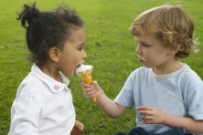 | * | * | * | * | * | * | * | * | * | * |  | * | * | * | * | * | *
Christmas nativity Classes 1 and 2 joined together to perform the school’s nativity.  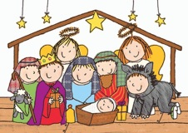 | * | * |  |  |  |  |  |  |  |  |  | * | * | * | * | *
Spring Term RE What makes a place special? Starting with our own special places we thought of what makes religious buildings special to people of all faiths.  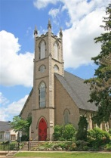 |  |  | * |  | * |  |  |  |  |  |  | * |  |  | *
Church Service: Easter  Crayke pupils celebrated the resurrection of Jesus through exploring bible readings, poems, prayer and song.  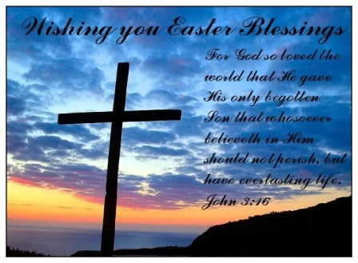 | * |  |  |  | * | * | * | * | * | * | * | * | * | * | *
Class 3: Martin Luther King  Inspired by the Bible reference BLESSED are the peacemakers, for they will be called children of God.  Matthew 5:9.  Children in Class 3 looked at the life of Martin Luther King.  Following this they imagined they had the power to make a decision for the world. They thought about what they would change to benefit mankind.                              

