**Crayke Chronicle**

**Friday 19th May**

**Red Team**

**SATs**

Well done to the children in Class 2 who have completed their SATs this week. Despite the challenging nature of the assessments, all of the children remained focused and applied a huge amount of effort – well done!

**Mrs. Forshaw & Mrs. Smith**

It is with great sadness, that I am informing you about the departure of two long serving members of staff. Mrs. Forshaw and her family are relocating to Scotland over the summer. Mrs. Smith will be leaving us after 20 years of exemplary service. Both will be sadly missed by all those associated with our school, when they leave Crayke at the end of the summer term.

**Summer Production – Treasure Island**

Class 4 found out this week that their production will be a modified musical version of Robert Louis Stevenson’s Treasure Island. The children already have a detailed understanding of the plot, and have started to learn the songs, in preparation for the performances in the final week of the summer term.

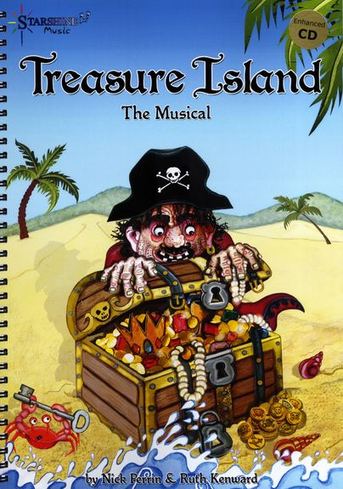

**Where's Church this week?**

**Sunday 21st May**

10.30am Morning Service at Brandsby. All welcome.

If you want to go a little further afield, there is an All-age service at Carlton Husthwaite, also at 10.30am.

Best wishes,

Revd Liz



In Class 1, the children will be able to be acknowledged as Whizz of the week...

**Whizz of the Week**

**Class 1 – Harry Shepherd**

Each week a child will be selected from our classes to receive the title of *Maths Whizz* of the Week or *English Expert* of the Week. Congratulations to this week’s children...

**Maths Whizz of the Week**

**Class 2 – All of Year 2**

**Class 3 – Isabella Hill**

**Class 4 – Lipxin Tang**

**English Expert of the Week**

**Class 2 – All of Year 2**

**Class 3 – Oscar Ashworth**

**Class 4 – Oakes Ellis**

**Team Points**

This week’s winners are:





*At Crayke Church of England Primary School, we have our own news team, 'The Roving Reporters.' The team is made up of children from School Council. The Roving Reporter’s articles will be included in the Crayke Chronicle.*

**Roving Reporters**

**Saplings Update**

In School Council, we went to check on the saplings that we planted earlier in the year. They are doing really well, although a few of them look like the rabbits have managed to nibble them despite the tree protectors. One of them has nearly grown up to the top of the cane that is holding the sapling up! We all got to take a picture on Mrs Rayner’s purple camera. We were surprised by the size and healthiness of most of the saplings. Their leaves were really green and healthy.

**By Betty, Mani, Dominic, Abi, Ellenor and Emily.**

