**Crayke Chronicle**

**Friday 3rd March**

**Blue Team**

**World Book Day at Crayke**

As you can see from the photograph below the children and staff really enjoyed getting into the spirit of World Book Day. I would like to thank parents and carers for helping to assemble the costumes (although hopefully easier to arrange than in recent years).

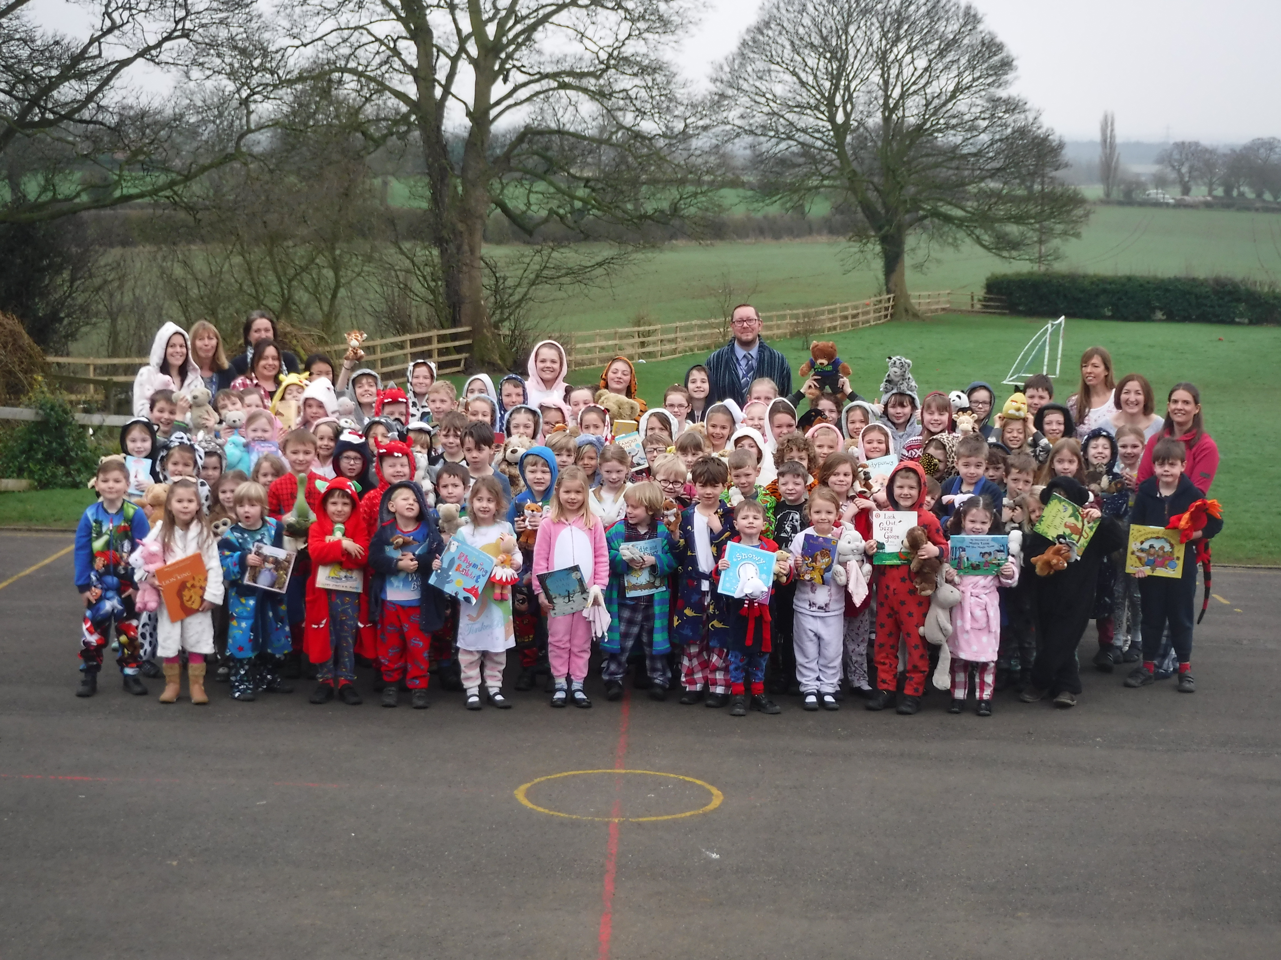

**Terrific Scientific in Class Four**

Children in Class Four completed an investigation to establish if hard or soft water has an impact on the Mpemba effect, whereby hot water is sometimes observed to freeze faster than cool water.

Our results were submitted to the University of Southampton; the outcomes surprised lots of the children.

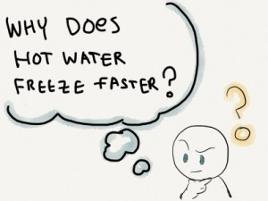

**Forthcoming Meetings**

Following the letter explaining Confederation arrangements from September, a meeting will be held at 6pm on Monday 6th March.

I will be running an information evening for parents/carers on Thursday 9th March at 6pm. As part of the evening I will be covering a range of internet based topics, which will be linked to the theme of keeping your children safe online.

**Where's Church this week?**

**Sunday March 5th 2017**

It's family service time again. 10.30am at St Cuthbert, Crayke. Come and discover what it really means when we pray 'lead us not into temptation'. Drinks and snacks from 10.30am, followed by the service, which lasts about 40 minutes.

Also - 10.30am Holy Communion at All Saints, Brandsby.

Best wishes,

Revd Liz



In Class 1, the children will be able to be acknowledged as Whizz of the week...

**Whizz of the Week**

**Class 1 – Sebastian Hindley**

Each week a child will be selected from our classes to receive the title of *Maths Whizz* of the Week or *English Expert* of the Week. Congratulations to this week’s children...

**Maths Whizz of the Week**

**Class 2 – Olivia Young**

**Class 3 – Nancy Bramall-Smith**

**Class 4 – Amy Helfferich**

**English Expert of the Week**

**Class 2 – Sein Tomkinson**

**Class 3 – Abi Walsh**

**Class 4 – Jack Redshaw**

**Team Points**

This week’s winners are:





*At Crayke Church of England Primary School, we have our own news team, 'The Roving Reporters.' The team is made up of children from School Council. The Roving Reporter’s articles will be included in the Crayke Chronicle.*

**Roving Reporters**

We are leading our school to achieve the Green Tree Schools Award. We are excited to tell you that we have earned our ‘Bronze Award’ by doing the following things:

**Recycling Christmas Cards**

Thank you to everyone who brought in Christmas cards because this has earned us a point towards the award, whilst helping to look after the environment.

T**he Man Who Planted Trees Assembly**

Mrs Rayner did an assembly before Christmas, from the Woodland Trust. She told us a story about a kind man who transformed his local environment by planting acorns. This earned us two points towards the award.

**Free Trees**

Last year, we applied to the Woodland Trust for some free hedging trees. We are very excited about receiving trees, which will be going on our school field along the wooden fence. This will help the environment as well as providing shade for us and a habitat for wildlife. This has earned us two more points towards our Green Tree Schools Award and will change our playground forever.

Our next aim is to get the silver award. To do this, we are going to:

• Reduce our CO2 emissions by creating posters that remind people to turn the lights off when they have finished with them.

• Set woodland themed homework, encouraging us to visit a wood and write a poem or write about what you did.

• Class 3 are going to write fantasy stories, using woodland as a setting.

After that, we will be aiming for the gold and platinum awards!

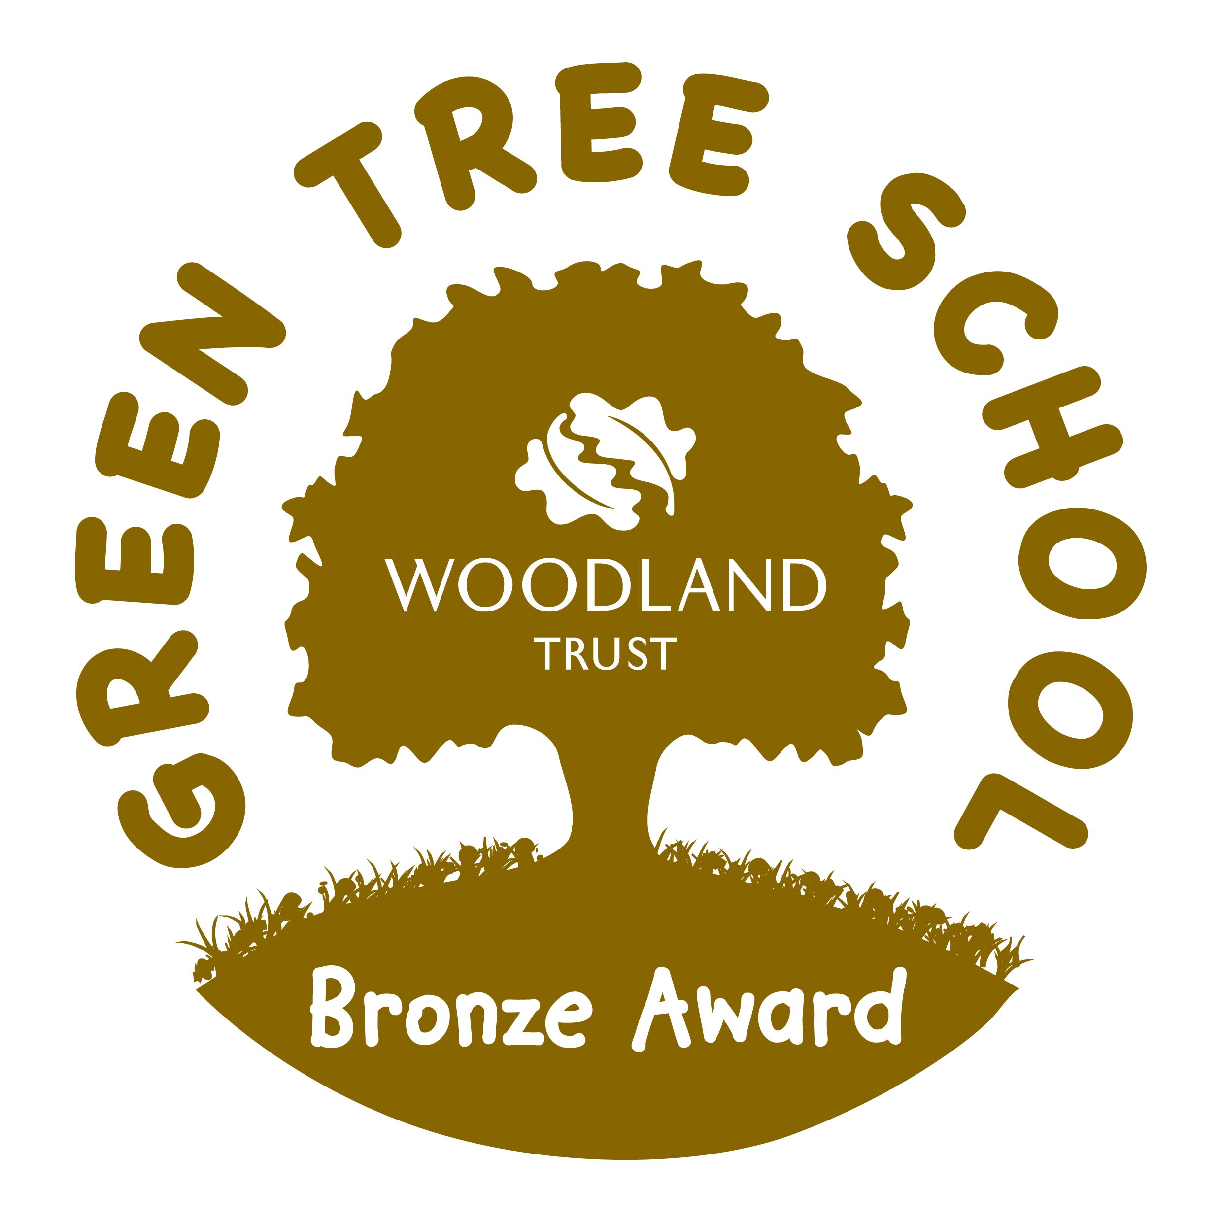

By Alexa, Emily, Gaby, Abi, Ellenor, Mani, Dominic, Betty and Marley.