Class 4 Homework Spring Term (2nd half)
Weekly activities: Spelling activities, independent reading (25-30 minutes each night recorded in reading diaries), multiplication tables and maths activity.

What are the Saint’s Days for England, Scotland, Wales and Ireland?  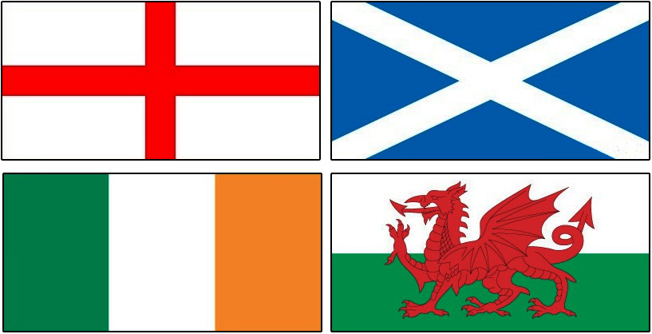  Do some research and present your findings in any way you wish! E.g. factfile, pictorial representation of findings, write a song, record your findings, use craft material!?  YOU CHOOSE!  (To be completed by 16th March) |   Tell me about your favourite film!  Who is in it? What happens? Why do you love it? How does it make you feel? | 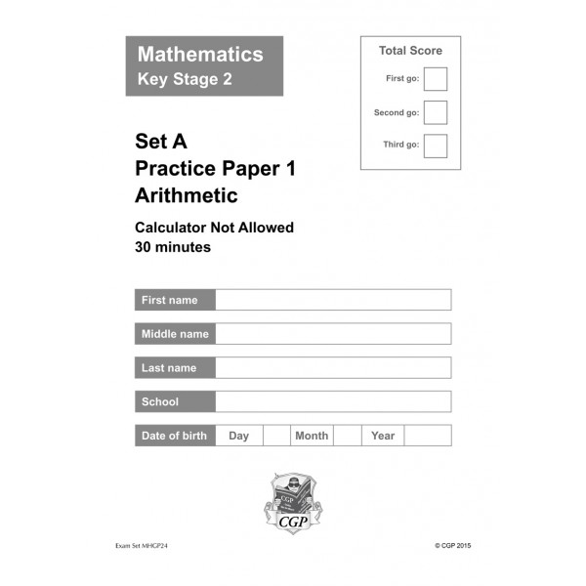Year 6: 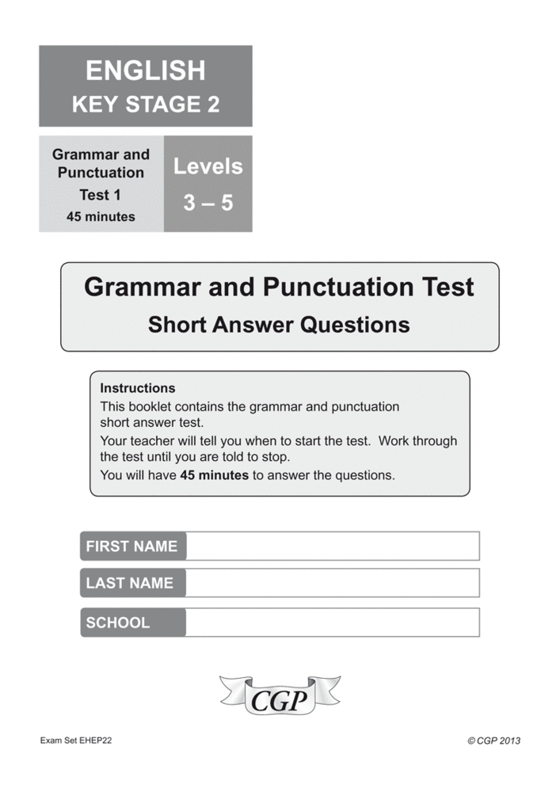  Continue to complete your CGP papers.  Class 4:  Continue to learn your spellings, practise your times tables and read regularly. I know you’re all busy but this is really important!  (ONGOING)
Easter Around the World  Reading Comprehension    Complete the comprehension activity.  (To be completed by 27th March) | Family Activity:  Look for the first signs of Spring e.g. buds, snowdrops, crocuses.    How can you record these first signs of Spring?  Do some observational drawings?  Write some poetry?  Take some photographs?  Or maybe something different?  YOU CHOOSE! | On a piece of A4 I would like you to design an image to represent one of the 'fundamental British values':  - democracy  - the rule of law  - individual liberty  - mutual respect  You can use a method of your choice but please don’t stick your finished work in your homework book.  (To be completed by 3rd April)
 http://www.meaningfulchocolate.co.uk/
Competition Details
We would like children to draw their version of what happened on Easter Sunday according to the Bible. They could also use a short quotation from the Gospel in their design. It has to be on A4 and entries need to be with us by 17th March.
The Real Easter Egg is all about sharing the Easter story so we would be fascinated to see how young people visualise what happened that first Easter Sunday. There will be a prize of £250 for the winning primary school, secondary school and Sunday school or Messy Church with runners-up prizes of £150 for second placed entries.
Entry Details
All entries must be completed on A4 paper.
On the back of each entry you need to indicate the name of child, age, school or church and a contact number.
Entries should be sent to:
MCC Basement Suite, 11a Eagle Brow, Lymm, Cheshire, WA13 0LP
….and must arrive by 5pm on Friday 17th March 2017.
We regret thatwe will be unable to return posters or to receive entries via email.
The competition is open to all children but limited to one entry per person.

***IF ENTERING, PLEASE SEND ENTRIES DIRECT TO THE ABOVE ADDRESS RATHER THAN THROUGH SCHOOL***

