Crayke Church of England Primary School
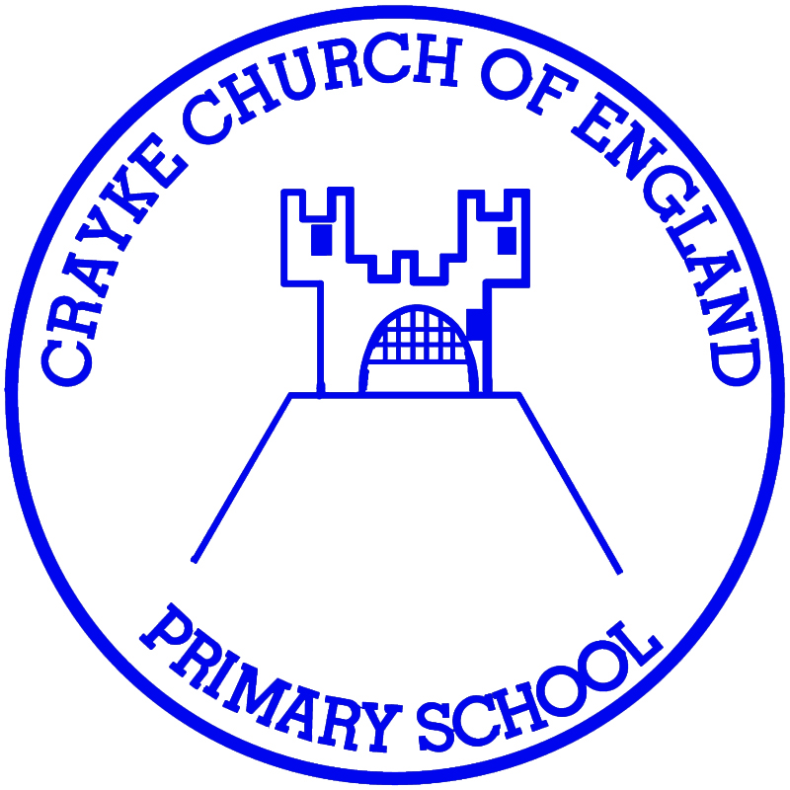
Easingwold Road
Crayke
North Yorkshire YO61 4TZ
Tel/Fax: 01347 821767
E.mail: admin@crayke.n-yorks.sch.uk
Website: craykeschool.org

HEADTEACHER – Mr. Andrew Buttery

Annual Report for the Year ended 31st March 2016

The Crayke Church of England School Fund is governed by a Constitution and is a registered charity no. 1051985. Its address is at Crayke Church of England Primary School, Easingwold Road, Crayke. YO61 4TZ. The charity trustees during the year to 31st March 2016 were the governors of the school (some of whom left/joined throughout the year), namely

Mrs. Lesley Hartley Chair
Mr. Dean Fielding Vice Chair
Mr. Hugh Porter Vice Chair
Mr. Norman Jackson
Rev. Liz Hassall
Mrs. Fiona Warriner
Mrs. Ann Chappell
Mr. M. Pepper
Mrs. Sharon McBroom
Mr. Paul Reid
Mrs. Heather Ellerker
Mr. Daniel Curtois
Mr. Andrew Buttery
Mrs. Aniko Sheppard

The object of the fund is to advance the education of the pupils of the school by providing or assisting the provision of education, recreational and other charitable facilities in augmentation of such facilities financed by the Local Authority.

During the year the main activities of the fund were school trips, the sale of sweatshirts and visitors to the school.

The school fund has no restricted funds.

Hugh Porter - Chair
23rd November 2016
on behalf of the Board of Governors

CRAYKE CHURCH OF ENGLAND SCHOOL FUND

Income and Expenditure for
April 2015 – March 2016

Income 2015/16 2014/15
Petty Cash 226.07 110.00
School Trips 1154.00 1248.66
Residential Trips 2443.25 4932.50
Sweatshirts 1485.80 1386.50
Photographs 127.42 206.20
Donations 2703.48 640.70
Swimming 658.50 1176.50
Fairtrade ----- 842.07
CHASA 905.50 1485.18 9704.02 12028.31

Expenditure

Petty Cash 1051.53 771.77 Sweatshirts 1241.74 1365.71
Books 312.25 194.57
Donations 739.86 200.50
Swimming 190.00 520.00
Visitors to School 125.70 126.90
Fairtrade ----- 547.51
Sponsorship ----- 273.60
CHASA 405.50 910.65
9353.83 13561.46

Excess of Income over Expenditure - £350.19

