7th November 2016

Dear Parent or Carer

Many of the local primary schools have kindly agreed to host a meeting at their schools on various dates and times for parents and children who are considering Easingwold School as their choice of secondary school. It will be an opportunity for us to meet parents and children and enable them to ask any questions they might have about the school and the transition process. The venues, dates and times are shown below. Please feel free to attend any of the meetings, it does not necessarily need to be your child’s primary school venue which you attend. The meetings will last approximately an hour.

Date | Day | Time | Venue
14th Nov | Mon | 4.30pm | Huby C of E Primary School
15th Nov | Tues | 4.30pm | Stillington Community Primary School
15th Nov | Tues | 6pm | Easingwold Community School
22nd Nov | Tues | 4.30pm | St Peters Primary School, Brafferton
22nd Nov | Tues | 6pm | Alne Primary School
23rd Nov | Wed | 6pm | Linton on Ouse Primary School
28th Nov | Mon | 6pm | Forest of Galtres Primary School, Shipton
29th Nov | Tues | 6pm | Crayke C of E Primary School

The format of the meeting will be question and answer rather than a formal presentation and either Mr R A Pritchard (Interim Executive Headteacher) or Mr P Brockwell (Interim Headteacher) will be attending with me. We will hopefully have with us some pupils who recently joined us from your primary schools to help us to answer your questions and provide a different perspective on the school.

Parents and their children from any year group are welcome, although the evening is likely to be of most relevance to those in Year 6.

We hope you can make it and look forward to meeting you.

Yours sincerely
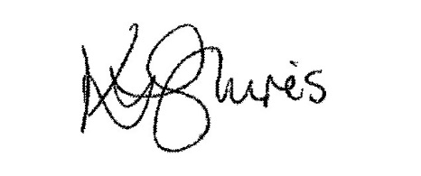

Mrs Karen Shires
Associate Senior Leader Transition

