**Crayke Chronicle**

**Friday 9th September**

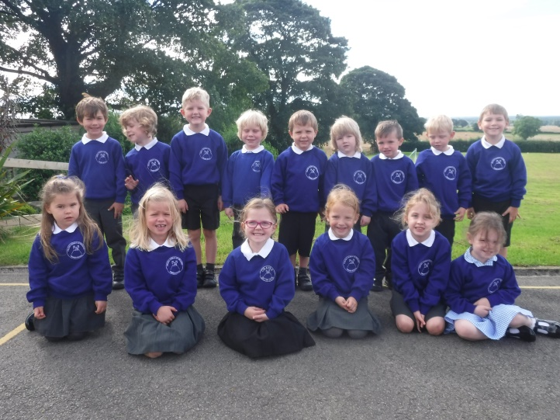

**New starters**

**Autumn term**

Firstly, I would like to welcome the students and staff back for the new academic year. I hope that you have all had restful and enjoyable holidays and are looking forward to another school year which I am sure will be successful and exciting for all. We also give a warm welcome to our 15 pupils joining us in Class One.

**Newsletters**

Weekly newsletters (Crayke Chronicle) will be added to the school website to keep parents informed about what is going on at school. Newsletters will come out on a Friday so don’t forget to check the website and subscribe to receive updates.

**School contact details**

If you need to contact the school office Mrs. Bacon is available on 01347 821767. The office can also be reached by email on [admin@crayke.n-yorks.sch.uk](mailto:admin@crayke.n-yorks.sch.uk).

**Pupil absence**

If your child is unable to come into school please can you contact the school office, either by telephone, letter or in person on the first day of absence. Registers are checked twice a day and the school office will contact any parent where there is an unexplained absence for a pupil. If you know your child will be absent at a future date e.g. hospital appointment, please can the request for absence be given to the school office and not to the class teacher.

**CHASA**

Our Friends association (CHASA) do a wonderful job of providing a range of enjoyable social events throughout the year as well as providing valuable additional funds that are spent on resources for your children. Please continue to support CHASA this year; it would be wonderful to have a large turnout at their meeting on Tuesday 13th September at 7.30pm. The meeting will be held at school. If you have never been to a meeting please consider coming along.

**Midday Supervisory Assistant**

We currently have a vacancy for the position of midday supervisor at our school. At present the role would involve working from 12pm to 1pm, Monday to Friday (term time only). For further details please contact the school office.

**Contacting the Headteacher**

If you would like to contact me directly, my non-teaching days are Wednesday, Thursday & Friday. Alternatively, I can be reached by email on [headteacher@crayke.n-yorks.sch.uk](mailto:headteacher@crayke.n-yorks.sch.uk).

**Jeans for Genes Day**

On Friday, 23rd September, it is the annual Jeans for Genes day. Children should wear their normal school uniform on top, i.e. t-shirt and sweatshirt, but they may wear their jeans to school for a suggested donation of £1.



For more information on this ground-breaking charity please visit [www.jeansforgenesday.org/](http://www.jeansforgenesday.org/)

**Curriculum Information**

Thanks to generous support from CHASA, all children will have access to specialised French teaching. *Le Club Francais* will work throughout all our classes (on a Friday afternoon).

Children in Classes Three & Four will have alternating ukulele lessons throughout 2016/17. Mr. Hills (a music specialist) will bring a selection of ukuleles with him. However, it would be wonderful if the children could have their own instruments. This would allow them to practice between lessons – ukuleles can be purchased from Amazon for as little as £14.00.

Children in Classes One & Two will work with Mrs. Halliday (a music specialist), on Monday afternoons. Mrs. Halliday will also work with Mrs. Sheppard to run Young Voices.

**Where's Church this week?**

Welcome back after the summer. For those of you who are new to the school, as a Church of England school, one of the ways we try to maintain links between the school and the local community is by publicising the times and venues of the local church services each week.

Everyone is welcome to our services, whether it is the village you live in or another one. I’ll try and flag up which services are particularly aimed at children, but all ages are welcome at all our services.

**Sunday 11th September**

10.30am Holy Communion at Byland Abbey

This week we have something a little different: an outdoor service at Byland Abbey (between Coxwold and Wass). Do come along – it is a fabulous setting.

Best wishes,

Revd Liz

Rector of Crayke, Brandsby, Yearsley, Coxwold, Husthwaite, Carlton Husthwaite and Wass