Class 3 Homework Autumn Term (1st half)
Weekly activities: Spelling practice, independent reading (10-15 minutes each night recorded in home/school record),
multiplication and division facts practice and maths activity.
History  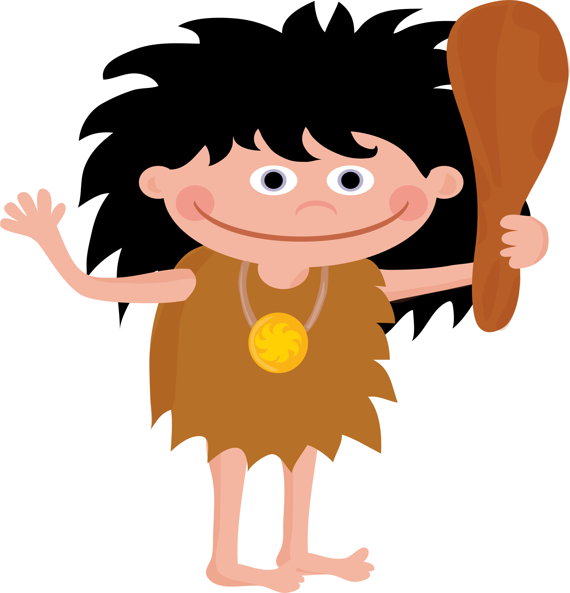  Research Stone Age, Bronze Age or Iron Age clothing in Ancient Britain. Present your findings neatly in your homework book.  Research due: Friday 16th September.  Then plan and prepare an outfit to wear on our special ‘Ancient Britain’ day in school after half term, from one of these time periods.  You can download a helpful ideas sheet from our class page gallery on DB Primary.  Ancient Britain Day: Friday 11th November. | Creative Task  Make an edible stone henge! Put the recipe for your delicious creation, and some photos of you creating it, in your homework book.  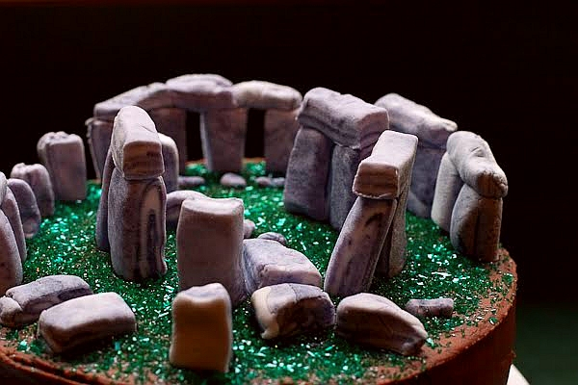  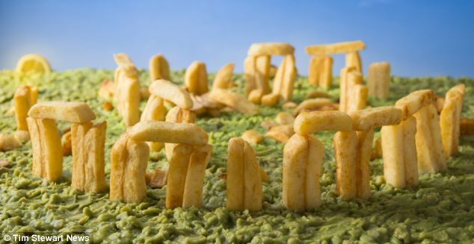  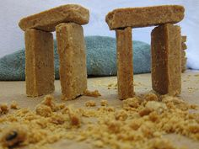 |   English  Begin your 100 books reading challenge!  Tick off any books that you have already read, in one colour (use a key to show which these are.) Then, see how many other books from the list you can read this year. You can recommend those and other books, on our ‘Reading Corner’ forum on DB Primary. Remember to keep reading your books from school, too!  (Ongoing)
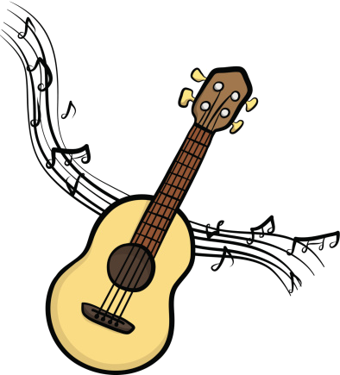  Music  Practise your ukulele skills at home.  (Ongoing this term) | Family Activity    Visit a historical site such as a castle, abbey or ancient monument and find out about its history. Put photos and information in your homework book. |   Blogging  Get on DB Primary and get blogging! Think about the audience and purpose of your blog, making it interesting. Once you’ve started, keep it up!  First blog-entry due: Friday 30th September.
Explore a Cave  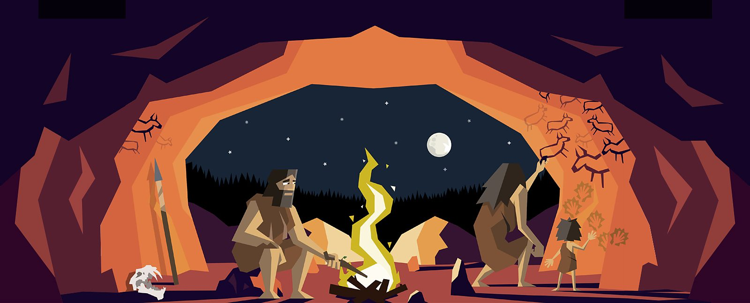  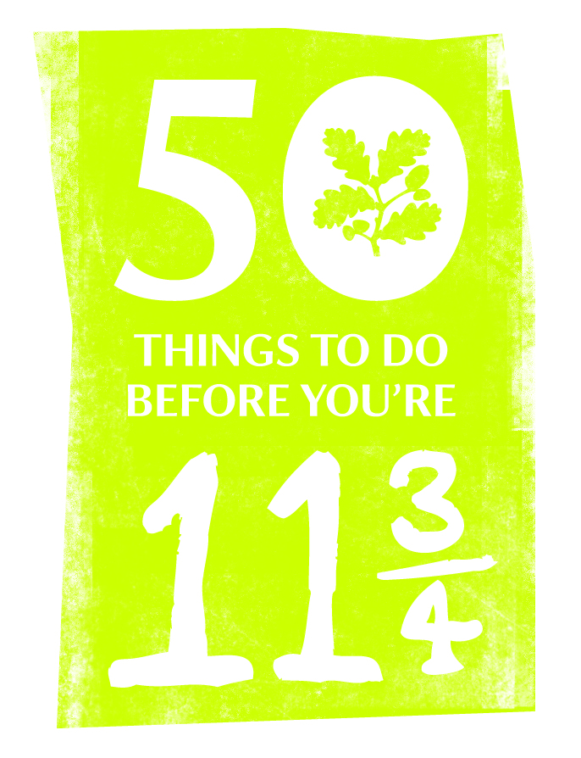  (Taken from 50 things to do before you're 11¾ from the National Trust). |   Mathletics  How many Mathletics certificates can you achieve before half term?  If you can, print them off and bring them in.  Please let me know when you have achieved a certificate. | Get Active!    Show me what physical activity you enjoy doing, that gets your heart-rate up. You could take photos, draw pictures and /or write about your physical activity in your homework book.

