PLEASE HELP!!
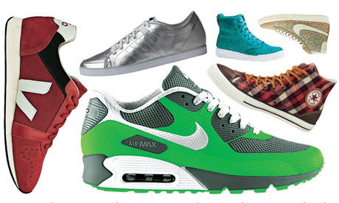
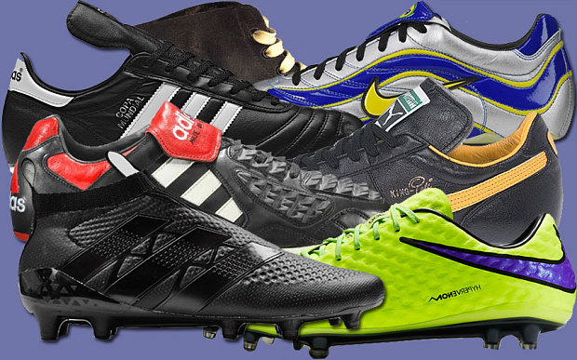
And make a child SMILE!!
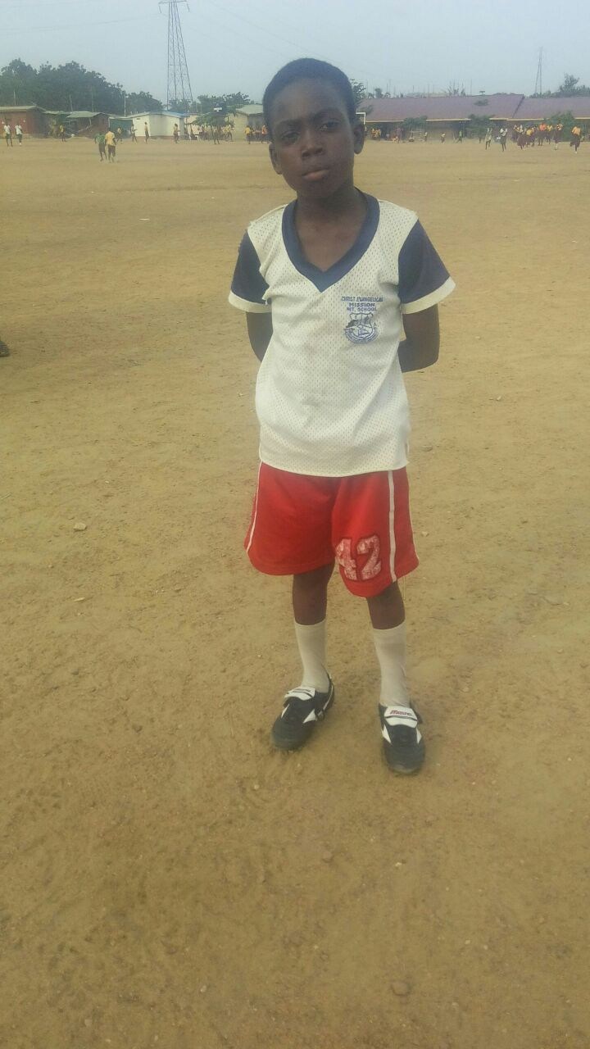
Ghana PHOTO
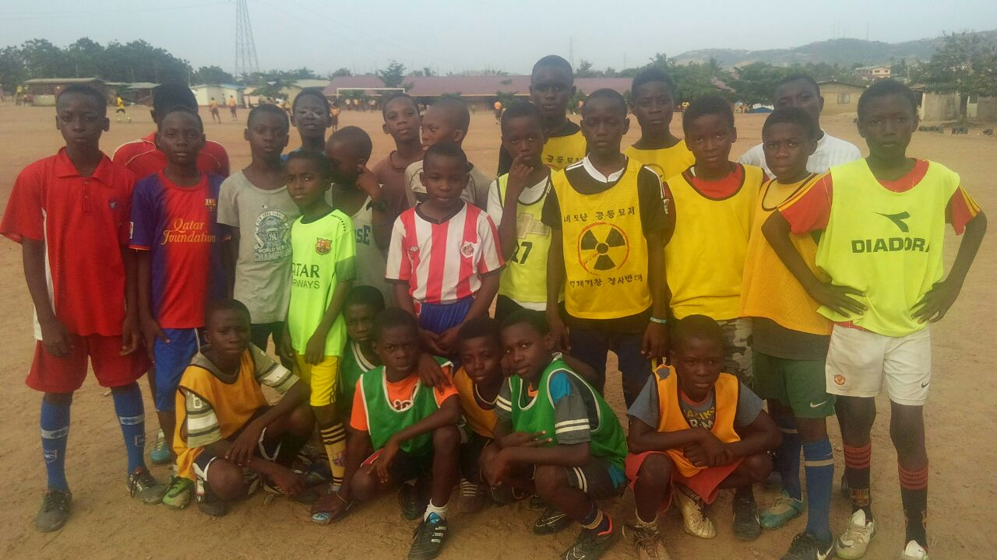
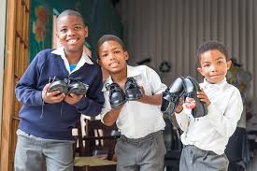

- We have supported needy children/teens in Ghana for 15 years.
- Do you have any unwanted trainers/football boots/school shoes?
- A pair of shoes means children can attend school.
- Trainers/football boots/socks means they no longer have to play their favourite game in bare feet!
All donations will be sent to Ghana in August. THANK YOU!!
Please leave your donations in the School Office for collection on 8th July 2016

