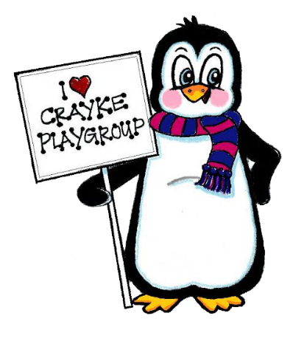
Early Years Practitioner
Level 2 / 3
Crayke Pre-School Playgroup
Approved provider of Early Years education from age 2 years.
Contact Caroline (Manager) on 079879811620
to arrange a visit / obtain an application pack
To work with our early years’ pre-school playgroup with children aged 2-5yrs. The right candidate will hold experience of working in a pre-school environment, show excellent use of initiative, safeguarding, an ability to tune in to and inspire our children.
Hours 8.15-15.30 Monday’s and Thursday’s each week term time. Preferably L2 or L3 qualified. Pay is dependent on qualifications and experience.
Crayke Playgroup is committed to safeguarding and promoting the welfare of young children - all successful candidates will be subject to an enhanced DBS check. Crayke Playgroup is an equal opportunities employer.
Deadline – Friday 8th April 2016
Crayke Pre School Committee,
Crayke Playgroup, Crayke Sports Hall, Crayke,
North Yorkshire. YO61 4TZ

