

**A FREE accredited course suitable for parents and volunteers who are (or are thinking about) helping in school and wish to gain a qualification - NCFE Level 2 Award Support Work in Schools.**

**Thursdays 25th Feb - 19th May 2016**

**9.30am - 2.30pm**

**(no sessions during school holidays)**

**RAF Linton on Ouse**

**(open to adults from military and non-military families)**

.

**Helping in Schools – NCFE Level 2 Award**

[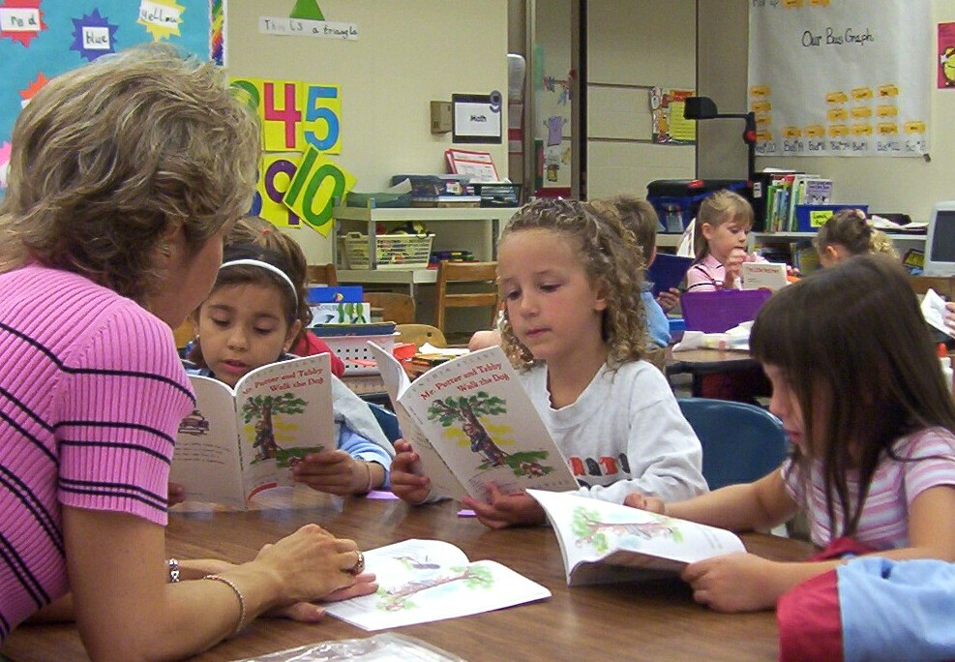](http://www.google.co.uk/url?sa=i&rct=j&q=&esrc=s&source=images&cd=&cad=rja&uact=8&ved=0CAcQjRxqFQoTCMfUhcL6kccCFUy1FAodl38K7Q&url=http://pleasureinlearning.com/2015/01/15/r2-magic-treehouses-and-little-debbie/&ei=ZAPCVceSE8zqUpf_qegO&bvm=bv.99261572,d.d24&psig=AFQjCNFnrKRMgG3AtKrNHeIgPPkpc0qtOw&ust=1438864547293177)

[](http://www.google.co.uk/url?sa=i&rct=j&q=&esrc=s&source=images&cd=&cad=rja&uact=8&ved=0CAcQjRxqFQoTCMfUhcL6kccCFUy1FAodl38K7Q&url=http://pleasureinlearning.com/2015/01/15/r2-magic-treehouses-and-little-debbie/&ei=ZAPCVceSE8zqUpf_qegO&bvm=bv.99261572,d.d24&psig=AFQjCNFnrKRMgG3AtKrNHeIgPPkpc0qtOw&ust=1438864547293177)

Yorkshire & Humber Region

**www.wea.org.uk/yh**

For more course information and to book a place contact:

**Diane Quinney 07824 545919 Email: dquinney@wea.org.uk**